**Case Report**

**Follow Up Case of Left Knee Total Knee Replacement (TKR): A Case Review**

**Himanshu Koshle*, Rabab Kaur and Kriti Agarwal**

MPT Orthopaedics, Assistant Professor, Department of Physiotherapy, Galgotias University Delhi NCR, India

**\*Corresponding author:** Himanshu Koshle, MPT Orthopaedics, Assistant Professor, Department of Physiotherapy, Galgotias University Delhi NCR, India, Tel: 7828158535, E-mail: [hkoshle@gmail.com](mailto:hkoshle@gmail.com)

**Citation:** Himanshu Koshle (2022) Follow Up Case of Left Knee Total Knee Replacement (TKR): A Case Review. JASC-Jscholar-2: 101

**Abstract**

Poor wound healing following a major lower limb amputation can result in poor rehabilitation outcomes, which can be further worsened if the patient has recurrent falls and stump trauma during the wound healing stage. Direct trauma to the stump can result in bony fractures at the margins of the residual bones, and loose bony fragments may form inside the stump. These bony fragments can hinder the process of stump wound healing and interfere with prosthetic limb use and rehabilitation.

**Keywords:** Amputation; Trauma; Rehabilitation

**Introduction**

The knee is the most common site of osteoarthritis, which further follows to the hand and hip. The proportion of the population aged 45 years and older with doctor-diagnosed osteoarthritis is estimated to increase from 26·6% to 29·5% for any location, from 13·8% to 15·7% for the knee, and from 5·8 to 6·9% for the hip [1]. The pain and loss of function can be disabling; in developed countries, the resulting socioeconomic burden is significant, costing between 10% and 25% of Gross domestic product (GDP). osteoarthritis treatment has traditionally consisted of pain management combined with joint replacement [2]. Although prevalence numbers vary, particularly due to varying definitions of Osteoarthritis (OA), it is conclusive that aging is the single greatest risk factor for the development of Osteoarthritis. The presence of both radiographic and symptomatic Osteoarthritis increases over the human lifespan. Increased rates with aging have been noted in the knee, hip, and hand. Worldwide estimates are that 9.6% of men and 18% of women older than 60 years have symptomatic Osteoarthritis. The Framingham Osteoarthritis study found that 27% of those aged 63 to 70 years had radiographic evidence of knee Osteoarthritis, increasing to 44% in the age group older than 80 years [3]. Most common presenting symptom of knee osteoarthritis is pain that worsens with use and improves with rest. Certain symptoms usually involve stiffness that improves after 30 minutes of activity (inactivity gelling), crepitus, swelling, and limping. In more advanced stages, Patients may present with symptoms of instability, genu valgum (knock knee), or varum (bowleg). Varus deformity is more prevalent than valgus deformity because it involves the medial compartment of the knee more frequently.

Treatment for knee osteoarthritis can be broken down into non-surgical and surgical management. Initial treatment begins with non-surgical modalities and moves to surgical treatment once the non-surgical methods are no longer effective. A wide range of non-surgical modalities is available for the treatment of knee osteoarthritis. These interventions do not alter the underlying disease process, but they may substantially diminish pain and disability [4]. Total knee replacement should be considered as a last resort. According to the American Academy of Orthopaedic Surgeons, A Total knee arthroplasty is the surgical treatment option for patients failing conservative management and those with osteoarthritis in more than one compartment. It is regarded as a valuable intervention for patients who have severe daily pain along with radiographic evidence of knee osteoarthritis [4]. The main indication for total knee arthroplasty is relief of pain associated with knee osteoarthritis if nonsurgical treatment has been ineffective. The complication rate of total knee replacement is 5.4 percent of patients and 7.6 percent of knees.[5] We reported a case in 55-year-old female patient who underwent Total Knee Replacement.

**Case Report**

We report this unusual case of a female housewife who visited us with a compliant of pain and numbness, 5 years ago. After conducting the physiotherapy assessment, the patient was guided with certain knee exercises after which the symptoms were managed conservatively. But with the diagnosis of osteoarthritis and under the orthopaedic consultation the patient underwent right total knee replacement, in the year 2015. Not after much break of two years, this 55-year-old female patient revisited us with pain and stiffness in her left knee. On X Ray investigation and after the diagnosis of osteoarthritis in her left knee also, the patient was advised for the left total knee replacement surgery. The surgical notes reported that the patient underwent cemented total knee replacement of left knee and Greater trochanter fixation with tension band wire. A midline central incision was given.

This followed up case of left total knee replacement, with a history of right TKR, visited our clinic with a chief complain of pain in left knee around the dressing area and a stiffness in left knee more than the right. On assessment it was subjectivised that the pain in the left knee aggravates while walking and doing knee bending activities. The nature of pain was periodic and quality was dull aching. The Numeric pain rating scale as per the patient was 6/10. Locking or giving away of the knee was absent. There was no abnormal sensation, but a stomach discomfort and numbness in feet were reported as an associated symptom. The patient has no medical history of hypertension or diabetes, but reports a left ventricular hypertrophy a grade 1 diastolic dysfunction. She is a socially sound and active women, consuming no alcohol and is a non-smoker. The patient reported some functional limitation to daily living activities like: difficulty in turning in bed, independent sit to stand, independent walking without walker and further difficulty in stair climbing. The patient is a good and cooperative woman with ectomorphic built type.

On assessing the posture in:

**Supine view:** The left lower limb: hip was externally rotated, hallux valgus and flat foot present. The right hip is neutral, but flat foot. Quadriceps muscle atrophy was present in right thigh.

**Sitting: lateral view:** Forward head and stooping shoulder. Anterior view: patient puts more weight on the right side, left shoulder elevated. Left hip externally rotated with left foot eversion.

**Standing:** Forward head posture, right shoulder elevated following compensatory movement, Right hip externally rotated and putting more weight on right leg than left.

**Gait pattern:** The patient was using the partial weight bearing with walker. Takes longer step with involved leg i.e., the left leg and shorter step length by the uninvolved leg. While walking the patient flexes the trunk forward in mid and late stance. During swing phase the knee bending increased in right leg, while decreased in left knee flexion. Furthermore, the left heel strike was absent.

**Assistive device**: Walker

**Willingness to participate**: present.

There was a mild swelling present in left foot, the skin was dry and scaly. The scar was not visualised as covered by the dressing. The following figure 1 and figure 2 show the anterior and lateral view of left lower limb with dressing.

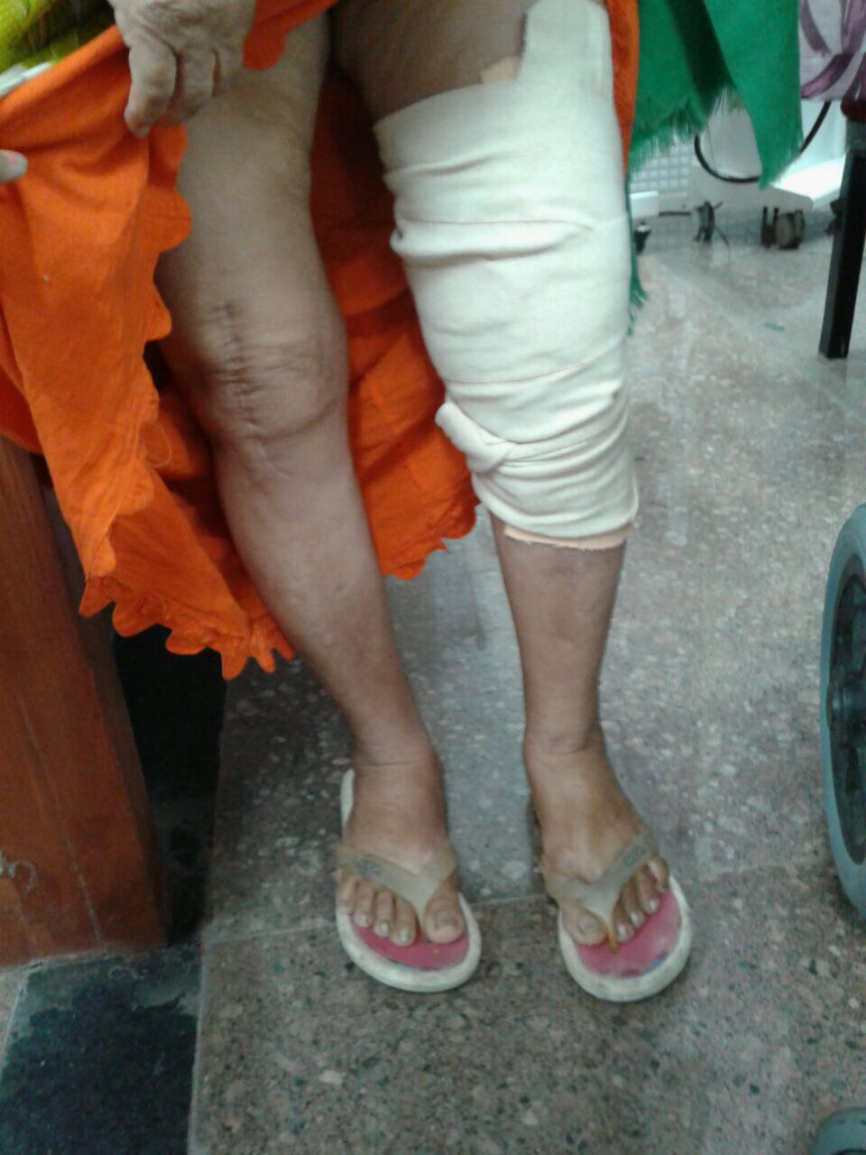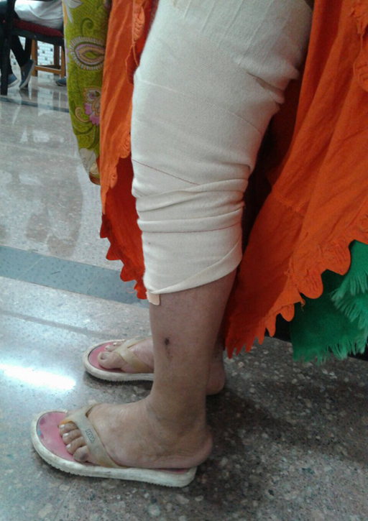

**Figure 1: -** Anterior View **Figure 2: -** Lateral View

On motor examination, the range of motion and manual muscle strength were reported as follow:

|  |  |  |  |  |
| --- | --- | --- | --- | --- |
| **JOINT** | **MOVEMENT** | **ROM RIGHT** | **LEFT** | **REMARKS** |
| HIP (supine) | Flexion | 0-50 | 0-70 | With knee bend, empty end feel (RT) |
| supine | Abduction | 0-30 | 0-30 | Firm |
|  | Adduction | 0-30 | 0-30 |  |
| Knee | Flexion | 25-90 | 20-90 | Empty end feel |
|  | Extension | 90-25 | 90-25 | empty end feel |
| Ankle | Dorsiflexion | 0-20 | 0-20 | Soft tissue stretch |
|  | Plantarflexion | 0-25 | 0-25 | Soft tissue stretch |
|  | Inversion | 0-25 | 0-25 | Soft tissue stretch |
|  | Eversion | 0-15 | 0-15 | Soft tissue stretch |

**Table 1:** Range of motion

|  |  |  |  |
| --- | --- | --- | --- |
| **Joint** | **Muscle group** | **Right** | **Left** |
| Hip | Flexors | 3 | 3+ |
|  | Abductors | 3 | 3 |
| Knee | Flexors | 3 | 3+ |
|  | Extensors | 3 | 4 |
| Ankle | Dorsiflexor | 3+ | -4 |
|  | Plantarflexor | -4 | -4 |
|  | Inversion | 3+ | 3+ |
|  | Eversion | 3+ | 3+ |

**Table 2:** Manual Muscle Test

Joint play: patellar mobility was reduced bilaterally

Limb length measurement:

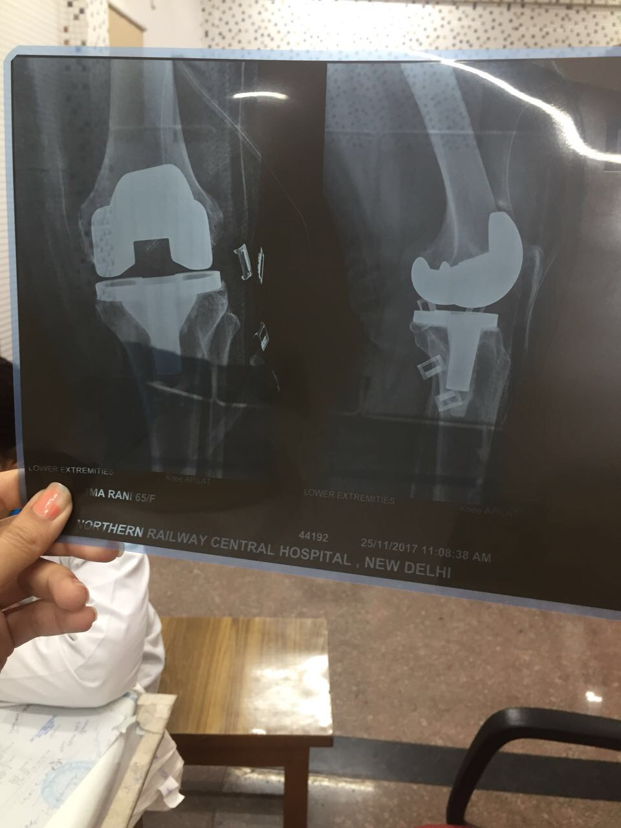

**Figure 3:** X-ray Post Left TKR

Considering the knee replacement surgery and the chief complaints a plan of treatment was formed inclusive of the symptoms and patient short- and long-term goals. The treatment plan followed was:

* Hip and knee strengthening exercises (isometric quads, hamstring, gluteal, abduction – adduction, standing hip extension, terminal knee extension)
* Continuous Passive Motion
* Active rom exercises for hip and knee joint
* Ankle toe movements
* Gait training progressing to symmetrical weight bearing on lower extremity
* Stair ascending and descending
* Balance and proprioceptive exercises
* Activity of Daily Living training

**Conclusion**

The study conducted on the patient undergoing total knee replacement surgery concluded the effectiveness of early mobilization and rehabilitation for fast recover. The study reports that even after the Total Knee Replacement, the symptoms of pain and stiffness is often reported by the patients, which can be treated and prevented by the approach of physical therapy. This defines the importance of need of physiotherapy in postoperative care with the aim of early mobilization.

**References**

1. Hunter David J, Bierma-Zeinstra Sita (2019) Osteoarthritis. The Lancet 393: 1745-59.

2. S Glyn-Jones, A J R Palmer, R Agricola, A J Price, T L Vincent, et al. (2015) A J Carr Lancet 386: 376–87.

3. Benjamin Abramoff, Franklin E (2019) Caldera 2019: 0025-7125.

4. Hsu H, Siwiec RM (2020) Knee Osteoarthritis. In: StatPearls. StatPearls Publishing, Treasure Island (FL).

5. Søren T, Skou PT, Ewa M Roos PT (2015) A Randomized, Controlled Trial of Total Knee Replacement 373: 1597-606.