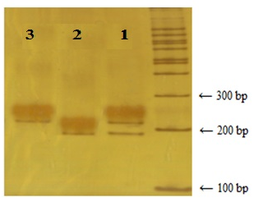

**Figure 1:** Electrophoresis of PCR fragments of UGT2B15 gene polymorphism after exposure to Sau3AI restriction enzyme on 8% polyacrylamide gel. Lane 1, in which a 187 and a 215 base pair fragments are visible, indicates the DY genotype. The 28bp.fragment is removed from the gel due to its small size, so it is not visible. Lane 2 shows DD genotype containing a cleavage site for the enzyme in both alleles and is cut into two fragments of 187 and 28 bp. Finally, lane 3 represents the YY genotype with 215 bp fragment due to the lack of the enzyme cleavage site