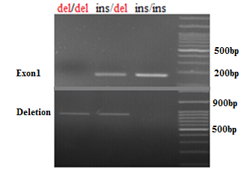

**Figure 2:** Electrophoresis of UGT2B17 gene PCR fragments on 2.5% agarose gel. The ins/ins genotype indicates that this gene has not been deleted. In this case, the deletion primer will not be able to amplify the region and only one 173 bp fragment will be detected. In the del/ins genotype, one of the alleles of the gene is deleted and the other is present, so two fragments of 173 bp and 893 bp are amplified. In the third line, which shows the del/del genotype, due to the homozygosity for deletion in both alleles of the studied gene, an 893 bp fragment is shown