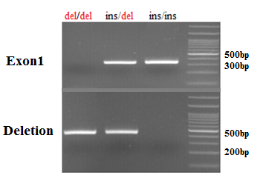

**Figure 3:** Electrophoresis of UGT2B28 gene PCR fragments on 2.5% agarose gel. The ins/ins genotype indicates that this gene has not been deleted. In this case, the deletion primer will not be able amplify the region and a unique fragment of 324 bp will be detected. In the del/ins genotype, one of the alleles of the gene is deleted and the other is present, so two fragments of 324 and 450 bp are amplified. In the third line, which represents the del/del genotype, due to the deletion of both alleles, a 450 bp fragment is produced