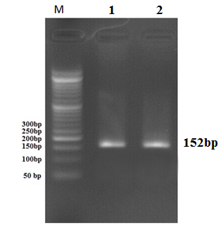

**Figure 4:** The electrophoresis of TNF-α gene promoter PCR product to show rs361525 polymorphism. Analysis was performed on 2% agarose gel. In this figure, the 152 bp band is the expected amplified fragment. Lanes1 and 2 are samples and M is a 50bp DNA ladder