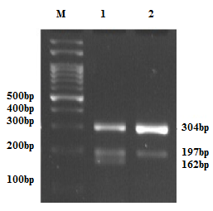

**Figure 6:** Electrophoresis of PCR fragments related to rs1800629 polymorphism of TNF-α gene on 2% agarose gel. Lane 1, in which three pieces of 304, 197 and 162 base pairs are seen, indicates the GA genotype. Lane 2, which shows 304 and 197 base pairs, represents the GG genotype