Minor changes related to Big Data Mining and Its Challenges: A Review

The order of the authors names should be:

Amjad A Alaskar\*, Hailah A Almesned, Nouf N Almuqati and Dr. Mohammad M. Hassan

\*Corresponding author: Amjad A Alaskar, King Saud University, Riyadh, Saudi Arabia, Tel: +966114695202, E-mail: [439203736@student.ksu.edu.sa](mailto:439203736@student.ksu.edu.sa)

Citation: Amjad A Alaskar\*, Hailah A Almesned, Nouf N Almuqati, Dr. Mohammad M. Hassan (2022) Big Data Mining and Its Challenges: A Review. J Comput Sci Software Dev 2: 1-8.

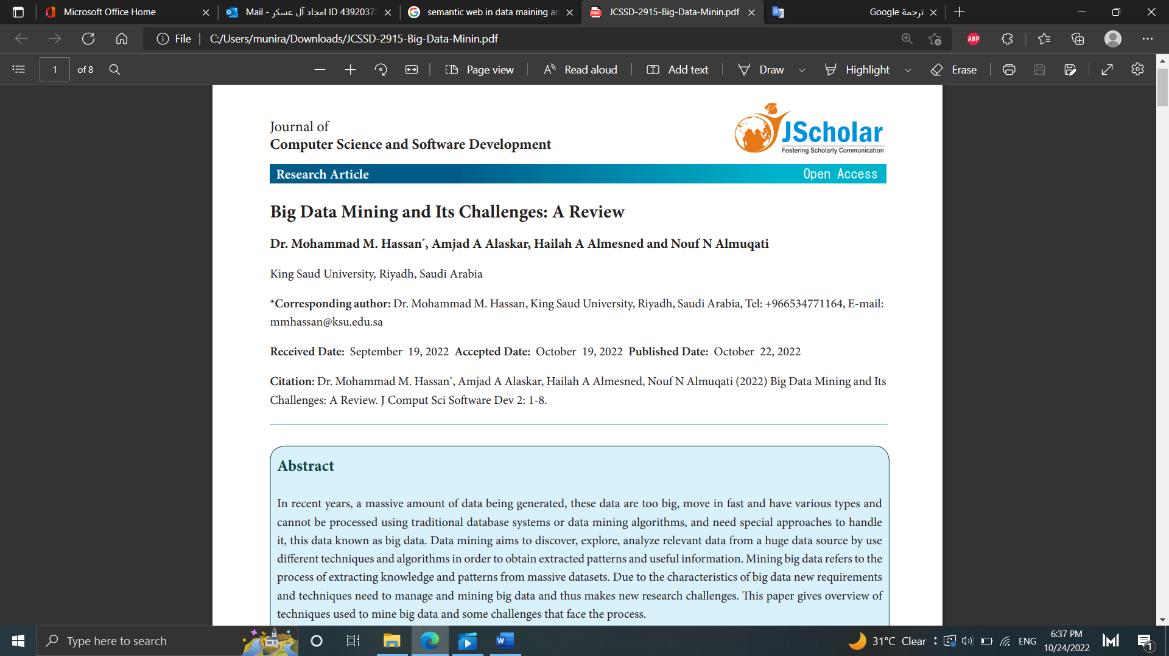

In page 2 a better quality of Figure 1: The KDD process [19].

