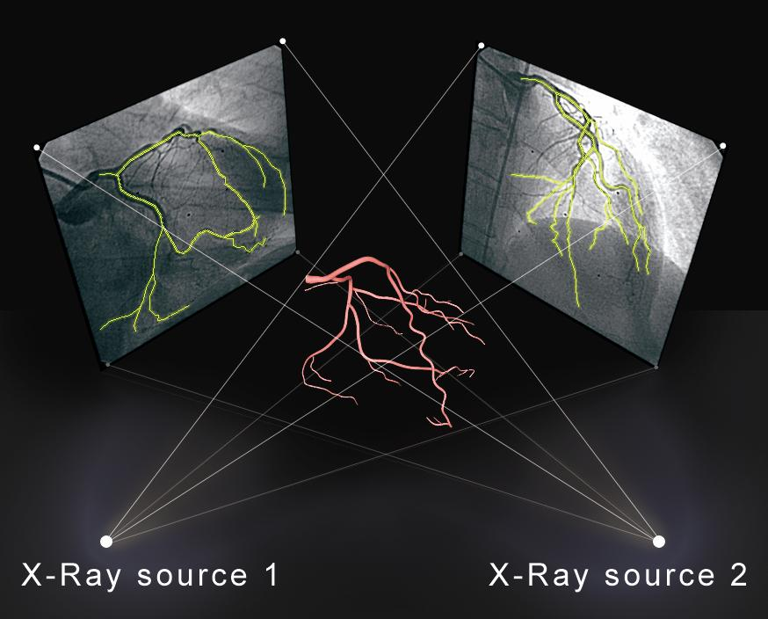

**Figure 1:** Three Dimensional coronary models reconstructed from two planar angiograms.

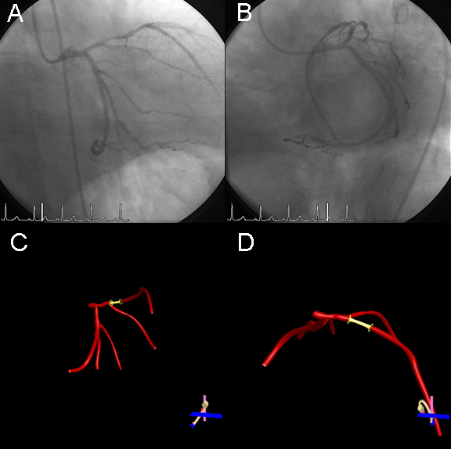

Figure 2: 3DRA analysis of the mid-LAD lesion.

A) and B) Initial RAO CAUD and LAO CAUD projections > 30° in angulation utilized for 3D coronary model reconstruction. C) 3D model in operator selected view of RAO 1/CAUD 39 projection with 17% foreshortening as described on the Optimal View Map (OVM). B) Rotated 3D reconstruction to RAO 45/CRAN 30 minimizing the foreshortening to 0% while enabling visualization of the first diagonal branch.

*3D= three dimensional, CRAN= cranial, CAUD= caudal, LAD=left anterior descending artery, RAO= right anterior oblique*

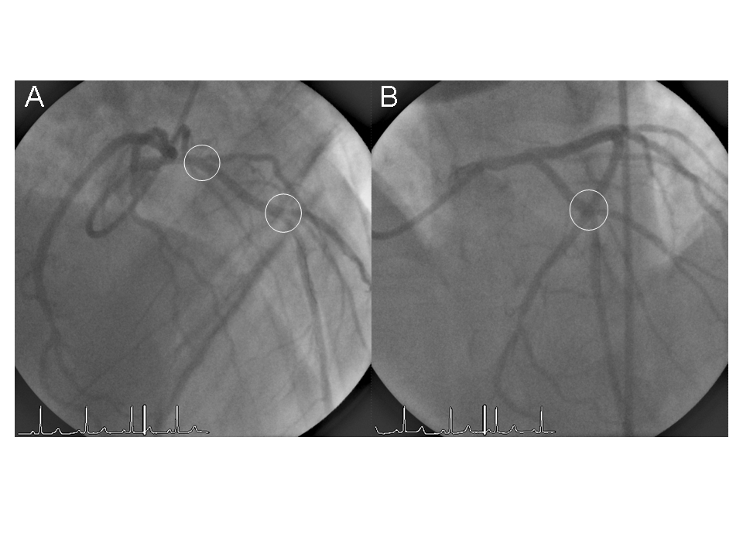

**Figure 3:** 3DRA assisted optimal view projection of the mid-LAD minimizing foreshortening and overlap.

A) 3DRA assisted projection of the post-PCI mid-LAD illustrating well separated diagonal branches (circles) with a minimally foreshortened mid-LAD. B) Prior operator selected view of the mid-LAD with an obscured first diagonal branch and overlapped second diagonal (circle). The impact of foreshortening length estimation is noted with a 17% difference length of the segment between the two diagonal branches in panel A versus panel B.

*3DRA= three dimensional reconstruction, CRAN= cranial, LAD=left anterior descending artery, PCI= percutaneous coronary intervention*