Journal of

### Fertility Sterility and Reproductive Health



Research Article

Open Access

Smoking and Varicocele Adversely affect Sperm Enzyme Profile as Evidenced by Alpha-Naphthyl Acetate Esterase, Acid Phosphatase and Alkaline Phosphatase Cytochemistry

### Rukiye Erdogan1, Celik Ilhami2,* and Ulku Nur Canbolat2

1Rukiye Erdogan, Selcuk University Medical Faculty, Andrology Laboratory, Konya, Turkey

2Department of Histology and Embryology, Faculty of Veterinary Medicine, University of Selçuk, Konya, Turkey

**\*Corresponding Author:** Celik Ilhami, Department of Histology and Embryology, Faculty of Veterinary Medicine, University of Selcuk, Konya, Turkey, Tel: 903322232627, E-mail: [icel@selcuk.edu.tr,](mailto:icel@selcuk.edu.tr) ORCID ID: 0000-0002-3587-7609

**Received Date:** December 16, 2023 **Accepted Date:** January 16, 2024 **Published Date:** January 19, 2024

**Citation:** Celik Ilhami (2024) Smoking and Varicocele Adversely affect Sperm Enzyme Profile as Evidenced by Alpha-Naph- thyl Acetate Esterase, Acid Phosphatase and Alkaline Phosphatase Cytochemistry. J Fertil Steril Reprod Health 3: 1-13

**Abstract**

**Background:** In addition to the other factors, varicocele is responsible for one third of male reproductive disorders. The inci- dence of varicocele ranges between 35-40% in men with primary infertility, increases to 80% in secondary infertility. Among adult males with varicoceles, 90% are present unilaterally on the left side while 10% are present bilaterally**.** Varicocelectomy has a beneficial effect on the improvement of semen quality and male fertility. Although the etiology of varicocele remains unclear, it reduces testicular blood renewal with a consequent accumulation of toxic substances. Thus, varicocele can poten- tiate the toxic effects of the genotoxic substances such as those found in cigarette smoke. Current human semen analysis is not sufficient to determine the fertility potential of a semen sample. In particular, there is insufficient information on the ef- fects of varicocele and smoking on sperm enzymes. In this study, α-naphthyl acetate esterase, acid phosphatase and alkaline phosphatase activities of the human sperm were determined. Semen samples were obtained from sexually mature healthy non-smokers, non-smokers with varicocele, non-smokers with varicocelectomy, smokers without varicocele and smokers with varicocelectomy. Semen smears were prepared, air-dried, fixed. Enzyme cytochemically processed specimens were ex- amined examined under a light microscope for positive reactions of the enzymes.

**Results:** The healthy non-smoking group group had the highest enzyme positivites of the investigated enzymes. The positivi- ties significantly was lower in the non-smoker varicocele group and reached in its lowest level in the smoker varicocele group. Varicocelectomy significantly increased positivity percentages of the 3 enzymes. Nevertheless the increase in the with varicocelectomized smokers group was lower than the other groups.

©2024 The Authors. Published by the JScholar under the terms of the Crea-tive Com- mons Attribution License [http://creativecommons.org/licenses/by/3.0/,](http://creativecommons.org/licenses/by/3.0/) which per- mits unrestricted use, provided the original author and source are credited.

**Conclusions:** The enzyme cytochemical results of this study have revealed that smoking and varicocele signifcantly reduced the sperm counts and motility in accordance with the significant decreases in the alpha-naphthyl acetate esterase, acid and alkaline phosphatase positivity profiles of the samples. Although varicocelectomy provided significant improvement in the positivity profiles of the investigated enzymes, keeping smoking limited the positive effect of the varicocelectomy. Cyto- chemical demonstration of the sperm enzymes might be a useful tool in sperm quality evaluation.

**Keywords:** Acid Phosphatase**;** Alkaline Phosphatase**;** Alpha-Naphthyl Acetate Esterase; Semen**;** Sperm Enzymes

**Abbreviations**

ACP-ase: Acid phosphatase; ALP-ase: Alkaline phosphatase; ANAE: α-naphthyl acetate esterase; ICSI: Intracytoplasmic sperm injection; PBS: Phosphate buffer saline; ROS: Reactive oxygen species; RT: Room temperature; WHO: World Health Organization

## Background

Infertility, classically defined as the inability to achieve pregnancy after 12 months of sexual relations well distributed throughout the menstrual cycle and without the use of contraceptives, affects around 15% of couples of re- productive age and the male partner is responsible for up to 50% of these cases [1].

Many adverse internal and external conditions, such as high testicular temperature, varicocele, nutrition, ag- ing, environmental pollutants, infections, cryptorchidism, varicocele, drug addiction and smoking, have detrimental ef- fects on male fertility through their unique pathophysiologi- cal mechanisms. The optimum temperature required for regular spermatogenesis to occur is approximately 35°C, and thermoregulation of the testicles is achieved by elonga- tion of the musculus cremaster and heat exchange between the spermatic artery and the plexus pampiniformis using the countercurrent principle [2,3].

Varicocele (Curling varicocele), which is the abnor- mal dilatation of the efferent veins in the pampaniform plexus, is associated with alterered semen quality, decreased sperm functional integrity and seminal oxidative stress, di- minished seminal plasma protein profiles which may cause the altered semen phenotype. Dilatation, stasis and high pressure in the plexus pampiniformis veins of the funiculus spermaticus are typical in the disease. Disposing of anatomi- cal features, narrowing and obstruction of the veins are facil- itating factors in the etiology of varicocele [3]. The left testis

is more susceptible to varicocele. Since varicocele progres- sively damages testicular tissues over time, testicular devel- opment is regressed, spermatogenesis is disrupted and infer- tility develops. The increase of varicoele from 35% to 40% in men with primary infertility to 80% in men with se- condary infertility, suggests that the disorder causes a pro- gressive decline in male fertility [2]. Ligation of dilated veins greatly improves testicular functions including sper- matogenesis and sperm quality in 80% of cases after the op- eration.

Varicocele can potentiate the toxic effects of envi- ronmental exposure to genotoxic substances such as ci- garette smoke cecause that varicocele reduces testicular blood renewal resulting in accumulation of toxic substances [4]. Also, an association between oxidative stress and im- paired sperm function in patients with varicocele has been evidenced by increased levels of reactive oxygen spe- cies(ROS) and reduced total antioxidant capacity [5].

It was long known that smoking has negative ef- fects on sperm count and motility, as well as sperm mor- phology. Nicotine is the most important substance of ap- proximately 4000 toxic substances found in smoke. In heavy smokers, semen volume, sperm count, sperm motility decrease and the rate of abnormal sperm increases. The most affected parameter in smokers is sperm motility, which determines sperm fertilization [6]. Smoking prevents these people from having children, even with assisted repro- ductive techniques. Because even in intracytoplasmic sperm injection (ICSI), motile sperm are also preferred in sperm se-

lection.

Traditional human semen analysis primarily deter-

monstrated in the head, midpiece and tail of bovine sperma- tozoa [17].

mine morphology, concentration and motility of the sperm, because low sperm count, progressive forward motility and deterioration in morphology are considered evidence of fer- tility problems. Although these methods provide valuable re- sults, they are not decisive in determining the fertility of the semen sample [7]. Therefore, intense efforts have been made to develop new laboratory tests that determine the fer- tilizing capacity of human sperm. More recent efforts to pre- dict male fertility have focused on the ability of sperm to un- dergo the acrosome reaction. A positive correlation has been found between the frequency of induction of the acro- some reaction and fertility under in vitro conditions [8]. Lar- son and Miller [9] suggested that the acrosomal status of the sperm could be clearly determined within a few minutes us- ing Coomassie blue staining.

A number of enzyme activities have been demons- trated in both sperm and seminal plasma of some mam- malian species, including humans [10,11]. Previous re- searchers have used complex biochemical techniques to de- termine the amount and location of sperm enzymes [12]. Re- cently, cytochemical methods have begun to be used in re- search on sperm enzymes.

Most sperm enzymes are essential for the fertiliza- tion ability of sperm [13]. Acrosomal enzymes of sperm are mostly acidic hydrolytic enzymes that play an important role in sperm penetration during oocyte fertilization [13].

A water-soluble enzyme, acrosomal hyaluronidase is the first enzyme to leak from the acrosome into the semi- nal plasma and digests the hyaluronic acid between the cu- mulus oophoricus and corona radiata cells. Acid-phospha- tase (ACP-ase) and alkaline-phosphatase (ALP-ase) were biochemically first detected in different pieces of human sperm by Wislocki [14]. Experiments by Allison and Hartree [15] revealed that ACP-ase is mainly located in the acrosome. Edvinsson et al. [10] also detected ACP-ase activi- ty on the outer surface of the human sperm membrane, which was previously detected biochemically in seminal plasma. Non-specific esterase is mainly found in the middle piece of the mouse sperms [16]. Cholinesterase has been de-

The cytochemical analysis of the enzymes in differ- ent pieces of sperm, especially in the sperm head and its acrosome, can provide useful clues in the evaluation of sperm quality. In the present study, the differences between the positivities of α-naphthyl acetate esterase (ANAE), ACP-ase and ALP-ase were determined in the semen sam- ples of sexually mature and non-smokers without varicocele (healthy), non-smokers with varicocele, non-smokers with varicocelectomy, smokers without varicocele, and smokers with varicocelectomy.

## Methods

### Materials and Groups

In the study, the semen samples were taken from a total of 42 men with fertility problems, aged between 21-45 years, under the directives of the Ethics Committee of (Deci- sion number: 2017/187 dated 07.6.2017). Semen donors were selected with their own consent among men accepted to the faculty's Andrology Laboratory. Donors who were smokers or nonsmokers had no medical history of chronic diseases such as serious urological infection and undescend- ed testicles, diabetes, hypertension and rheumatism, with or without varicocele surgery.

After semen quality evaluation, semen samples were divided into 5 groups: non-smoker non-varicocele group, non-smoker varicocele group, non-smoker varicoc- electomy group, smoker varicocele and smoker varicocelec- tomy groups.

### Collecting and Quality Evaluation the Semen Sam- ples

Semen samples were collected into sterile contain- ers by masturbation after at least three days of sexual absti- nence. For macroscopic examination, the samples were liq- uefied in an oven at 37°C for 15-60 minutes. After evaluat- ing the viscosity, appearance, volume and pH of each sam- ple, the samples were examined under a light microscope (CX41, Olympus, Japan) with a X20 objective.

### Sperm Washing

For this purpose, 1 ml of fresh semen sample was diluted with 9 ml of phosphate buffer saline (0.1 M PBS, pH 7.4), and centrifuged at 800 G at room temperature (RT, 22°C) for 8 minutes. The process was repeated 3 times. Af- ter the third centrifugation, the sperm pellet was diluted with 2 ml of PBS. Semen smears were prepared, air-dried at RT, and stained (Spermac FP17S11, Minitube, Belgium).

Both macroscopic and microscopic semen quality were evaluated according to the fifth guideline of the World Health Organization (WHO) [18]. Sperms were counted and motility was determined using a hemocytometer. At least, 200 motile spermatozoa were counted in each sample, and motility data were expressed as the percentage of motile sperm of the total sperm count. Semen samples that were evaluated as azoospermic upon microscopic examination were excluded from the study. Appropriate smears were used in enzyme cytochemical procedures.

### ANAE Cytochemistry

Semen smears were fixed in glutaraldehyde-ace- tone (pH 4.8) at −10°C for 5 min and then washed three times with distilled water. The incubation solution was pre- pared according to Çelik et al. [19]. The air-dried smears were kept in the incubation solution at 37°C in a controlled manner for 60 minutes. Upon formation of the reddish brown reaction product, the incubation was terminated, the slides were washed 3 times with distilled water, and the nu- clei were stained with 2% methyl green (M8884, Sigma-Al- drich, Germany). Slides were coverslipped using synthetic resin.

### ACP-ase Cytochemistry

Air-dried smears were fixed in a solution contain- ing 10 ml of methyl alcohol, 60 ml of acetone, 30 ml of dis- tilled water and 630 mg of citric acid at -10°C for 5 minutes. The enzymatic reaction was carried out by azo dye simulta- neous coupling method [20]. The final pH of the incubation solution was adjusted to 5.0 with 1N NaOH solution and then filtered. The smears were kept in the solution at room temperature for 1 hour in a controlled manner. At the end of the incubation, nuclei were stained with 2% methyl green

in acetate buffer (pH 4.8). Slides were coverslipped using Kaiser’s gelatin.

### ALP-ase Cytochemistry

ALP-ase activity was determined by the simultane- ous azo-binding method according to Lojda et al. [21]. Brief- ly, smears were fixed in formal calcium at -10°C for 5 min, washed three times with distilled water, and air dried. The enzymatic reaction was confirmed by the azo dye simultane- ous coupling method using sodium α-naphthyl phosphate (N7000, Sigma-Aldrich, Germany) as substrate and fast red TR (F6760, Sigma-Aldrich, Germany) as chromogen. The smears were incubated in the incubation solution in a con- trolled manner at room temperature for 10-15 minutes. When the reddish brown reaction product was formed, the incubation was terminated and the smears were washed 3 times with distilled water. The cell nuclei were stained with 2% methyl green in acetate buffer (pH 4.8), and slides were coverslipped using Kaiser’s gelatin. All samples were ex- amined with a Nikon Eclipse E-400 light microscope equipped with a DS-5M digital camera head and DS-L1 cam- era control unit (Nikon, Japan) with an X100 objective. In each smear, total sperm were counted until a count of 200 enzymatically positive sperm was reached, and the results were expressed as a percentage (%) of the total sperm count.

### Statistical Analysis

The data were analyzed with the IBM SPSS (IBM Corp., Armonk, USA) software for Windows. Since the data obtained from the cytochemical representation of ANAE, ACP-ase, and ALP-ase were not normally distributed, the data were first analyzed by the Kruskal Wallis test. Mann Whitney U-test was used to compare the significance of the differences between the mean values of the groups. A value of p< 0.05 was considered statistically significant.

## Results

### Semen Quality of the Groups

Individual semen quality data of the donors are given in the table 1. Sperm concentration was highest in the non-smoking and non-varicocele groups, decreased signifi- cantly when smoking and varicocele coexisted, while the

smoking varicocele group had the lowest level.

**Table 1:** Semen quality parameters of the donors

|  |  |  |  |  |  |  |  |  |  |  |
| --- | --- | --- | --- | --- | --- | --- | --- | --- | --- | --- |
| **Groups** | **Case numbers** | **Age (Year)** | **Sperm**  **6**  **concentration(X10**  **cell/ml)** | **Total motility (%)** | **Progresive Motility (%)** | **Nonprogressive motility (%)** | **Sperm vitality (%)** | **Head abnormality (%)** | **Neck-middle piece abnormality (%)** | **Tail abnormality (%)** |
| **Non-smoker non-varicocele** | 1 | 45 | 80 | 70 | 51 | 19 | 76 | 86 | 14 | 16 |
| 2 | 30 | 40 | 65 | 47 | 18 | 69 | 88 | 16 | 19 |
| 3 | 34 | 80 | 70 | 55 | 15 | 73 | 89 | 16 | 23 |
| 4 | 28 | 80 | 62 | 44 | 18 | 65 | 88 | 9 | 17 |
| 5 | 55 | 52 | 69 | 56 | 13 | 74 | 89 | 14 | 9 |
| 6 | 32 | 70 | 66 | 50 | 16 | 72 | 87 | 18 | 8 |
| 7 | 28 | 20 | 65 | 45 | 20 | 69 | 89 | 14 | 19 |
| **Non-smoker varicole** | 8 | 32 | 28 | 79 | 61 | 18 | 82 | 87 | 17 | 13 |
| 9 | 28 | 80 | 66 | 50 | 16 | 69 | 87 | 18 | 23 |
| 10 | 20 | 60 | 70 | 53 | 17 | 75 | 89 | 13 | 18 |
| 11 | 19 | 65 | 60 | 39 | 21 | 67 | 85 | 17 | 15 |
| 12 | 28 | 55 | 76 | 60 | 16 | 79 | 89 | 13 | 21 |
| 13 | 26 | 35 | 66 | 52 | 14 | 71 | 86 | 15 | 17 |
| 14 | 28 | 54 | 78 | 60 | 18 | 82 | 89 | 9 | 18 |
| 15 | 40 | 100 | 70 | 56 | 14 | 76 | 90 | 19 | 15 |
| **Non-smoker varicolectomy** | 16 | 42 | 60 | 67 | 54 | 13 | 68 | 87 | 10 | 15 |
| 17 | 29 | 82 | 78 | 60 | 18 | 84 | 90 | 14 | 12 |
| 18 | 27 | 30 | 70 | 53 | 17 | 74 | 88 | 13 | 22 |
| 19 | 30 | 22 | 63 | 36 | 27 | 69 | 89 | 16 | 23 |
| 20 | 37 | 25 | 68 | 52 | 16 | 72 | 85 | 18 | 21 |
| 21 | 32 | 16 | 25 | 13 | 12 | 29 | 87 | 12 | 17 |
| 22 | 24 | 60 | 70 | 55 | 15 | 73 | 90 | 15 | 18 |
| 23 | 30 | 50 | 60 | 48 | 12 | 65 | 89 | 11 | 10 |
| **Smoker varicocele** | 24 | 29 | 80 | 70 | 52 | 18 | 76 | 86 | 19 | 21 |
| 25 | 21 | 26 | 65 | 50 | 15 | 68 | 88 | 16 | 19 |
| 26 | 18 | 32 | 68 | 50 | 18 | 71 | 89 | 18 | 18 |
| 27 | 28 | 34 | 65 | 47 | 18 | 69 | 89 | 21 | 22 |
| 28 | 24 | 72 | 60 | 42 | 18 | 63 | 90 | 13 | 16 |
| 29 | 25 | 20 | 65 | 50 | 15 | 69 | 88 | 14 | 18 |
| 30 | 35 | 60 | 65 | 52 | 13 | 71 | 89 | 12 | 19 |
| 31 | 22 | 23 | 65 | 43 | 22 | 68 | 87 | 19 | 14 |
| 32 | 31 | 28 | 70 | 52 | 18 | 75 | 90 | 15 | 27 |
| 33 | 26 | 35 | 74 | 60 | 14 | 77 | 92 | 19 | 14 |
| **Smoker varicocelectomy** | 34 | 35 | 15 | 66 | 46 | 20 | 69 | 89 | 16 | 20 |
| 35 | 30 | 16 | 69 | 50 | 19 | 73 | 89 | 16 | 22 |

|  |  |  |  |  |  |  |  |  |  |  |
| --- | --- | --- | --- | --- | --- | --- | --- | --- | --- | --- |
|  | 36 | 32 | 100 | 74 | 56 | 18 | 78 | 88 | 16 | 21 |
| 37 | 28 | 24 | 71 | 54 | 17 | 76 | 87 | 11 | 12 |
| 38 | 25 | 16 | 62 | 43 | 19 | 67 | 88 | 11 | 10 |
| 39 | 35 | 20 | 50 | 35 | 15 | 54 | 89 | 11 | 18 |
| 40 | 38 | 16 | 75 | 56 | 19 | 81 | 92 | 13 | 11 |
| 41 | 36 | 20 | 60 | 40 | 20 | 66 | 89 | 22 | 7 |
| 42 | 23 | 60 | 70 | 53 | 17 | 76 | 92 | 15 | 17 |

Varicocele alone caused a significant decrease in sperm concentration. Although varicocele surgery causes a significant increase in sperm concentration. Smoking weak- ened the positive effect of varicocele surgery (Figure 1).

The healthy non-smoker group had the highest sperm motility. Varicocele significantly reduced sperm motility. Varicocelectomy significantly increased sperm motility. However, smoking weakened the effectiveness of the varicocelectomy (Figure 1).

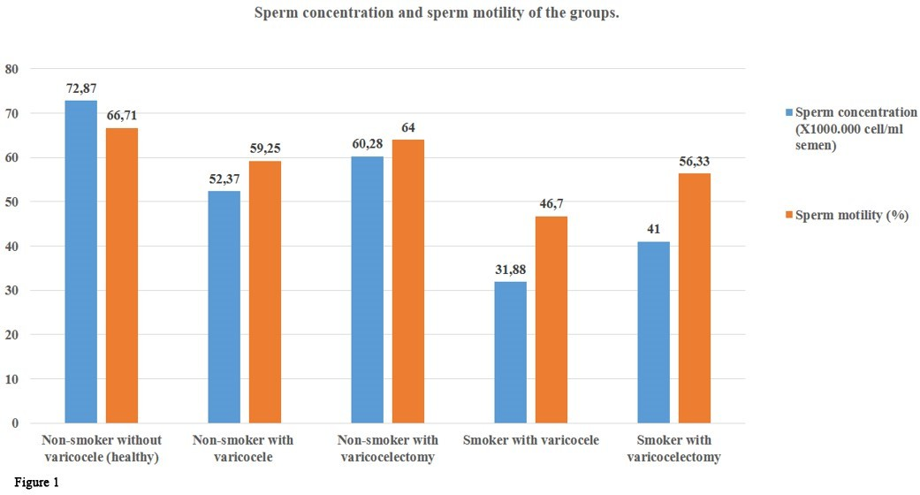

**Figure 1:** Sperm concentration and sperm motility of the groups

### Morphological Evaluation of the ANAE Positivity

ANAE positivity was observed mainly in the head part of the sperm, behind the equator and close to the mid- dle part, in the granular form and reddish-brown granules or bands adjacent to the cell membrane, and rarely in the

form of bands localized in the middle part. Mononuclear so- matic cells and semen droplets also gave strong ANAE posi- tivity. The distribution and localization of the reaction prod- uct of the ANAE enzyme of the groups were quite similar (Figure 2).

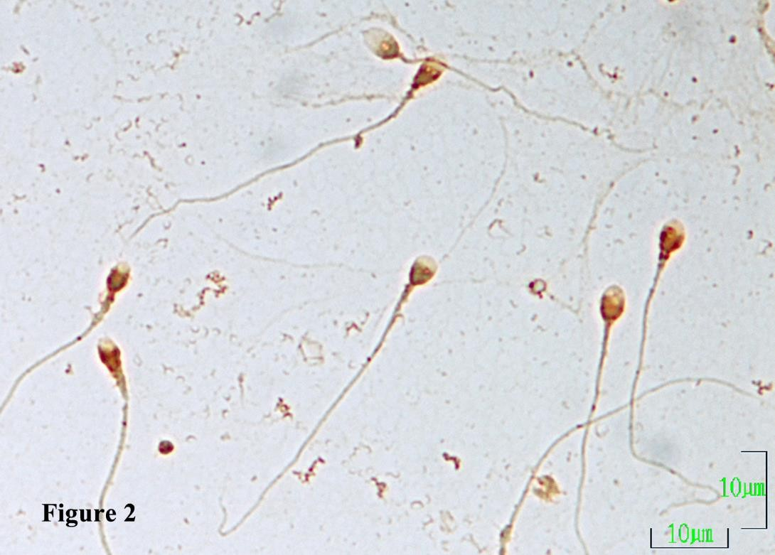

**Figure 2:** ANAE positive spermatozoa with different positivity patterns in the non-smoker varicocele group are seen. The reaction product is mainly located in the sperm head, behind the equator, and close to the middle piece, as granules and bands adjacent to the cell membrane, and rarely in the middle piece of the sperm. Semen droplets also gave strong ANAE positivity. ANAE demonstration. Magnification bar: 10 µm

### Morphological Evaluation of the ACP-ase Positivity

ACP-ase positivity was observed in some samples as pale diffuse pinkish-red staining in the acrosome of the sperm and small granules stained dense pinkish-red in the same locations and in the middle and tail pieces. In most of

the samples, the ACP-ase reaction product lcated in the mid- dle piece of the sperm. The positivity was also observed in somatic cells and semen droplets. There was no difference between the groups in terms of distribution and localization of ACP-ase (Figure 3).

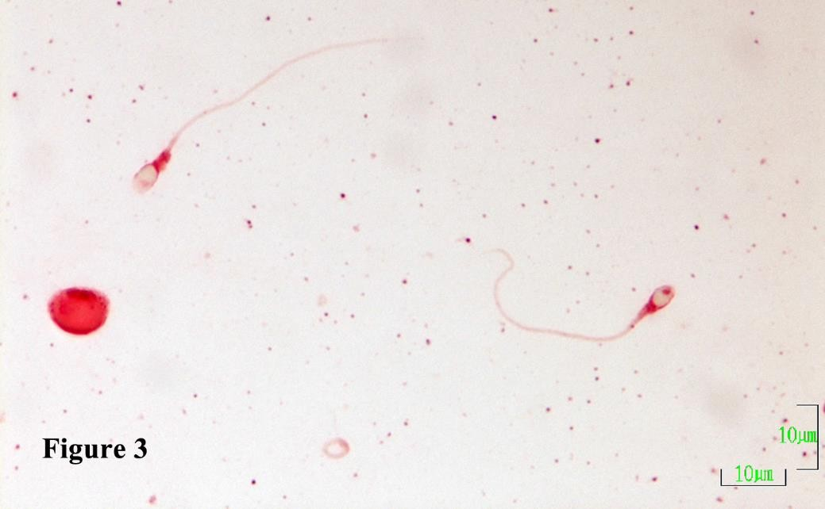

**Figure 3:** ACP-ase positive spermatozoa with different positivity patterns in the smoker varicocelectomy group are seen. The pinkish-red re- action products are located mainly as a pale diffuse staining in the acrosome, stronger in the middle, and weakly stained product in the tail of the sperm. Somatic cells and semen droplets also gave a positive reaction. ACP-ase demonstration. Magnification bar: 10 µm.

### Morphological Evaluation of the ALP-ase Positivity

ALP-ase positivity was observed as reddish-brown granules located predominantly in the head and neck re-

gions of the sperm. No significant difference was observed between the ALP-ase enzyme positivity patterns of the groups (Figure 4).

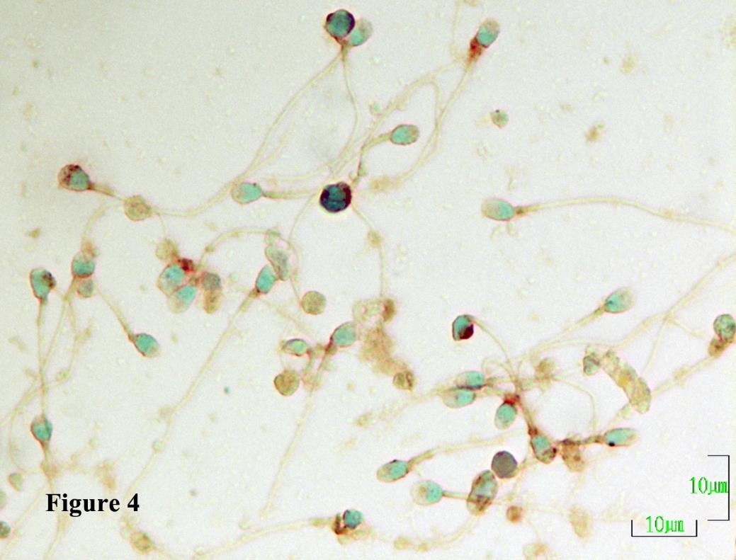

**Figure 4:** ALP-ase positive spermatozoa in the non-smoker varicocele group. ALP-ase reaction products are reddish-brown small granules, which are mainly located in the head and neck pieces of the spermatozoon. ALP-ase demonstration. Magnification bar: 10 µm

### Enzyme Positivity Frequency Results

Significant individual differences were observed in

ANAE, ACP-ase, and ALP-ase positivity. The mean ANAE, ACP-ase, and ALP-ase positivity of each of the groups were quite similar and displayed similar changes (Figure 5).

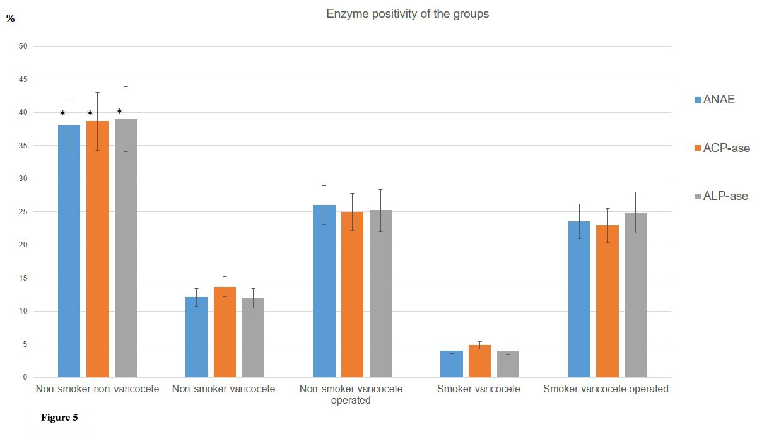

**Figure 5:** Enzyme positivity of the groups

ANAE positivity was highest (38.11%) in the non- smoking and non-varicocele group. ANAE positivity de- creased significantly (P<0.05) in the non-smoker varicocele group (12.06%). The lowest (4.00%) ANAE positivity was observed in the smoker group with varicocele (Figure 5). ANAE positivity was significantly higher in the non-smok- ing varicocelectomy group (26.00%). In the smoker varicoc- electomy group, ANAE positivity increased significantly (P<0.05) and reached 23.50%. In this group, the positive contribution of varicocele surgery to sperm ANAE positivi- ty was evident. Although it was slightly lower than that of the non-smoking varicocele surgery group, the difference between the mean values of the two groups was not statisti- cally significant (P >0.05, Figure 5).

While the ACP-ase positivity was the highest (38.65%) in the non-smoker and non-varicocele group, the smoker-varicocele group had the lowest ACP-ase positivity (4.82%). ACP-ase positivity in the non-smoking varicocele group was significantly (P<0.05) lower than the non-smok- ing non-varicocele group (Figure 5). ACP-ase positivity in- creased significantly (P<0.05) and reached 24.95% in the non-smoking group and varicocelectomy group. Although ACP-ase positivity increased significantly (P<0.05) and reached 22.93% in the smoker varicocelectomy group, the positivity was slightly lower (24.95%) than in the non-smok- er varicocelectomy group (Figure 5).

ALP-ase positivity was highest (38.95%) in the non-smoker non-varicocele group, it was lowest (3.98%) in the smoker varicocele group. The positivity of the non- smoker with varicocele group was significantly (P<0.05) low- er (11.94%) than the non-smoker non-varicocele group (Fig- ure 4). ALP-ase positivity increased (25.21%) in the non- smoking with varicocelectomy group. Although ALP-ase positivity increased (24.85%) in the smoker with varicocelec- tomy group, the increase was slightly lower than that of the non-smoker with varicocelectomy group. The difference be- tween the mean values of the two groups was statistically in- significant (P>0.05, Figure 5).

## Discussion

Semen quality evaluation is the first and most im- portant step in determining male infertility. In previous

years, sperm concentration, vitality, motility, and morpho- logical features that can be examined with light microscope gathered attentions in determining semen quality [22]. How- ever these parameters are relatively far from determining the actual fertilization capacity of the sperm. Reactive oxy- gen species (ROS) induce formation of malondialdehyde, a known marker of lipid peroxidation from oxidative injury. Such oxidative modifications result in severe detoriations in sperm lipid membranes, leading to suboptimal fertiliza- tion [23]. Fertilizing potential of sperm mainly depends on the integrity and functionality all of the cellular structures, especially plasma membrane integrity [23,24]. Determina- tion of acrosomal membrane integrity is of great impor- tance in this respect. One of the simplest techniques that can be applied for this purpose is the determination of sperm enzymes, especially acrosomal enzymes. Due to the disruption of sperm production stages, these enzymes are ei- ther produced insufficiently or leak into the seminal plasma due to membrane damage. In this case, the acrosome reac- tion does not occur normally and the sperm becomes infer- tile. Therefore, determining the leakage of sperm acrosomal enzymes into the seminal plasma can provide important in- formation about the acrosomal and cell membrane integrity of the sperm [11]. Thus, cytochemical analysis of sperm en- zymes, especially acrosomal enzymes, can ensure important findings in the evaluation of semen quality.

Scientific data regarding the harmful effects of smoking and varicocele on sperm enzymes are not suffi- cient. In this study, the positivity patterns of ANAE, ACP- ase and ALP-ase showed similar properties in all groups**.** ANAE, ACP-ase and ALP-ase positivity levels of the non- smoking varicocele group were significantly (P<0.05) lower than the non-smoking non-varicocele group. These results show that varicocele has significant negative effects on the ANAE, ACP-ase and ALP-ase positivity levels of sperm. In- deed, the positivity levels of the investigated enzymes were significantly higher (P<0.05) in the non-smoker with varico- celectomy group. This increase shows that varicocele surgery improves testicular thermoregulation and increases the positivity of the examined enzymes. Sperm enzymes play an important role in sperm function, especially fertiliza- tion. Acrosomal enzymes facilitate the penetration of sperm into oocyte II by ensuring the dispersion of cumulus oopho-

rus and corona radiata cells and the breakdown of hyaluron-

ic acid in the zona pellucida during fertilization. Wislocki

[14] reported that ACP-ase and ALP-ase were found in hu- man sperm. ACP-ase is mainly found in the head, equato- rial segment, galea capitis, middle and tail pieces of human sperm. The ALP-ase reaction was mainly seen at the head and neck junction [16]. In this study, ACP-ase and ALP-ase showed a positivity pattern similar to the findings of previ- ous researchers [14-16]. Both ACP-ase and ALP-ase are lyso- somal enzymes. ACP-ase is obtained at the last stage of sper- matogenesis and regulates the Ca+2 ion level of the microen- vironment by catalyzing the hydrolysis of various phos- phate esters [24]. Because ACP-ase and ALP-ase are found in high concentrations in the prostate, these enzymes are the most important seminal plasma enzymes and their lev- els in seminal plasma can provide valuable information about the health and function of the prostate.

In men with varicocele, the variables of conventio- nal semen analysis showed greater relations to sperm DNA quality, mitochondrial activity and acrosome integrity [22]. Acrosomal enzymes are found in seminal plasma at differ- ent concentrations depending on the permeability of the acrosomal membranes and the degree of damage to the membranes. Since the integrity of acrosomal membranes is extremely important in preventing premature leakage of acrosomal enzymes, membrane disruption is one of the ear- liest morphological signs of spermatozoon damage. A dam- aged sperm severely loses its penetration and fertilization ability. Thus, the integrity of the acrosomal membranes has vital importance in spermatozoon penetration. Previous re- searchers suggested that there might be a close relationship between the increased enzymatic activity of seminal plasma and poor semen fertility [25,26]. Cytochemical staining of sperm enzymes in semen smears can be an important tool in determining damage to sperm membranes. In a previous study [11], ANAE positivity significantly decreased and ex- tracelular enzyme positivity was also observed between sperm culsters in frozen-thawed bull semen. The research- ers [11] concluded that these results may be due to the mem- brane damage occurring during freeze-thaw processes. Sig- nificant declines in ANAE positivity in the tobacco smokers with varicocele group of the present study might show that varicocele and smoking may cause structural defects in sperm membranes. Similarly, the low positivity rates of ACP-ase and ALP-ase in the smokers with varicocele group

also supports the result reported above. High total acrosin activity has been reported in varicocele individuals [27]. Their results revealed that DNA fragmentation and pro- tamine deficiency, as negative parameters in fertility, im- proved post-surgery; however, total acrosin activity as a pos- itive parameter in fertility is higher in the varicocele individ- uals compared with fertile and decreases to a value close to the fertile control post-surgery.

Varicocele is the cause for one-third of all cases of male infertility [2]. In a varicocele, intrascrotal temperature increases and causes abnormal testicular histology, and de- creases sperm quality [28,29]. Varicocele also negatively af- fects sperm function by disrupting the acrosome reaction [29]. Sperm motility reduces, possibly due to the produc- tion of sperm with structural and functional defects. In the present study, the non-smokers group with varicocele had significantly lower (P<0.05) sperm concentrations than the non-smokers group without varicocele. Varicocele surgery resulted in a significant recovery in sperm concentration. This result evidenced that varicocele hinders sperm produc- tion.

Varicocele reduces testicular blood renewal with a consequent accumulation of toxic substances. Thus, it can potentiate the toxic effects of environmental exposure to genotoxic substances such as those found in cigarette smoke [4,30]. In men with varicocele, smoking is associated with al- tered semen quality, decreased sperm functional integrity and seminal oxidative stress. Alterations in seminal plasma protein profiles are also present and may explain the altered semen phenotype [4]. In the present study, the sperm con- centration and sperm motility decreased significantly when tobacco smoking and varicocele coexisted. Smoking signifi- cantly reduced the positive effect of varicocele surgery. Non-smoking and the absence of varicocele ensure that sperm motility is normal. Although varicocele surgery signi- ficantly increased sperm motility, continue smoking re- duced the positive effect of varicocele surgery on sperm motility.

## Conclusions

The enzyme cytochemical results of this study have revealed that smoking and varicocele caused signifi-

cant decreases in sperm counts and motility in accordance with the decreases in sperm ANAE, ACP-ase, and ALP-ase positivity levels. Varicocelectomy provided a significant im- provement in the positivity of these enzymes. Nevertheless, keeping smoking resulted in a significant decrease in the positive effect of the surgery. Although this study covered a small number of samples, the cytochemially demonstrated ANAE, ACP-ase, and ALP-ase positivity level of spermato- zoa can be considered as an auxiliary parameter in the evalu- ation of semen quality in humans.

# Declarations

**Ethics Approval and Consent to Participate**

The Ethics Committee of Selçuk University Medi- cal Faculty approved the study (Decision number: 2017/187, date: 07.6.2017). All methods were performed in accordance with the relevant guidelines and regulations. All participants signed informed consent.

# Consent for Publication

Consent for publication was acquired from all pa-

tients.

## Availability of Data and Material

All data generated and/ or analysed during this study are included in this published article.

## Competing Interests

The authors have no competing interests.

## Funding

This study was summarized from PhD. Thesis by Rukiye Erdoğan funded by SUBAP, Scientific Research Pro- jects Coordinating Office of Selcuk University (Project No. 17202045).

## Authors’ Contributions

RE and İÇ contributed to conception and study de- sign; RE and ÜNC contributed to data collection and labora- tory investigations; İÇ analysed the data; RE and ÜNC draft- ed the initial manuscript; RE, İÇ and ÜNC reviewed and ap- proved the final manuscript.

## Acknowledgements

Not applicable.

## References

1. Borght MV, Christine W (2018) Fertility and infertili- ty: definition and epidemiology. Clin Biochem 62: 2-10.
2. Agarwal A, Sharma R, Durairajanayagam D, Ayaz A, Cui Z, Willard B, et al. (2015) E. Major protein alterations in spermatozoa from infertile men with unilateral varicocele. Re- prod Biol Endocrinol 13: 1-22.
3. Sheehan MM, Ramasamy R, Lamb DJ (2014) Molecu- lar mechanisms involved in varicocele-associated infertility. J Assist Reprod Genet 31:521-6.
4. Fariello RM, Risso Pariz JR, Spaine DM, Gozzo FC, Pi- lau EJ, Fraietta R, et al. (2012) Effect of smoking on the func- tional aspects of sperm and seminal plasma protein profiles in patients with varicocele. Human Reprod 27: 3140-9.
5. Walczak-Jedrzejowska R, Wolski JK, Slowikowska-Hil- czer J (2013) The role of oxidative stress and antioxidants in male fertility. Cent European J Urol 66: 60-7.
6. Cui X, Jing X, Wu X, Wang Z, Li Q (2016) Potential ef- fect of smoking on semen quality through DNA damage and the downregulation of Chk1 in sperm. Mol Med Rep 20: 753-61.
7. Wang C, Ronald S, Swerdloff RS (2014) Limitations of semen analysis as a test of male fertility and anticipated needs from newer tests. Fertil Steril 102: 1502-7.
8. Xu F, Guo G, Zhu W and Fan L (2018) Human sperm acrosome function assays are predictive of fertilization rate in vitro: a retrospective cohort study and meta-analysis. Reprod Biol Endocrin 16: 1-29.
9. Hirose M, Honda A, Fulka H, Tamura-Nakano M, Ma- toba S, Tomishima T, et al. (2020) Acrosin is essential for sperm penetration through the zona pellucida in hamsters. PNAS USA 117: 2513-8.
10. Edvinsson A, Heyden G, Steen Y, Nilsson S (1981) Enzyme histochemical studies of human spermatozoa corre- lated with the spermiogram. Int J Androl 4: 297-303.
11. Canbolat ÜN, Çelik İ, Erdoğan R (2020) Determina- tion of alpha-naphthyl acetate esterase activity of native and

frozen-thawed bull sperm acrosomes. Eur J Vet Sci 36: 1-7.

1. Okabe M (2018) Sperm-egg interaction and fertiliza- tion: past, present, and future. Biol Reprod 99: 134-46.
2. Talwar P (2015) Sperm function test. J Human Re- prod Sci 8: 61-9.
3. Wislocki GB (1950) Cytochemical reactions of hu- man spermatozoa and seminal plasma. Anat Rec 108: 645-61.
4. Allison AC, Hartree EF (1970) Lysosomal enzymes in the acrosome and their possible role infertilization. J Reprod Fertil 21: 501-15.
5. Mathur RS (1971) Histo-enzymological observations on spermatozoa of inbred strains of mice. J Reprod Fertil 27: 5-11.
6. Mann T (1969) The science of reproduction. Nature 224: 649654.
7. WHO, (2010) Laboratory manual for the examina- tion and processing of human semen, 5th Edit.
8. Çelik İ, Aştı RN, Işık MK (1994) Farklı yaşlardaki sığırların perifer kan T-lenfosit oranlarında görülen değişik- likler. Hayvancılık Araştırma Dergisi 4: 68-72.
9. Barka T, Anderson PJ (1962) Histochemical methods for acid phosphatase using hexazonium pararosanilin as a coupler. J Histochem Cytochem 10: 741-53.
10. Lojda Z, Grossrau R, Schibler TH (1979) Enzyme his- tochemistry: A laboratory manual. Springer-Verlag Berlin Heidelberg, New York.
11. Blumer CG, Restelli AE, Del Giudice PT, Soler TB, Fraietta R, Nichi M, et al. (2012) Effect of varicocele on sperm function and semen oxidative stress. BJU Int 109: 259-65.
12. Kumar D, Kumar P, Singh P, Yadav SP, Yadav PS (2016) Assessment of sperm damages during different stages of cryopreservation in water buffalo by fluorescent probes. Cytotechnology 68: 451-8.
13. Miteva R, Zapryanova D, Fasulkov IV, Yotov S,

Mircheva T (2010) Investigations on acid phosphatase activi- ty in the seminal plasma of humans and animals. Trakia J Sci 8: 20-3.

1. Gould SF, Bernstein MH (1973) The Localisation of bovine sperm hyaluronidases. Differentiation 3: 123-32.
2. Foulkes JA, Whatson PA (1975) Hyaluronidase activi- ty in seminal plasma as a method of assessing bull sperm in- tegrity. J Reprod Fertil 43: 449-53.
3. Navaeian-Kalat N, Deemeh MR, Tavalaee M (2011) High total acrosin activity in varicocele individuals. Androlo- gia 44: 634-41.
4. Shafik A, Wali MA, Abdel YE, Azis M, Saleh M, El- Kateb S, et al. (1989) Experimental model of varicocele. Eur Urol 16: 298-303.
5. Reichart M, Eltes F, Soffer Y, Zigenreich E, Yogev L, Bartoov B (2000) Sperm ultra morphology is a pathophysio- logical indicator of spermatogenesis in males suffering from varicocele. Andrologia 32: 139-45.
6. Sepaniak S, Forges T, Gerard H, Foliguet B, Bene MC, Monnier-Barbarino P (2006) The influence of cigarette smoking on human sperm quality and DNA fragmentation. Toxicology 223: 54-60.

