**Research Article**

**Instrumented Indentation Based Methods to Assess Fracture Toughness (KIC) of Self-Compacting Concrete: Influence of Water to Binder (W/B) Ratio and Type of Concrete.**

**Grairia S1*, Bouali A1, Nettour D2, Chrait Y1, Montagne A3, Iost A3, Chicot D4**

1Laboratoire de Génie Civil et Hydraulique - LGCH, Université 8mai 45, Guelma, Algeria.

2Ecole Nationale Supérieure des Mines et Métallurgie, Annaba, Algérie

3Arts et Métiers Paris Tech, MSMP, ENSAM, 8 Boulevard Louis XIV, Lille, France.

4Laboratoire de Génie Civil et géo-Environnement, Université de Lille, 59650 Villeneuve d’Ascq, France.

**\*Corresponding author:** Grairia S, Laboratoire de Génie Civil et Hydraulique - LGCH, Université 8mai 45, Guelma, Algeria, Tel: +213 772789809, Email: [s.grairia@hotmail.fr](mailto:s.grairia@hotmail.fr)

**Received on:** Mar 18, 2022 **Accepted on:** May 06, 2022 **Published on:** May 08, 2022

**Citation:** Grairia S, Bouali A, Nettour D, Chrait Y, Montagne A, et al. (2022) Instrumented Indentation Based Methods to Assess Fracture Toughness (KIC) of Self-Compacting Concrete: Influence of Water to Binder (W/B) Ratio and Type of Concrete. J Mater sci Appl 6: 1-19 (2: 203).

**Abstract**

The main objective of this paper (whose principal results are experimental) is threefold:

To show that the fundamental characteristics of the concrete, namely fracture toughness (KIC), can also be determined experimentally from the slopes of the graphs (C3/2 = f (P)) deduced from load-displacement (P = f (h)), using the instrumented indentation test.

To study of the water to binder (w/b) ratio effect on this fracture parameter.

To compare between fracture parameter of self-compacting concrete (SCC) and normal Vibrated concrete (NVC) with same compressive strength.

For this purpose, five mixing compositions of self-compacting concrete (SCC) with different water/binder ratios of 0.33 to 0.41 (water/cement ratio = 0.44 to 0.56) and two mixing compositions of normal vibrated concrete (NVC) were prepared. The fracture behavior of both (SCCs) and (NVCs) with laboratory-size specimens under instrumented indentation test (IIT) was investigated. It was found that the fracture toughness values of self-compacting concrete increased with decreasing of (w/b) ratio. The largest values of the stress intensity factor KIC was showed by concretes with the lowest (w/b) ratio (w/b= 0.33, the case of SCC5). Moreover, it is confirmed that self-compacting concretes exhibit good fracture toughness than those of normal vibrated concretes at same compressive strength. The obtained results indicated that there is a remarkable relationship between the water/binder (water/cement) ratio, fracture behavior and mechanical properties of these materials. It is shown that the instrumented indentation technique can be very useful for determination of fracture parameters.

**Keywords**: Self-Compacting Concrete, Critical Stress Intensity Factor, Fracture Toughness, Water to Binder Ratio, Indentation Tests, Crack.

**Introduction**

In recent decades, self-compacting concrete as a new generation of high-performance concrete has been recognized as an important advance in the concrete industry and therefore considered to be the subject of extensive research studies [1,2]. Compared to conventional vibrated concrete, which is generally not economical with a high water / cement ratio and low workability with difficulty of placement, self-compacting concrete is classified as a high performance concrete for its ability to position itself under its own weight. without the need for vibration, and its ability to avoid segregation and blockage. SCC's benefits are its high sustainability, low labor requirements and high quality. This generation of concrete can also provide safer construction, economic, technical and environmental benefits attributed to self-compacting concrete mixtures such as reducing noise emissions, improving construction speed, excellent surface finish high workability and permeability [3,4]. Due to its low intrinsic porosity, SCCs generally have high performance properties in terms of mechanical behavior and durability.

To better understand SCCs mechanical behavior, a number of experimental studies have been conducted [5,6]. Despite numerous recent studies on the mechanical properties of SCCs, very few studies are available concerning their mechanical behavior of fracture. The mechanics of fracture as a revolution in concrete design is an extremely important aspect to consider when designing and analyzing the structural response of the concrete element, especially for massive structures [7]. However, one of the main properties that characterize the brittleness of a concrete and describes its fracture behavior, is the critical stress intensity factor KIC also called fracture toughness.

The fracture toughness describes the ease with which propagates a crack or defect in a material. It constitutes a fundamental property that characterizes the level of load that can undergo a concrete structure, and thus makes it possible to estimate its possible degradation and thus its residual life. This property can be evaluated using various experimental methods such as tensile tests (TT), three-point bending tests (3PBT) and the wedge-splitting test (WST). These tests are often controversial, sensitive to experimental conditions, and not very reproducible since the dispersion of results can reach 50% in inter-laboratory comparisons [8].

The choice of the fracture toughness determination method depends on the availability of time, resources, and the level of precision required for the application. One particularly attractive procedure due to its simplicity for routine evaluations of engineering materials is the indentation fracture (IF) method. Although the IF method can only measure approaches of the values of KIC, is a convenient technique for evaluation of many brittle engineering materials. Assuming the presence of a preexisting, sharp, fatigue crack, the material fracture toughness values identified by this test method characterize its resistance to: (1) fracture of a stationary crack, (2) fracture after some stable tearing, (3) stable tearing onset, and (4) sustained stable tearing. This test method is particularly useful when the material response cannot be anticipated before the test, making reliable they obtained result.

It (this technique) has been widely accepted in order to deal with the problem of the toughness of materials [9-12]. It is relatively simple to implement and only requires a standard micro / macro hardness tester. A small piece of material, with a surface free of stress and cracks, is sufficient as a test sample. To explain the effects of cracking on concrete elements, fracture parameters such as fracture toughness (KIC) must be determined [14]. Although some references represent empirical relationships for the determination of fracture parameters [15], there is still debate on the issue of fracture behavior [13], which can be attributed to the remarkable influences of the constituents of the concrete matrix, the water / cement ratio (w/ c) and the size dependence of the breaking behavior [16].

For instance, according to Abrams’ law, Ince and Alyamac [17] demonstrated that there are certain relations between the fracture parameters and w/c (w/b) ratio in concrete. Prokopski and Langier [18] found that as the content of water in the NVC mixes increases, the stress intensity factor KIC remarkably drops. Prokopski et al. [19] considered the effect of water/cement ratio on the fracture toughness of concrete and claimed that the increase of this water/cement ratio increased the porosity of interfacial transition zone (ITZ) and lowered the KIC. Among the properties of hardened concrete, fracture behavior is a fundamental phenomenon in design and safety assessment of structures especially large-scale structures [20].

This paper describes an experimental study on the characterization of SCC fracture parameter (KIC) using the instrumented indentation method (IIM) and investigates the effect of (w / b) ratio and type of concrete on this parameter. To do this, tests were performed on parallelepipedic specimens of the same size and different (w / b) ratios. Until now, the nanoindentation test was widely used to measure the modulus of elasticity and the hardness of the matrix manufactured at different water-binder ratios. However, micro and macroindentation tests have been widely used to measure fracture toughness of the concrete matrix. Based on the obtained results, the fracture properties of NVC and SCC such as fracture toughness KIC, are calculated and compared.

**Fracture Parameters Determination**

No standardized experimental setups exist to measure the fracture properties of concrete. Yet various propositions can be found in literature, each having their own advantages and shortcomings. The most popular and commonly applied experiments are tensile tests, three-point bending tests and the wedge-splitting tests on concrete specimens. But in this study, a new alternative rarely used in this type of characterization which is the instrumented indentation method.

In order to be close to the reality of the results, it was preferable to determine this fracture parameter KIC experimentally, which strongly confirms its agreement with the physical characteristics of the lengths of the obtained cracks.

**Experimental Indentation model**

To experimentally determine the crack resistance (fracture toughness) of brittle materials, Vickers indentation is one of the most widely used methods if one refers to the number of works dealing with this technique [21,22]. Compared to the conventional techniques mentioned above, the indentation technique has several advantages. Indeed, the Vickers indentation method requires only polished flat surfaces and indentation equipment. The principle of this method is to apply the indenter under a given load and to measure the length of the corresponding cracks generated at the ends of the imprint. The calculation of the fracture toughness, taking into account the two parameters (the load (P) and the length (a) of the crack), will also depend on the shape of the crack. Among the most used relationships, the relations (1) and (2) proposed by Evans [23] and Shetty [24] to determine the experimental relations proposed by Milekhine (3) and (4) [25].

In this method, using the graphs C3/2 = f (P) or al1/2 = f (P) and depending on the cracking mode, the fracture toughness KIC is obtained experimentally from the slopes of these graphs.

To do this, five steps must be taken:

**Step 1:** Use the relations (1) and (2) proposed by Evans [23] and Shetty [24] to determine the relations (3) and (4) proposed by Milekhine [25], C3/2 = f (P) for median cracking mode and al1/2 = f (P) for the Palmqvist cracking mode:

**KIC, M** = 0.0824.P / C3/2 for median cracks mode (M) (1)

**KIC, P** = 0.0319.P / al1/2 for Palmqvist cracks mode (P) (2)

Where:

**C** and l: are the average crack lengths obtained with the Vickers indentation (microns), **P**: is the Vickers indentation load,

**KIC, M** and **KIC, P:** are the fracture toughness in the two modes (Median and Palmqvist).

These relationships have the advantage of not requiring knowledge of the elastic modulus difficult to access for certain materials.

**Step 2:** Draw the graphs of the functions C3/2 = f (P) or a.l1/2 = f (P), according to the cracking mode (Median M or Palmqvist P) to study, with:

KIC, M = 0.0824.P/C 3/2 so C3/2 = (0.0824/ K IC, M ).P (3)

KIC, P = 0.0319.P/a l1/2 so a.l1/2 = (0.0319/ KIC, P).P (4)

Equations (4) such as (5) have the advantage that they can be transformed algebraically into linear regression equations of the form:

Y = A.X + B

Where:

A = (0.0824 / KIC, M) represents the slope of the regression line C3/2 = f (P) in Mode M. A = (0.0319 / KIC, P) represents the slope of the regression line al1/2 = f (P) in Mode P

**Step 3:** Choose the Vickers Indentation Cracking Mode.

For the calculation of toughness, it is necessary to know the shape of the cracks because the mathematical expressions used depend on the cracking regime ((Median or Palmqvist).

For example, Matsumoto [26] observed a Palmqvist cracks system under low loads and median cracks for higher loads on the same material. However, the limit load between these two systems is between 500 and 600N Cook [27] and Kaliszewski [28], by systematically studying the shape of the crack as a function of the indentation load, have shown that Palmqvist-type cracks form at low loads and then turn into Median-type cracks, above a critical load whose value depends on the material. To explain the transition between the two modes of cracking, Lube [29] proposed the existence of a central zone. Figure 1 explains very schematically the transition between the two Vickers indentation-cracking systems.

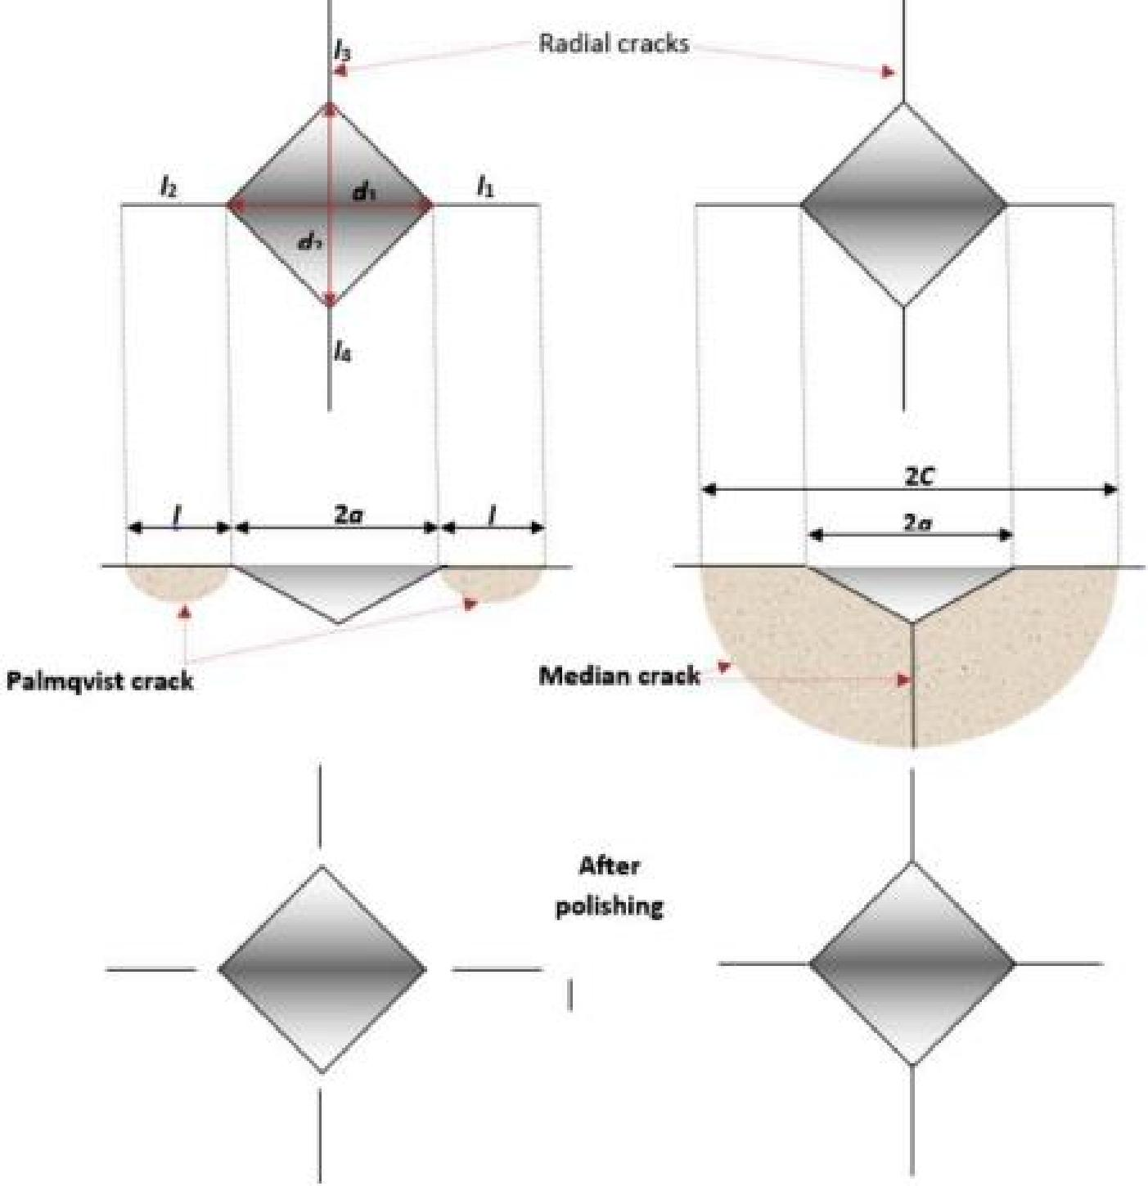

**Figure 1**. Cracks under indentation (a) of median type or half-penny crack (type M) and (b) type

Palmqvist (Type P).

As shown in Figure 2, the size of the central area is related to the size of the impression diagonal. Thus, for low loads, the crack would be Palmqvist (P) type. Whereas, for high loads, the cracks would be of Median type (M), the load being sufficient for the crack to cross the central zone. In both cracking modes (M and P), the experimental results must be aligned on straight lines. The examples treated by

A. PERTUZ et al [30] show that the representation C3/2 = f (P) also makes it possible to characterize the cracking mode and to calculate the toughness from the obtained straight lines. Whatever the method envisaged, it is understood that there can be only one value of toughness KIC for a given material in a given state.

In addition, for the materials studied by A. PERTUZ et al [30], they showed that Palmqvist cracking type is associated with the lowest indentation loads and Median cracking type at the highest loads. They have, however, seen that the calculation of the slope of the representative curves with sufficient precision depends on the number of experimental points.

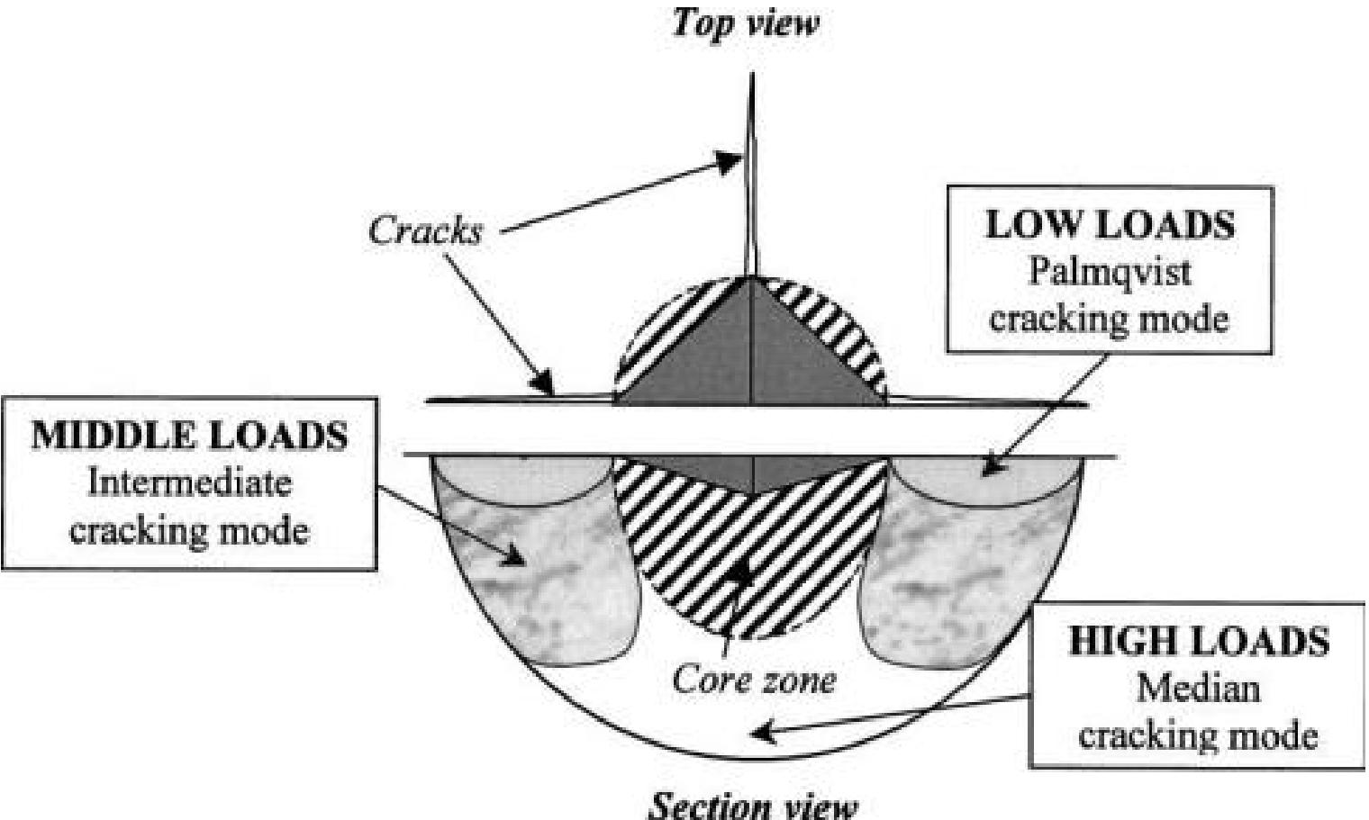

**Figure 2:** Schematic view of the indented surface (top view) and the cross section (section view) of Vickers indentation cracking system.

Moreover, Fisher [31] has shown that a deviation of the linearity in the representation C3/2 = f (P) was due to the presence of residual stresses. A. PERTUZ et al [30] have also shown that it is not necessary to predetermine the shape of cracks to calculate toughness.

The only measure of the lengths of the cracks on the surface of the indented material is sufficient. Indeed, they saw that the calculation of the toughness by supposing a type of crack M or of type P leads to the same value.

**Step 4:** Calculation of mode I fracture toughness KIC:

As mentioned above and considering the importance of the loads used (high loads) in our study, the cracking mode chosen is median (M). Since the graphs of these functions are straight lines, their equations are of the form:

Y = A.X + B

Where:

X represents the load P; Y represents the crack length C3/2, A, always represents the slope of these regression lines and B, the value of C3/2 when the load P = 0 N.

That is to say, we will have, from the two following relations (5) and (6):

C3/2 = A.P +B (experimental relation). (5)

C3/2 = (0.0824 / KIC, M).P (theoretical relation, (6)

deduced from relation (V.2) with:

(0.0824 / KIC,M ) = A = slope, calculated from the graph C3/2 = f (P)

and

C3/2 = B value when P = 0 N (i.e. the value of crack length “C” at the beginning of Loading).

The relation (7) which give us the experimental fracture toughness:

K ICM = (0.0824 / slope A). (7)

**Note:** In order to have the fracture toughness kIC,M in (MPa.m1/2), the slope A must be in

(µ3/2 / N) and the ratio (0.0824 / slope A) must be multiplied by 1000.

**Experimental Program**

**Materials and Mix Proportions**

In this study, in order to evaluate the fracture parameters of concrete at different water to binder ratios, SCC mixes were designed for two different strength levels (mid and high strengths). To achieve this aim, five SCC mixes with w/b ratios of 0.41; 0,39; 0,37; 0,35 and 0,33 and two NVC mixes with w/b ratios of 0.53 and 0.36 were made. In each mix, the cement used is an ordinary Portland cement (CEM I 42.5 N) made by Hjar Essoud-Skikda cement factory (Skikda, Algeria), with a strength category of 42.5 N/mm2 and with sulphate resistance properties and low heat of hydration, according to NF EN 197-1 standard [32]. Its Density is 3.100 t/m3 and Specific surface area-BET is 0,3480 m2/g.

Two Ultra-fine aggregates as mineral admixtures were used: a) Limestone powder (Lp), provided by ENG factory (Ain Touta - Batna, Algeria) having a calcium carbonate (CaCO3) content of 97.6%, with purity and great fineness, are introduced into the mixtures of self-compacting concretes in order to improve the plastic viscosity and achieving the required stability. Its specific gravity is 2.60 t/m3, its specific surface area-BET is 0, 5226 m2/g and its fineness modulus is 0,19. b) Silica fume (Sf) Medaplast HP provided by GRANITEX Company (Oued Smar-Algiers, Algeria) is used to replace 8.0% by mass of cement. Most standards and codes [33-34] recommend the use of this silica fume as an additive for the replacement of about 5-10% by mass of the cement. The incorporated silica fume is a pozzolan in the form of a very active fine powder. Its density is 1.07 t/m3, was used to enhance viscosity and its Specific surface area-BET is 21,7 m2/g.

Three nominal classes of crushed limestone aggregates (Ain Touta, Batna-Algeria) and a local sea sand are used for the production of all SCC and VC mixtures:

a. A natural sea sand 0/3 (ss) with a fineness modulus of 2.35 (preferential sand), a specific gravity of 2.67 t/m3 and absorption percentage of 0.90%,

b. Crushed limestone sand 0/4 (cs) with a fineness modulus of 3, a specific gravity of 2.52 t/m3 and absorption percentage of 0.70 %,

c. A Small gravel 4/8 (g1) with a specific gravity of 2.64 t/m3, absorption percent of 0.28 % and a Medium gravel 8/16 (g2) with a specific gravity of 2.63 t/m3, absorption percent of 0.37 %. All physical properties of aggregates were calculated according to [34] and all appropriate corrections have been adopted in order for the aggregates to reach the surface-dry-saturated state according to EN 1097-6: 2000 [35].

The required fluidity of self-placing concretes is achieved by incorporating suitable doses of Medaflow superplasticizer polycarboxylate (pce) according to EN 934-2: 2009 [36]. Super plasticizers are used to improve the fluidity of the concrete and reduce the amount of water to be added. This same super plasticizer is used for the production of mixtures of vibrated concrete.

In order to achieve better uniformity in all mixes, the concrete was mixed for 6 min. After mixing, workability properties of the SCC were evaluated by measuring the slump flow, L-Box and V-funnel according to EFNARC recommendation [37]. Mix proportions and properties of the fresh concrete for both mix designs are presented in **Table 1.**

**Table 1.** Compositions and fresh properties of the mixtures.

|  |  |  |  |  |  |  |  |  |  |  |  |  |  |
| --- | --- | --- | --- | --- | --- | --- | --- | --- | --- | --- | --- | --- | --- |
| **Concretes**  **Pc** | **S s** | **Cs** | **g1** | **Materials (kg/m3) g2 Lp Sf** | | | **w** | **Sp** | **w/b** | **w/c** | **fresh properties**  **S.flow (mm) L-box V-funnel (s)** | | |
| **SCC1** 368 | 570 | 243 | 328 | 492 | 100 | 32 | 187 | 8 | 0.41 | 0.51 | 730 | 0.90 | 8.0 |
| **SCC2** 368 | 570 | 243 | 328 | 492 | 100 | 32 | 178 | 8 | 0.39 | 0.48 | 720 | 0.87 | 8.4 |
| **SCC3** 368 | 570 | 243 | 328 | 492 | 100 | 32 | 169 | 8 | 0.37 | 0.46 | 705 | 0.86 | 9.2 |
| **SCC4** 368 | 570 | 243 | 328 | 492 | 100 | 32 | 160 | 8 | 0.35 | 0.43 | 695 | 0.84 | 10.4 |
| **SCC5** 368 | 570 | 243 | 328 | 492 | 100 | 32 | 151 | 8 | 0.33 | 0.41 | 675 | 0.81 | 11.7 |
| **NVC1** 400 | 570 | 243 | 379 | 567 | **/** | **/** | 214 | **/** | 0.53 | 0.53 | **/** | **/** | **/** |
| **NVC4** 400 | 570 | 243 | 379 | 567 | **/** | **/** | 144 | 13, | 2 0.36 | 0.36 | **/** | **/** | **/** |
| **EFNARC /** | **/** | **/** | **/** | **/** | **/** |  | **/** | **/** | **/** | **/** | 650–800 | > 0,8 | (8-14) |

Element cast and specimen preparation

An experimental program was conducted to determine the SCC fracture toughness and its correlation with water to binder ratio (w/b) as well as its comparison with that of NVCs with similar compressive strengths. To do this, five self-compacting concretes (SCC) and two normal vibrated concretes (NVC), identical in shapes and sizes, were manufactured at the same time (see Figure.3). For NVC reference mixes, the concrete was poured and compacted using conventional hand-held poker vibrators. In the case of SCC mixtures, SCC was normally poured into the formwork and filled the length of 1200 mm over a (140x140) mm2 section without vibration. The formwork was stripped in one day and the Concrete were put into the water to cure during 28 days under water at (20 ± 2°C and 95 ± 5% RH). The samples for the fracture toughness by indentation test were extracted from the middle section of the concrete element by cutting 140x140 mm cores perpendicular to its length. Small samples of length = 70mm, width = 70mm and thickness = 22mm were then cut from these samples using a diamond saw (Figure 3). This was followed by procedures [38], including resin embedding, precision cutting, grinding, polishing and ultrasonic cleaning to obtain final parallelepiped test specimens (70x70x18) mm3 for the indentation test. Therefore, samples for fracture toughness testing were prepared from the SCC1, SCC2, SCC3, SCC4, SCC5 and NVC1, NVC4 mixtures.

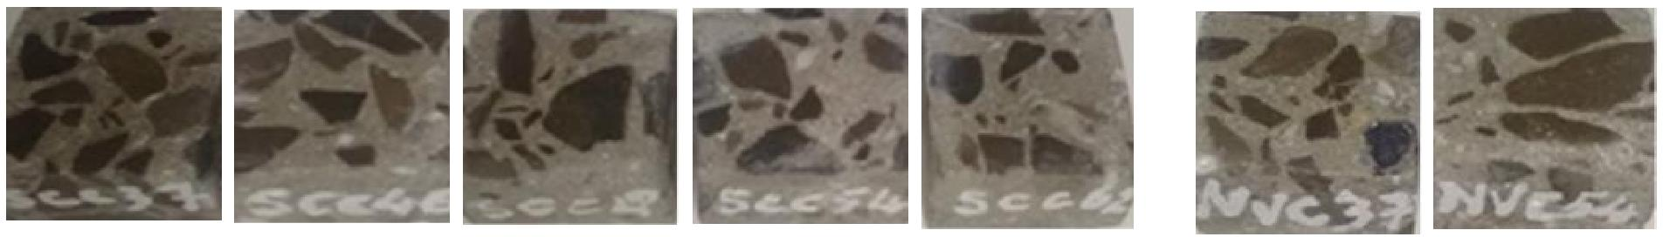

SCC1 SCC2 SCC3 SCC4 SCC5 NVC1 NVC4

**Figure 3:** Samples of SCC and NVC for Instrumented Indentation Tests

**Determination of fracture parameters by Vickers indentation test (VIT).**

In order to determine the fracture toughness by VIT, we have re-designed the peak loads (maximum loads) and intervals of a Vickers 2,50 kN indentation Zwick Rowell test machine. A series of indentation loads ranging from 400 to 1400 N with a fitted interval of 200 N was selected to induce the formation of different radial cracks at room temperature. In each Vickers indentation test, the dwelling time is 20 s and unloading time is 15 s. However, the method requires many indentation tests to determine the value of (KIC). The indentation must be performed from three to six load conditions to obtain the crack curve, and five indentations are needed for each load level to determine a reliable mean crack length.

**a b**

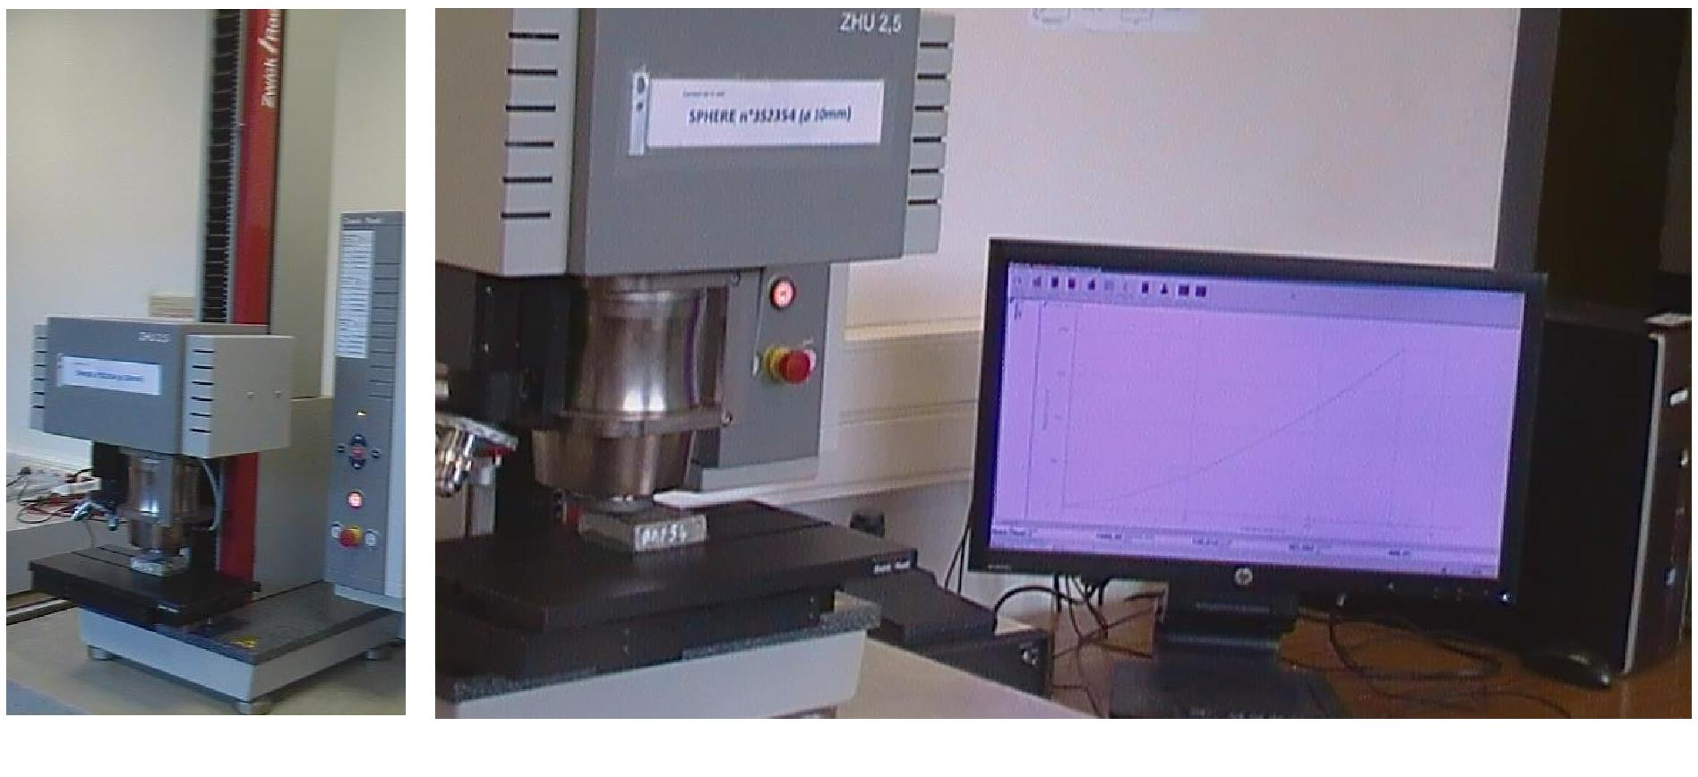

**Figure 4**: instrumented indentation test set-up: (a) General view of the macro indenter Zwick and   
(b).zoom on the two cells of observation and indentation.

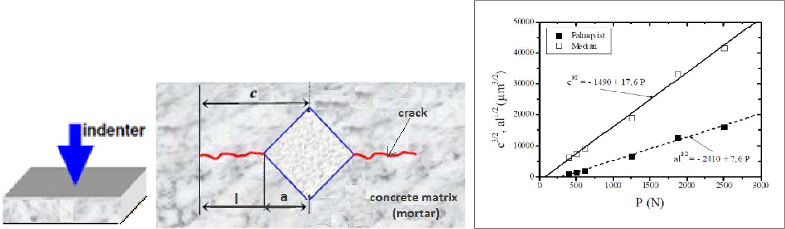

**(a) (b) (c)**

**Figure. 5.** a) Schematic illustration of an instrumented indentation test on of the specimen face), b) The   
dimensions associated to the crack length and diagonal indent measurements and c) The C3/2 = f (P)   
and a.l1/2 = f(P) graphs with their respective slopes, used to calculate the corresponding fracture   
toughness values kIC in both modes (M and P) and this for the material studied by Pertuz et al.[30]:   
Sintered tungsten carbide *WC - WTi.*

The indentation load is applied progressively to its maximum value (peak load) and apparition of a crack on the surface of specimen was measured (Figure 5-b) and (Figure 6-c). The instrumented indentation test was stopped when the maximum load is occurred. All images of residual impressions were observed and the lengths of Vickers indentation cracks were measured by the apparatus with in-situ microscopy and charge coupled device camera. The instrumented indentation test set-up is shown in Fig.4.

**Compressive strength measurement.**

For each concrete mixture, four (04) standard cylinders (160 x 320 mm) were cast using steel molds. In total, 28 standard cylinders were cast for all mixtures, which were cured under laboratory room conditions (at 20 ± 2°C, and 95 ± 5% RH), in order to receive the same treatment as the specimens designated for the compressive strength tests. At the end of the curing period (28 days), all four cylindrical specimens of each mixture were tested on a servo hydraulic compression frame, conforming to EN 12390- 4:2009 [39], to determine the mean compressive strength in agree with the standard EN 12390-3:2009 [40]. The results of the compressive strength are given in Table 2**.**

**Table 2:** Fracture parameters and other mechanical properties.

|  |  |  |  |  |  |  |  |
| --- | --- | --- | --- | --- | --- | --- | --- |
| **concrete Matrix** | **SCC1** | **SCC2** | **SCC3** | **SCC4** | **SCC5** | **NVC1** | **NVC4** |
| **w/b ratio** | 0.41 | 0.39 | 0.37 | 0.35 | 0.33 | 0.53 | 0.36 |
| **w/c ratio** | 0.51 | 0.48 | 0.46 | 0.43 | 0.41 | 0.53 | 0.36 |
| **fc28, cyl. (MPa)** | 36.7 | 41.3 | 46.5 | 54.3 | 61.7 | 36.4 | 53.6 |
| **E(GPa)** | 28.3 | 34.5 | 42.4 | 47.9 | 51.8 | 34.9 | 49.2 |
| **Slope of C3/2 = f (P)** | 36.29 | 34.47 | 32.56 | 30.40 | 28.71 | 34,62 | 29.74 |
| **KICM MPa.m1/2** | 2.27 | 2.39 | 2.53 | 2.71 | 2.87 | 2,38 | 2,77 |

**E (GPa):** Young's modulus determined by Nanoindentation Tests (Grid Indentation Technique)

# Results and Discussions

After demolding the elements, a better surface finishing for the edges and corners of the self- compacting samples were observed compared to most of the NVC specimens. This result confirmed by others authors [41] reveals the excellent filling capacity of SCC even for small elements which require small quantities of concrete.

### **Compressive strength**

As can be seen in Table 2, the compressive strength varies with the water-to-binder ratio and tends to increase as the ratio decreases. It should be noted that the compressive strength is clearly influenced by the water-to-binder ratio to a large extent. The decrease in mechanical properties is probably due to the percentage of porosity of the self-placing matrix, which depends on this water-binder ratio.

### Fracture characteristics based on Vickers indentation test

The experimental configuration is illustrated in Figure 4 and Figure 6. It consists in testing a resistive matrix of concrete of its fracturing. Load, displacement and crack length are recorded during the test. For each applied load (P), the average of crack lengths (c) and half-diagonal (a) (μm) can be calculated, then the fracture parameter, namely fracture toughness (KIC).

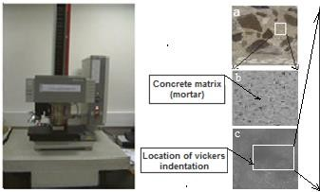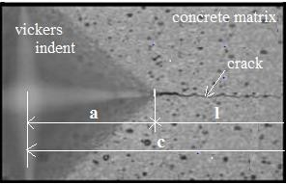

**Figure 6:** Photographs of the SCC4 specimen: a) Indentation test sample, b) Enlarged view of the zone to be indented prior to the test and c) Enlarged view of the area indented after the test: cracking on the surface of the SCC4 matrix after loading at 800N.

**Indentation Load (N)**



9.00E+02

**SCC4 (w/b = 0,35)**

8.00E+02

7.00E+02

6.00E+02

5.00E+02

4.00E+02

3.00E+02

2.00E+02

1.00E+02

0.00E+00

0.00E+00 1.00E+02 2.00E+02 3.00E+02 4.00E+02 5.00E+02 6.00E+02 7.00E+02

**Indentation Depth (µm)**

|  |  |  |  |  |  |  |
| --- | --- | --- | --- | --- | --- | --- |
|  |  |  |  |  |  |  |
|  |  |  |  |  |  |  |
|  |  |  |  |  |  |  |
|  |  |  |  |  |  |  |
|  |  |  |  |  |  |  |
|  |  |  |  |  |  |  |
|  |  |  |  |  |  |  |
|  |  |  |  |  |  |  |
|  |  |  |  |  |  |  |

**Figure 7:** Load–displacement curves obtained for SCC4 mix (w/c = 0.43, w/b = 0.35) under 800 N loading.

As discussed above, KIC at different indented locations; Figure 7 shows an example of Vickers indentation graph P = f(h), (Load (P) versus the displacement or indentation depth (h)); applied in normal rectangular coordinates. Through this graph, other derived graphs C3/2 = f (P) are obtained and discussed (Figure 8).

Therefore, Through the results of the analysis of the graphs given by way of example in Figure 8, Table 2 collects all the slopes of the different regression lines and fracture toughness KIC. For information, w

/ b ratios and w / c ratios are also given in this table for each type of concrete.



**SCC4 (w/b = 0,35)**

**50000**

**45000**

**40000**

**35000**

**30000**

**25000**

**20000**

**15000**

**10000**

**200**

**400**

**600**

**800**

**1000 1200**

**1400**

**1600**

**Indentation Load P(N)**

**Crack Lenrth C3/2 ( µm3/2)**

|  |  |  |  |  |  |  |
| --- | --- | --- | --- | --- | --- | --- |
|  |  |  |  |  |  |  |
|  |  | **C3** | **/2 = 30,405.** | **P - 385,92** |  |  |
|  |  |  | **R² = 0,98** | **57** |  |  |
|  |  |  |  |  |  |  |
|  |  |  |  |  |  |  |
|  |  |  |  |  |  |  |
|  |  |  |  |  |  |  |
|  |  |  |  |  |  |  |

**Figure 8:** Crack length of the indent as a function of the indentation load obtained for SCC4 (w/b = 0.35).

The effects of the design parameters on fracture toughness obtained are presented and discussed in the following three subsections:

### **Influence of the water to binder ratio (w / b)**

It can be seen in Figure 9 that the slope of the regression line depends essentially on the ratio w/b. Reducing the w/b ratio also leads to a decrease in the slope of the different lines drawn for the five indented SCCs, indicating increasingly brittle behavior with increasing fracture toughness across these SCCs. This may be due to the fact that the pre-and post-peak areas in the crack length-load (C3/2 = f (P) curve are mainly due to initiation of micro cracks and their propagation. The same trend has been reported for NVCs. When indented on their surfaces, the SCC matrices have a KIC that gradually increases from the initial value of 2.27 to the final value of 2.87 MPa m1/2 once the ratio (w/b) decreases from 0,41 to 0.33 (w/c ratio from 0.51 to 0.41), (Figure 9, Table 2)**.** These results are fully consistent with the results of Sara Korte et al obtained by three-point bending tests [42].

**KIC ( MPa.m1/2 )**

**KIC ( MPa m1/2 )**



**3**

**2.8**

**2.6**

**2.4**

**2.2**

**2**

**0.31 0.335 0.36 0.385 0.41 0.435**

**water to binder ratio (w/b)**



**3**

**2.8**

**2.6**

**KIC = - 6,04 (w/c) + 5,322 R² = 0,9877**

**2.4**

**2.2**

**2**

**0.39 0.42 0.45 0.48 0.51 0.54**

**Water to cement ratio (w/c)**

|  |  |  |  |  |
| --- | --- | --- | --- | --- |
|  |  |  |  |  |
|  |  | **KIC = -7,**  **R²** | **6 (w/b) +**  **= 0,9945** | **5,366** |
|  |  |  |  |  |
|  |  |  |  |  |
|  |  |  |  |  |

**a b**

**Figure 9:** Variation in fracture toughness KIC versus water-to-binder ratio (w / b).

Based on the results obtained from the present study, a linear relationship between w/b or (w/c) and KIC was obtained as follows:

**KIC =** - 7.6 **(w/b) +** 5.366 **(**R2 = 0.9945) **or KIC = -** 6,04 (**w/c**) + 5,322 **(** R2 = 0,9877)

These relationships can be used to predict the KIC fracture toughness of SCC mixtures with different w/ b (or w/c) ratios. The variations of this SCC failure parameter with different w/b or w/ c ratios have been presented in Figure 9. As it is observed, KIC decreases as the w/b (or w/c) ratio increases. However, the influence of the water-binder ratio (w / b) or water to cement ratio (w/c) on the fracture parameter KIC is evident in Figure 9. Table 2 lists the results of this parameter, calculated by Eqs. (3), (5), (6) and (7) of paragraph 2.1. It is clear that the sample from SCC1, with the highest w / b ratio and therefore the weakest matrix, has the lowest crack resistance because it generates the lowest values for KIC, exp. This means that SCC1 is the most brittle. Same thing for the SCC5, which is the least brittle of the five SCC blends, therefore has the highest resistance to cracking because it generates the strongest values for KIC. In this study, as shown in Table 2, the fracture toughness of SCC is related to w/b (or w/c) ratio and increases by 26.4% when the w/b ratio decreases from 0.41 to 0, 33 (w/c decreases from 0.51 to 0.41) and its highest value occurs for w / b = 0.33 (w/c = 0.41).

Prokopski and Langier [43], Alyamac and Ince [44], John and Shah [45], and Beygi et al. [46],

Ince et al. [47], Mohammad Karamloo et al. [48] were researchers who investigated the influences of water/cement ratio on fracture toughness of NVC and SCC (see Table 3). Although each research program has its own properties, a comparison between the reported results and the data of this study might be helpful. To do so, the test results of this study and those reported for SCC, NC, and gravel concrete by other researchers are depicted in Figure10.

**Table 3:** Proposed empirical relations in the literature for SCC, NVC and other types of concrete

|  |  |  |
| --- | --- | --- |
| **Research program** | **Material** | **Proposed empirical relation** |
| Beygy et al. **[**46**]** | SCC | KIC = -57.57 (w/c) + 67.01 |
| Propcopski and Langier **[**43**]** | Gravel concrete without silica fume | KIC = -157.95 (w/c) + 162.66 |
| Ince et al. **[**47**]** | NVC | KIC = 142 **/** (9.6)1.5x w/c |
| Karamloo M. et al. **[**48**]** | SCCL | KIC = - 99.197 (w/c) + 63.827 R2 = 0.981 |
| Test results (of current study) | SCC | KIC = - 7.6 (w/b) + 5.366 R2 = 0,9945 |
| Test results (of current study) | SCC | KIC = - 6,046 (w/c) + 5,322 R2 = 0,9877 |

(SCLC): Self-Compacting Lightweight Concrete

In the mentioned studies in Table 3, it was observed that as the water/cement ratio increased, the fracture toughness decreased. It is clear in Table 2 and Fig. (9-b) that same trend was observed in this study. In addition, reviewing the mentioned researches showed that there is a robust relation between the fracture toughness and w/c (or w/b) ratio.

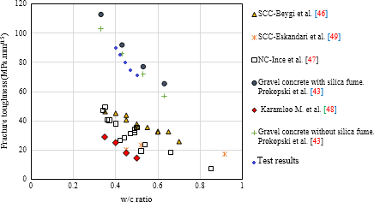

**Figure 10.** Fracture toughness versus w/c ratio for different types of concrete.

### **Influence of compressive strength**

The compressive strength, which many mechanical properties of concrete depend on, is commonly measured in experiments. Therefore, the fracture toughness can be determined as a function of the compressive strength. Fig.11 shows the variation of fracture toughness KIC as a function of compressive strength. It is evident that the KIC has increased as the compressive strength increases. As can be seen in Fig.11, an obvious tendency has been observed between compressive strength and fracture toughness. Since there is a correlation between the water / cement ratio and KIC, a robust relationship is expected between the compressive strength and this fracture parameter. With regard to SCC blends, with a compressive strength ranging from 51.3MPa (cyl) to 60.0 MPa (cyl), Korte et al. [50] concluded that KIC ranged from 2.61 to 2.90 MPam1/2 (11.11% increase), which is similar to our results: from 46.5 MPa to 61.7 MPa (cyl), KIC varies from 2.53 to 2.87 MPa.m1 2 (13.4% increase). Our results are therefore in agreement with those of the literature.

However, for compressive strengths, similar to those of our study, namely: 53.9 ± 7.9 MPa (SCC4),

65.0 ± 8.3 MPa (SCC5) and 53.4 ± 2.3 MPa (NVC4), and on the basis of the Hillerborg [51] and Anderson [52] approaches, Korté [42] determined fracture toughness values by 3PBTest on SCCs and NVCs that are very close to ours. For more precision, our values are exactly between the values determined by those of the Hillerborg approach and those of the Anderson approach (Table 4).

The results from [42] for SCC and NVC with compressive strength’s (identical to SCC4, SCC5 and NVC4), agree quite well with those for SCC, obtained in this study.

**Table 4:** Comparison of the results of toughness (KIC) with the literature.

|  |  |  |  |  |
| --- | --- | --- | --- | --- |
| **KIC fracture toughness calculations based on:** | **Concrete** | **SCC4** | **SCC5** | **NVC4** |
| 1- Literature results | fc28,cyl (MPa) | 53,9 ± 7,9 | 65,0 ± 8,3 | 53,4 ± 2,3 |
| \**Hillerborg Approach* (3PBTests) [51]. | KIC (MPa.m1/2) | 3,85 | 4,21 | 4,54 |
| * *Anderson Approach* (3PBTests) [52]. | KIC (Mpa.m1/2) | 1,23 | 1,43 | 1,78 |
| 2- Results of the current study | fc28,cyl (MPa) | 54,3 ± 2,2 | 61,7 ± 3,0 | 53,6 ± 1,6 |
| * *Grairia Approach* (IITests)**.** | KIC (MPam1/2) | 2,71 | 2,87 | 2,77 |

**\* 3PBTests**: Three Points Bending Tests. **\* IITests**: Instrumented Indentation Tests

In this study, the relationship between KIC and compressive strength, as shown in Figure.11**,** is presented using regression analysis with a correlation coefficient of 0.998 as:

KIC = 0.024 fc + 1.399 (8)

Where: KIC is the fracture toughness and fc28 is the 28 day average cylinder strength (MPa).

**3.5**

**3.25**

**3**

**2.75**

**2.5**

**2.25**

**2**

**1.75**

**30**

**35**

**40**

**45**

**fc28,cyl. (Mpa)**

**50**

**55**

**60**

**65**

**k IC (MPa.m1/2 )**

|  |  |  |  |  |  |  |
| --- | --- | --- | --- | --- | --- | --- |
|  |  |  |  |  |  |  |
|  |  | **K** | **IC = 0,02** | **4 (fc28)** | **+ 1,3991** |  |
|  |  |  | **R** | **² = 0,998** |  |  |
|  |  |  |  |  |  |  |
|  |  |  |  |  |  |  |
|  |  |  |  |  |  |  |
|  |  |  |  |  |  |  |

**Figure 11** : Variation in fracture toughness KIC versus compressive strength (fc28).

According to Figure.11**,** the test results obtained in this study are consistent with those reported by Korte et al. [50] and follow the same trend observed for SCC, where KIC increases as the compressive strength increases.

### **Influence of concrete type on fracture toughness**

We note that a distinct difference in fracture toughness appears between the two types of concrete, even if they have similar compressive strengths. For this, we see it well pronounce for low to medium strength concrete (4.85%) as for high strength concrete (2.21%) (Table 5). From Fig.12, the SCC fracture toughness is clearly lower than that of the reference NVCs. For the same compressive strength, the average increase in fracture toughness of NVCs compared to standard SCCs is 4.85% for a cylinder of 37MPa (class 41MPa, cub) and 2.21%, for a class 54MPa cylinder (class 60MPa, cub) respectively. In order to evaluate the experimental fracture toughness KIC exp, the Vickers indentation results of (SCC1, NVC1) and (SCC4, NVC4) mixtures couples are shown in Fig.12 and Table 5 for the same compressive strengths.

**Table 5:** Comparison of the performance of NVC fracture parameters compared to those of SCC with the same compressive strength:

|  |  |  |  |  |
| --- | --- | --- | --- | --- |
| **Concrete type** | **SCC1** | **NVC1** | **SCC4** | **NVC4** |
| fc 28, cyl (MPa) | 36.7 | 36.4 | 54.3 | 53.6 |
| KIC (MPa.m1/2) | 2.27 | 2.38 | 2.71 | 2.77 |
| E (GPa) | 28.3 | 34.9 | 47.9 | 49.2 |
| Resistance class fc28, cyl (MPa) | 37 | | 54 | |
| Resistance class fc28, cub (MPa) | 40 | | 60 | |
| Performance of KIC (NVC) **/** KIC (SCC) (%) | 4.85 | | 2.21 | |

The Instrumented Indentation Tests (IIT) results reveal a mutual relationship between the two types of concretes (NVC and SCC) is very clear: NVC1 and NVC4 shows the largest KIC values compared to that of SCC1 and SCC4 counterparts respectively with similar compressive strength (Table 2 and Table 5). Again, the presence of abundant amount of large particles in NVCs plays the most important role due to aggregate interlock to resist fracture increases. Here, as they are the most tougher, the NVC1 and NVC4 samples need a great deal of energy to be fractured compared to SCC1 and SCC4 samples with have the same compressive strengths.



**Fracture Toughness KIC of SCCi and NVCi with**

**similar strength.**

**3**

**2.5**

**2**

**1.5**

**1**

**0.5**

**KIC (MPa m1/2)**

|  |  |  |  |  |
| --- | --- | --- | --- | --- |
| **0** | **SCC1** | **NVC1** | **SCC4** | **NVC4** |
| **Series1** | **2.27** | **2.38** | **2.71** | **2.77** |

**Fig. 12:** Fracture parameter (KIC) comparison between SCC and NVC with similar

compressive strength.

The reason for this is that NVC1 and NVC4 contain coarser aggregates, whereas their counterparts SCC1 and SCC4 do not have this large amount of bridging and toughening elements. it appears that the aggregate interlock plays the most important role in the cracking process, producing larger fracture resistance parameter values for VC compared to those of SCC specimen. In any case, a distinct fracture behaviour is noticed, when comparing NVC to SCC. Moreover, Ambriose and Pera [53] and Bonen and Shah [54] reported that, due to lower content of aggregate in SCC, the modulus of elasticity of SCC is lower than that of NVC in the same strength, which is conform to our results (Table 2 and Table 5).

# Conclusion

The fracture behavior, based on the Evan, Chetty and Millekhine approach, of seven samples including five SCCs and two NVCs, under Vickers Indentation Test (VIT) was studied.

From the obtained results of this investigation, the following conclusions could be drawn:

1. Fracture toughness is highly affected by water to binder (water/cement) ratio. It was found that the largest values of the stress intensity factor, KIC, were shown by SCC with the lowest water / cement ratio, w/c = 0.33. This is explained by the reduction of the amount of water with presence of super plasticizer and large amounts of fines (silica fume, limestone powder,), which makes the matrix

of these SCCs less porous, uniform and dense, hence stronger thus improving its resistance to crack initiation and propagation (KIC) and also its compressive strength (fc28). In other words, fracture toughness increased by 26, 43 %, as the water/binder ratio decreased from 0.41 to 0.33.

1. When w/b ratio increases from 0.33 to 0.41, as a measure of fracture toughness in IIM decreases from 2, 87 to 2, 27, implying that concrete ductility increases with increase of w/c ratio.
2. As w/c decreases, the slope of the declining part of the crack length-load curve decreases and fracture toughness increases indicating brittle behavior.
3. However, for both types of concretes (SCC and NVC) with similar compressive strength values, ordinary vibrated concrete (NVC) was found to have good fracture toughness compared to self- consolidating concrete (SCC).
4. As the water/binder ratio decreased from 0.41 to 0.33, the modulus of elasticity, compressive strength of self-compacting concrete increased by 68.12%, and 83.03% respectively.
5. With regard to the test method and device used in this study, an effect of feasibility, simplicity and high precision is present, taking into account the performances of this method and this type of machine during instrumented indentation.

# Acknowledgements

The authors warmly thank the faculty of earth sciences at Badji Mokhtar Annaba University (Algeria) and its head, the Professor Nacer KHERICI for providing the necessary financial support for this research.

**Conflicts of Interest**

The authors declare no conflict of interest.

**References**

1. Sideris KK, Manita P (2013) Residual mechanical characteristics and spalling resistance of fiber reinforced self-compacting concretes exposed to elevated temperatures. Constr Build Mater 41: 296-302.

2. Sua-iam G, Makul N (2013) Utilization of limestone powder to improve the properties of self-compacting concrete incorporating high volumes of untreated rice husk ash as fine aggregate. Constr Build Mater 38:455–64

3. Jalal M, Mansouri E, Sharifipour M, Pouladkhan A (2012) Mechanical, rheological, durability and microstructural properties of high performance self-compacting concrete containing SiO2 micro and nanoparticles. Mater Des 34: 389-400.

4. Zhao H, Sun W, Xiaoming W, Gao B (2012) The effect of coarse aggregate gradation on the properties of self-compacting concrete. Mater Des 40: 109-116.

5. Jawahar JG, Sashidhar C, Reddy R, Peter JA (2013) Micro and macro level properties of fly ash blended self-compacting concrete. Mater Des 46: 696-705.

6. Rambo DAS, Silva FDA, Filho RDT (2014) Mechanical behavior of hybrid steel-fiber self-consolidating concrete: materials and structural aspects. Mater Des 54: 32-42.

7. Bazant ZP, Planas J (1998) Fracture and size effect in concrete and other quasi-brittle materials. CRC Press.

8. Bony JC, Claude G, Sorentz S (1973) Comparaison des essais d’adhérence par flexion (beam test) et par traction (pull-out test), Matériaux et Constructions 6: 395-401.

9. Weisbrod G and Rittel DA (2000) Method for Dynamic Fracture Toughness Determination Using Short Beams, International Journal of Fracture 104: 1-5.

10. Plaza LM (2003) Determination of Uncertaines in Plane Tougness (KIC) Testing, Seminario Sobre la Evaluación de la Incertidumbre en Ensayos Mecánicos, Universidad de la Rioja, España.

11. Evans AG and Charles EA (1976) Fracture Toughness Determination by Indentation, J. Am. Ceram. Soc 59: 371-372.

12. Niihara K, Morena R and Hasselman DPH (1982) Evaluation of KIC of Brittle Solids by The Indentation Method with Low Crack-To-Indentation Ratios. J Mater Sci Lett 1: 13-16.

13. Sim J-I, Yang K-H, Lee E-T, Yi S-T (2014) Effects of aggregate and specimen sizes on lightweight concrete fracture energy. J Mater Civ Eng 26: 845-854.

14. Gettu R, Bazant ZP, Karr ME (1990) Fracture properties and brittleness of high-strength concrete. ACI Mater J 87: 608-618.

15. Comitee Euro-International du Beton (CEB-FIP) (1999) Structural concrete: textbook on behavior, design and performance. Lausanne, Switzerland: International Federation for Structural Concrete (FIB).

16. Prokopski G, Langier B (2000) Effect of water/cement ratio and silica fume addition on the fracture toughness and morphology of fractured surfaces of gravel concretes. Cem Concr Res 3000: 1427-1433.

17. Ince R, Alyamac KE (2008) Determination of fracture parameters of concrete based on water–cement ratio. Indian J Eng Mater Sci 15: 14-22.

18. Prokopski G, Langier B (2000) Effect of water/cement ratio and silica fume addition on the fracture toughness and morphology of fractured surfaces of gravel concretes. Cem Concr Res 30: 1427-1433.

19. Prokopski G, Langier B (2000) Effect of water/cement ratio and silica fume addition on the fracture toughness and morphology of fractured surfaces of gravel concretes. Cem Concr Res 3000:1427-1433.

20. Bazant ZP, Planas J (1998) Fracture and size effect in concrete and other quasi-brittle materials. CRC Press.

21. Lawn BR, Swain MV (1975) Micro-fracture beneath point indentations in brittle solids. Journal of Material Science 10: 113.

22. Laugier MT (1987) New formula for indentation in ceramic. Journal of Materials Science Letters, 6: 355.

23. Evans AG, Charles EA (1976) Fracture toughness determination by indentations. Journal of American Ceramic Society 59: 371.

24. Shetty DK, Wright LG, Mincer PN, Clauer AH (1985) Indentation fracture of WC-Co cermets”. Journal of Materials Science 20: 1873.

25. Milkhine V, Onsoien MI, Solberg JK, Skaland T (2002) Mechanical properties of FeSi (E), FeSi2 and Mg2Si. Intermetallics10: 743.

26. Matsumoto RLK (1987) Journal of American Ceramic Society 70: 366.

27. Cook RF, Braun LM, Cannon WR (1994) Trapped Cracks at Indentations: I, Experiments on Yttria- Tetragonal Zirconia Polycrystals. Journal of Material Science 29: 2133.

28. Kaliszewski MS, Behrens G, Heuer AH (1994) Indentation Studies on Y2O3-Stabilized ZrO2: I. Development of Indentation-Induced Cracks. Journal of American Ceramic Society 77: 1185.

29. Evans AG, Wilshaw TR (1976) Quasi-static solid particle damage in brittle solids. Acta Metallurgical 24: 939.

30. Pertuz A (2003) L’indentation Vickers et Knoop des matériaux massifs ou revêtus: Dureté, tenacité et adhérence. Thèse de Doctorat, Lille1.

31. Fischer H, Marx R (2002) Fracture toughness of dental ceramics: comparison of bending and indentation method. Dental Materials 18: 12.

32. NF EN 197-1 (2012) Cement - Part 1: composition, specifications and conformity criteria for common cements.

33. ACI 234 (2006) Guide for the use of silica fume in concrete. American Concrete Institute.

34. Federal highway administration Silica fume. US department of transportation.

35. EN 1097 (2013) Tests for mechanical and physical properties of aggregates – Part 6: Determination of particle density and water absorption.

36. EN 934 (2009) Admixtures for concrete, mortar and grout – Part 2: Concrete admixtures. Definitions requirements, conformity, marking and labeling.

37. CEN. NBNEN 12350 testing fresh concrete (parts 2, 5, 8, 9 and 10). (2009/2010)

38. Zhu W, Sonebi M and Bartos PJM (2004) Bond and interfacial properties of reinforcement in self- compacting concrete. Advanced Concrete and Masonry Centre, University of Paisley, PAl 2BE, Scotland Materials and Structures / Matériaux et Constructions 37: 442-448.

39. EN 12390- 4, testing hardened concrete – Part 4: compressive strength (2009) Specification for testing machines.

40. EN 12390-3, Testing hardened concrete – Part 3: compressive strength of test specimens (2009).

41. Pop I, De Schutter G, Desnerck P, Onet T (2013) Bond between powder type self-compacting and steel reinforcement. Construction and Building Materials 41: 824-833.

42. Korte S, Boel V, De Corte W, De Schutter G (2014) Fracture toughness and cracking behaviour of SCC compared to VC. Key Engineering Materials 577-578: 205-208.

43. Prokopski G, Langier B (2000) Effect of water/cement ratio and silica fume addition on the fracture toughness and morphology of fractured surfaces of gravel concretes. Cem Concr Res 3000: 1427-1433.

44. Alyamaç KE, Ince R (2011) Investigation of self-compacting concrete by using fracture mechanics methods. International Balkans conference on challenges of civil engineering, BCCCE, EPOKA University, Tirana, ALBANIA.

45. John R, Shah SP (1989) Fracture mechanics analysis of high-strength concrete. J Mater Civ Eng 1: 185-198.

46. Beygi MHA, Kazemi MT, Nikbin IM, Amiri JV (2013) The effect of water to cement ratio on fracture parameters and brittleness of self-compacting concrete. Mater Des 50: 267-76.

47. Ince R, Kürsat EA (2008) Determination of fracture parameters of concrete based on water-cement ratio.

Indian J Eng Mater Sci 15: 14-22.

48. Karamloo M, Mazloom M, Payganeh G (2016) Influences of water to cement ratio on brittleness and fracture parameters of self-compacting lightweight concrete. Article in Press, Engineering Fracture Mechanics 168 227-241.

49. Eskandari H, Muralidhara S, Prasad B, Reddy BVV (2010) Size effect in self-consolidating concrete beams with and without notches. Sadhana 35: 303-317.

50. Korte S, Boel V, De Corte W and De Schutter G (2014) Static and fatigue fracture mechanics properties of self-compacting concrete using three-point bending tests and wedge-splitting tests. Construction and Building Materials 57: 1-8

51. Hillerborg A, Modeer M and Petersson PE (1976) Analysis of Crack Formation and Crack Growth in Concrete by Means of Fracture Mechanics and Finite Elements. Cement and Concrete Research 6: 773-782.

52. Anderson TL: Fracture Mechanics: Fundamentals and Applications (CRC Press, Taylor and Francis Group, Florida 2005).

53. Ambriose J, Pera J (2002) Design of self-leveling concrete. In: Shah SP, Daczko JA, Lingscheit JN, editors. First North American conference on the design and use of self-consolidating concrete.

54. Bonen D, Shah SP (2004) The effects of formulation on the properties of self-consolidating concrete. In: Kovler K, Marchand J, Mindess S, Weiss J, editors. Concrete science and engineering a tribute to Arnon Bentur, international RILEM symposium. Evanston, USA: RILEM Publications SARL 43-45.