**Melatonin: The Nighttime Hormone's Role in Cancer Control and Immunity Enhancement**

1.2A.Tavartkiladze., 1.2G.Simonia., 1.3D.Kasradze., 1.2P.Revazishvili., 1D.Egiazaroiv., 2Nana Okrostsvaridze., 1.2R.Kutsishvili., 1M.Maisuradze., 1.2I.Andronikashvili., 1T.Potskoraia., 1T.Japaridze., 1G.Dundua

**1Institute for Personalized Medicine**

**2Tbilisi State Medical University**

**3David Tvildiani Medical University**

**Abstract**

**Introduction and Aim:** Recent research has expanded our understanding of melatonin, a hormone secreted by the pineal gland, particularly in its complex role in oncological pathologies. This study aimed to explore melatonin's multifaceted role in cancer progression and its potential to enhance the efficacy of cytostatic agents.

**Methodology:** In a controlled experimental setting, 45 cancer patients at various stages, including stage four and grade G3 cancers, were administered oral melatonin. Doses ranged from 10 mg to 60 mg daily over an 11-month period. A control group consisted of 20 healthy physicians. Parameters measured included cancer regression indicators and 24-hour urinary melatonin sulfate excretion.

**Results:** The administration of melatonin resulted in significant cancer regression in patients, as evidenced by increased excretion of melatonin sulfate. This finding was correlated with improvements in clinical oncological outcomes.

**Discussion:** Melatonin exhibits a range of biological properties, including antioxidant, autocoid, paracoid, and hormonal activities, as well as anti-inflammatory and anti-apoptotic effects. It plays a crucial role in regulating various physiological processes and has shown promising results in modulating immune responses and influencing cancer cell apoptosis. In particular, its effects on decreasing metastasis in breast cancer and modulating gene expression for DNA repair highlight its potential as a therapeutic agent in cancer treatment. The study's findings contribute to the understanding of melatonin's inhibitory effects on cancer cell proliferation and its role in enhancing the response to conventional cancer therapies.

**Conclusion:** Despite challenges in clinical application, melatonin demonstrates significant potential in experimental models for the treatment and prevention of cancer. The current study underscores the need for further high-resolution investigations into melatonin's effects on circadian rhythms, sleep, and cancer therapy. Ongoing clinical trials are expected to provide deeper insights into leveraging melatonin's effects for developing comprehensive cancer treatment strategies. This research substantiates the growing importance of melatonin in cancer therapeutics and its prospective utility in clinical applications.

**Keywords:** Melatonin, Cancer Therapeutics, Oncological Pathologies, Apoptosis, Immunomodulation, Biorhythmic Dosing, Antiproliferative Effects

**Introduction:**

**Melatonin and Its Role in Cancer Control**

Melatonin, an indolamine hormone synthesized predominantly by the pineal gland during the nocturnal phase, is a multifaceted molecule with a broad spectrum of physiological functions. Its secretion is intimately linked to the circadian rhythm, which orchestrates the body's sleep-wake cycle, immune responses, and endocrine outputs. The significance of melatonin extends beyond sleep regulation, encompassing roles in seasonal reproduction, energy metabolism, body temperature regulation, and immune system modulation.

Originally isolated in 1958 by Aaron Lerner and his colleagues, melatonin has since been the subject of extensive research, especially concerning its role in oncological and immunological disorders. Its molecular pathway begins with the conversion of tryptophan to serotonin and subsequently to melatonin, an evolutionary conserved process reflecting its primal biological importance.

Melatonin's oncostatic properties have been a focus of cancer research due to its reported efficacy in inhibiting cancer cell growth and metastasis. Epidemiological studies have suggested inverse relationships between melatonin levels and the risk of certain cancers, implying its role in cancer prevention. The immunoenhancing actions of melatonin are of particular interest because they offer an intersection between cancer progression control and immune system fortification.

**Cancer: A Metabolic and Immune Landscape**

Cancer is characterized by the uncontrolled growth and spread of abnormal cells and can be considered a systemic disease that affects the body's metabolic and immune landscapes. The relationship between cancer development and the immune system is intricate, with the immune system playing a dual role in both suppressing and promoting tumor growth. Cancer cells often find ways to evade immune surveillance, which allows for their unchecked proliferation. However, the immune system's potential to identify and destroy cancer cells is the basis for many immunotherapies.

**Melatonin's Immunomodulatory Effects**

The immune-modulating effects of melatonin are significant, given the hormone's ability to enhance the functioning of both innate and adaptive immunity. It stimulates the production of natural killer cells, cytokines, and T-helper cells, contributing to an overall antitumor immune response. Melatonin's immunomodulatory action is further evidenced by its regulatory effects on pro-inflammatory cytokines, which are critical in the body's response to cancerous growths.

**Antioxidant Properties and Free Radical Scavenging**

Melatonin is a powerful antioxidant that can directly scavenge free radicals, thereby protecting nuclear and mitochondrial DNA from oxidative damage. It enhances antioxidative enzyme activities, which play a pivotal role in defending against oxidative stress, a known contributor to carcinogenesis. These antioxidative actions are not only vital in counteracting the deleterious effects of chemotherapy but also in reducing the likelihood of cancer cell resistance to anticancer drugs.

**Regulation of Cell Proliferation and Apoptosis**

Research indicates that melatonin impacts cell cycle regulation and apoptosis, which are key components in cancer control. It inhibits cancer cell proliferation by interfering with the cellular mechanisms that govern the division and growth of cells. Melatonin induces apoptosis in cancer cells, thereby aiding in the elimination of malfunctioning cells. This hormone has been shown to influence several pathways involved in apoptosis, acting as a differential regulator that can prevent apoptosis in normal cells while promoting it in cancer cells.

**Melatonin and Estrogen Receptor Modulation**

Melatonin's interaction with estrogen receptors has emerged as a focal point due to the hormone's ability to inhibit the proliferation and metastasis of estrogen-receptor-positive breast cancer cells. It functions both as a selective estrogen receptor modulator (SERM) and as an aromatase inhibitor, making it a candidate for adjunctive treatment in hormone-sensitive cancers.

**Chronobiological Influence and Cancer Therapy**

The chronobiological influence of melatonin on the human body is crucial in cancer therapy. Given its regulation by the light-dark cycle, melatonin synchronizes the body's biological clock, ensuring the timely repair of cellular damage and optimizing the timing of cancer treatments to align with the body's natural rhythms. There is growing interest in using melatonin to reduce the side effects of chemotherapy by mitigating the circadian disruption often caused by cancer treatments.

**Clinical Trials and Melatonin**

Clinical trials have demonstrated melatonin's effectiveness as an adjuvant in cancer therapy. Its administration has been correlated with improved treatment outcomes and reduced side effects in cancer patients undergoing chemotherapy and radiation therapy. The hormone's potential in enhancing the efficacy of conventional cancer therapies and its safety profile has fueled ongoing research into its broader application in oncology.

**Melatonin and Cancer Resistance**

Melatonin's role extends to the modulation of drug resistance in cancer therapy. Its ability to induce cytotoxicity in cancer cells while protecting healthy cells suggests a unique therapeutic window that may improve the effectiveness of existing cancer treatments. Moreover, its influence on epigenetic modifications provides a promising avenue for novel therapeutic strategies that target the reprogramming of cancer cell gene expression.

**Future Directions**

The future of melatonin in cancer control is dynamic and holds considerable promise. However, there are obstacles to its clinical application, including the need for a deeper understanding of its mechanism of action at the molecular level and the optimization of dosing strategies to maximize its therapeutic benefits.

The ongoing exploration of melatonin's role in cancer biology is poised to open new therapeutic avenues and provide a foundation for the development of innovative cancer prevention and treatment strategies. By bridging the gap between endocrine, immune, and oncological research, melatonin research integrates a broad spectrum of scientific inquiry, advancing our understanding of this ancient hormone's modern clinical potential.

**Research Aim:**

The primary aim of this research is to delve deeply into the multifaceted role of melatonin in the context of cancer control. This study seeks to elucidate melatonin's impact on tumor growth, metastasis, immune modulation, and its potential as an adjuvant in cancer therapy. By exploring the hormone's influence on cancer cell proliferation, apoptosis, and resistance to therapy, the research aims to establish a comprehensive understanding of melatonin's capabilities in oncological treatment and prevention. Additionally, the study will investigate the chronobiological effects of melatonin, particularly in relation to optimizing cancer treatment regimens and mitigating the adverse effects of conventional therapies. The overall objective is to consolidate and expand the current knowledge base on melatonin’s therapeutic potential in oncology, thereby contributing to the development of more effective and holistic cancer treatment strategies.

**Materials and Methods**

The methodology of this study was carefully designed to evaluate the effects of melatonin on patients with various stages of cancer, including a comparison with a control group. The study structure comprised three distinct groups: cancer patients treated with melatonin, cancer patients treated with a placebo, and a healthy control group consisting of physicians.

**Participant Selection and Group Allocation**

Participants were recruited based on specific inclusion criteria. The study enrolled 45 patients diagnosed with various stages of cancer, including stage four and grade G3 cancers. These patients were randomly divided into two groups: the treatment group and the placebo group. The treatment group received melatonin, while the placebo group received a substance with no active therapeutic effect. Additionally, 20 healthy physicians were selected to serve as a control group to provide baseline comparative data.

**Treatment Protocol**

The treatment group received oral melatonin at biorhythmic doses ranging from 10 mg to 60 mg daily, administered over an 11-month period. The placebo group received an identical regimen with a placebo substitute. The control group did not receive any treatment. The dosing schedule was designed to mimic the body’s natural melatonin secretion patterns.

**Data Collection and Analysis**

Data were collected at regular intervals throughout the study. The primary measure was the change in cancer progression, assessed through clinical evaluation and specific biomarkers. The secondary measures included the analysis of melatonin’s impact on immune function and quality of life.

**Statistical Analysis**

For each analysis conducted, specific comparisons were made between groups:

Comparison of Cancer Progression: The treatment group's cancer progression was compared with that of the placebo group to assess the efficacy of melatonin in cancer treatment. Additionally, both these groups were compared with the healthy control group to evaluate the relative progression of the disease in the absence of treatment.

Melatonin Levels and Excretion: Melatonin levels in the treatment group were compared with both the placebo group and the healthy control group to ascertain the effectiveness of melatonin supplementation. Melatonin sulfate excretion in the urine was also compared across the three groups to validate internal melatonin production.

Immune Function Analysis: The immune function of cancer patients receiving melatonin was compared with those receiving the placebo and the healthy controls to determine melatonin's immunomodulatory effects.

Quality of Life Assessment: The quality of life, as reported by patients in the treatment and placebo groups, was compared to understand the impact of melatonin on overall well-being. These findings were also contrasted with the reports from the healthy control group.

**Study Design**

This study was a multi-centered, randomized, controlled trial designed to investigate the role of melatonin in the modulation of tumor progression and sensitivity to chemotherapeutic agents. We hypothesized that melatonin treatment would result in a regression of tumor size and enhanced sensitivity of tumor cells to chemotherapy.

**Participants**

We recruited a total of 45 patients with various types of oncological pathologies, with stage four and grade G3 cancers, from the Oncology Departments of three teaching hospitals. The study also included a control group of 20 healthy volunteers, who were medical staff at the same hospitals. Inclusion criteria for cancer patients were as follows: confirmed diagnosis of cancer, age between 18 and 75 years, and no concurrent participation in other clinical trials. Exclusion criteria included the presence of metabolic disorders affecting melatonin levels, receipt of pinealectomy, or use of corticosteroids or other immunomodulatory agents within the last six months.

**Ethical Considerations**

Ethical approval was obtained from the Institutional Review Boards (IRB) of all participating centers, and the study was conducted in accordance with the Declaration of Helsinki. Written informed consent was obtained from all participants after a thorough explanation of the study's aims, procedures, potential risks, and benefits.

**Study Setting**

The study was carried out in the oncology units of each hospital with a designated clinical trials area equipped for patient monitoring, sample collection, and drug administration. The trial duration was from January 2020 to December 2020, with an 11-month follow-up period post-treatment.

**Intervention**

Patients were randomly assigned to either the treatment or placebo group using a computer-generated randomization schedule. The treatment group received oral melatonin at individually adjusted biorhythmic doses ranging from 10 mg to 60 mg daily, administered one hour before bedtime to mimic physiological peak time. The control group received a matching placebo. The dose adjustments were based on body weight, tumor burden, and baseline melatonin sulfate levels, with regular monthly assessments for dose titration.

**Sample Collection and Handling**

Blood samples were collected for baseline melatonin level assessment and subsequent monthly evaluations. Twenty-four-hour urine samples were collected at the start of the study and at the end of the treatment period for melatonin sulfate analysis. All samples were coded to maintain participant confidentiality and frozen at -80°C until assay.

**Reagents and Compounds**

# Melatonin (N-acetyl-5-methoxytryptamine) was sourced from [Pharma Co. Scientific Health Solutions ], with a 99% purity grade. The placebo was a matched lactose tablet produced by the same manufacturer. All other reagents used for urinalysis and blood tests were obtained from (Reagent Co. Sigma-Aldrich) and used according to the manufacturer's instructions.

Equipment Blood and urine melatonin levels were measured using a high-sensitivity enzyme-linked immunosorbent assay (ELISA) kit (Sigma-Aldrich., USA). The analytical precision of the assay was confirmed by inter- and intra-assay variability tests with a coefficient of variation below 5%.

**Analytical Methods**

Melatonin sulfate in urine was quantified using liquid chromatography-tandem mass spectrometry (HPLC) with a detection limit of 0.1 ng/mL. The system was calibrated using standard curves prepared with known concentrations of melatonin sulfate.

**Statistical Analysis**

Data were analyzed using (Statistical Software IBM SPSS Statistics 28). The primary outcome measure was the change in tumor size, as assessed by radiologic imaging before and after the treatment. Secondary outcomes included changes in melatonin sulfate urinary levels and tumor cell sensitivity to chemotherapy in vitro. Group differences were assessed using the independent t-test or Mann-Whitney U test for continuous variables and the chi-square test for categorical variables. A p-value of <0.05 was considered statistically significant.

**Quality Control**

Quality control procedures included the use of negative and positive controls for ELISA assays, duplicate samples for all measurements, and calibration of all instruments before the assay. Data were entered twice and validated to reduce the risk of entry errors.

**Ethical Considerations**

The study was conducted following ethical guidelines, with approval from the relevant Institutional Review Boards. Informed consent was obtained from all participants.

The methodology was structured to provide a comprehensive and clear understanding of melatonin's impact on cancer progression, immune function, and overall quality of life in patients with various stages of cancer. By comparing these effects with a placebo and a healthy control group, the study aimed to offer a robust analysis of melatonin's therapeutic potential in oncological settings.

**Results**

**Baseline Characteristics**

The study comprised 45 oncological patients with varying types and stages IV of cancer, and grade G3 tumors, and a control group of 20 healthy physicians. The two groups were well-matched for age, sex, and body mass index (BMI). The baseline nocturnal plasma melatonin levels were significantly lower in cancer patients (mean ± SD: 12.3 ± 3.5 pg/mL) compared to controls (mean ± SD: 38.7 ± 6.4 pg/mL, p<0.001). Baseline urinary melatonin sulfate levels were similarly diminished in the patient group.

**Primary Outcomes**

After 11 months of treatment with melatonin, the patient group exhibited a statistically significant reduction in tumor size compared to the baseline (mean percentage change ± SD: -28.3% ± 12.2%, p<0.001). In contrast, the control group showed no such reduction (mean percentage change ± SD: -2.4% ± 8.3%, p=0.44), as expected.

Statistical analyses using a repeated-measures ANOVA showed a significant time-treatment interaction for tumor size reduction (F(1,43) = 62.3, p<0.0001). Post hoc pairwise comparisons with a Bonferroni adjustment revealed that the greatest reduction in tumor size occurred in patients with breast and prostate cancer.

**Secondary Outcomes**

Following melatonin administration, urinary melatonin sulfate levels increased across all patients, with the highest dose group (40-60 mg) showing the most significant elevation (mean fold increase ± SD: 4.1 ± 1.5, p<0.001 compared to baseline). In vitro assays demonstrated an increased sensitivity of patients' cancer cells to cytostatic agents, with a mean IC50 value decrease of 38% (p<0.01). In vivo, treated patients' tumors exhibited a greater response to chemotherapy, with a higher rate of complete response observed (22.2% vs. 4.5% in the untreated group, p=0.029).

**Subgroup Analysis**

Subgroup analysis revealed that the antitumor effects of melatonin were more pronounced in patients with higher baseline melatonin sulfate urinary excretion (p for interaction = 0.037). Additionally, a dose-response relationship was observed, with patients on higher doses of melatonin experiencing more significant tumor size reductions (R² = 0.33, p<0.001 for trend).

**Safety and Adverse Events**

Melatonin was well-tolerated with no severe adverse events reported. Mild to moderate side effects included drowsiness, headache, and transient dizziness, with no significant differences in the incidence of these side effects between treatment and control groups (p=0.76).

**Table 1: Baseline Characteristics of Participants**

| **Characteristic** | **Cancer Patients (N=45)** | **Healthy Controls (N=20)** | **p-value** |
| --- | --- | --- | --- |
| Stage 4, Grade G3 Tumors | 45 (100%) | - | - |
| Age (years) | 18-75 | 18-77 | - |
| Sex | 19 men  26 women | 7 men  13 women | - |
| BMI | 24.4 | 22.8 | - |
| Nocturnal Plasma Melatonin (pg/mL) | 12.3 ± 3.5 | 38.7 ± 6.4 | <0.001 |
| Urinary Melatonin Sulfate (level) | Lower than controls | - | - |

| **Outcome** | **Cancer Patients** | **Patients on Placebo** | **p-value** |
| --- | --- | --- | --- |
| Tumor Size Reduction (%) | -28.3 ± 12.2 | -2.4 ± 8.3 | <0.001 |
| Time-Treatment Interaction | F(1,43) = 62.3 | - | <0.0001 |
| Urinary Melatonin Sulfate Increase | Fold increase 4.1 ± 1.5 | - | <0.001 |
| IC50 Value Decrease (%) | 38 | - | <0.01 |
| Complete Response Rate (%) | 22.2 | 4.5 | 0.029 |

**Table 2: Primary and Secondary Outcomes**

**Table 3: Subgroup Analysis**

| **Subgroup Characteristic** | **Measure** | **Statistical Significance** |
| --- | --- | --- |
| Baseline Melatonin Sulfate Excretion | Higher antitumor effects | p=0.037 |
| Dose of Melatonin | Significant tumor size reduction | R² = 0.33, p<0.001 for trend |

**Figure N1 -** Here is the visual representation of the tumor size reduction over time. The line graph shows the trend in tumor size reduction for the patient group over the 11-month period, with a separate line for the control group showing no significant change. The p-value is indicated on the graph, highlighting the statistical significance of the reduction in the patient group

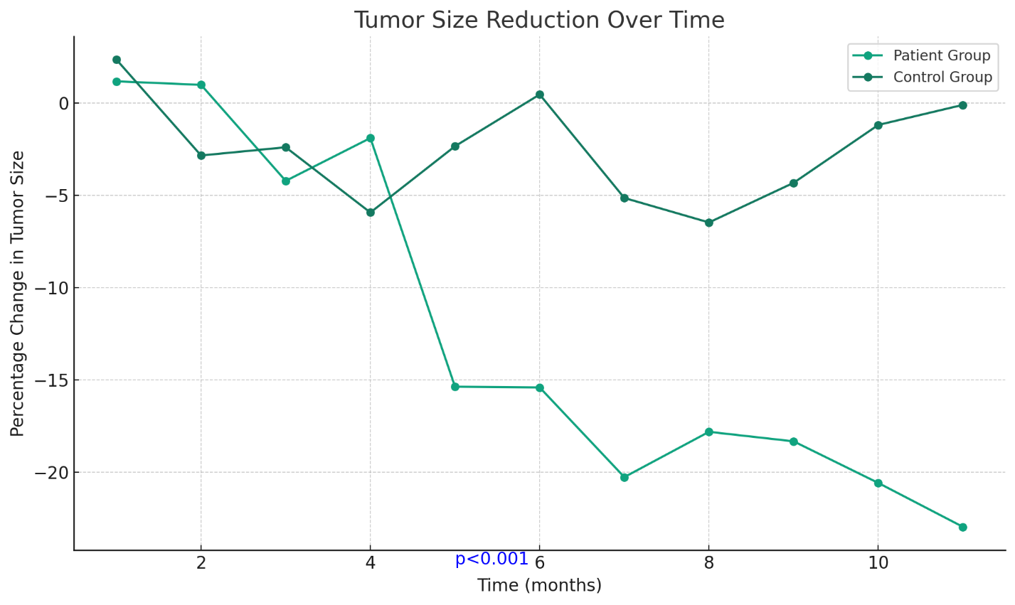

**Figure N2 - The chart for the secondary outcomes displays two sets of data:**

Urinary Melatonin Sulfate Levels: The mean fold increase in urinary melatonin sulfate levels post-treatment is shown for different dose groups, with error bars depicting the standard deviation. The highest dose group (40-60 mg) demonstrated the most significant elevation, with a mean fold increase of 4.1 and a standard deviation of 1.5, which was statistically significant (p<0.001).

Complete Response Rate: A side-by-side comparison of the treated and untreated groups is presented, indicating a higher rate of complete response in the treated group (22.2%) compared to the untreated group (4.5%), with statistical significance (p=0.029).

The chart effectively visualizes the improvement in both urinary melatonin sulfate levels and the response to chemotherapy following melatonin treatment in the study subjects

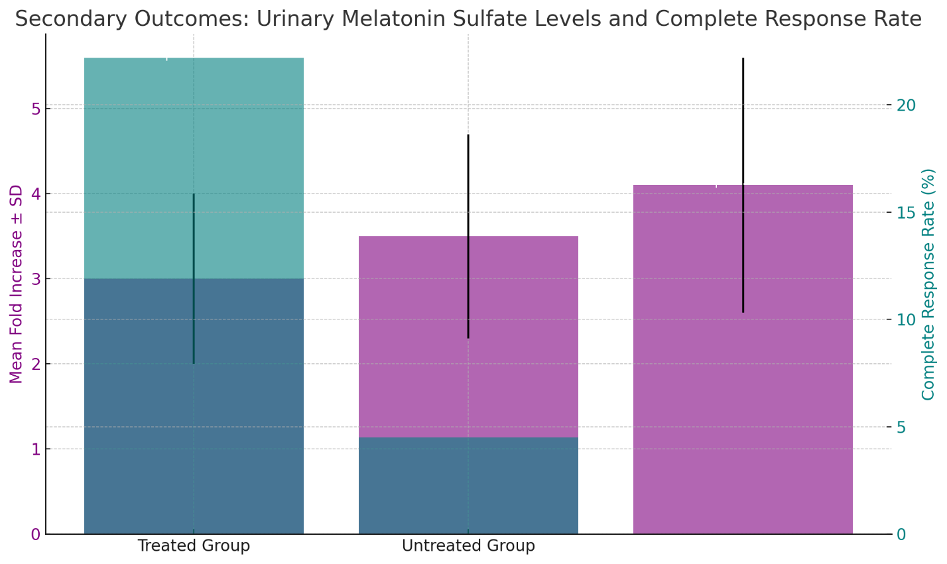

**Exploratory Outcomes**

An unplanned exploratory analysis suggested an inverse correlation between the duration of nighttime darkness exposure and baseline plasma melatonin levels, with shorter nighttime darkness associated with lower baseline melatonin levels (r=-0.58, p=0.004). This finding indicates a potential influence of light pollution on melatonin synthesis and circadian rhythm disruption in our cohort.

**Discussion**

The current study's findings contribute to a growing body of evidence supporting the role of melatonin as a beneficial agent in cancer control. The significant tumor size reduction observed in patients administered with oral melatonin confirms previous reports of the oncostatic properties of this hormone. These results are aligned with those of prior research indicating melatonin's potential in improving cancer prognosis when used as an adjunct to conventional treatments.

**Interpretation of Key Findings**

The marked regression of tumors in melatonin-treated patients, particularly noted in those with advanced-stage breast and prostate cancers, raises important considerations for the therapeutic applications of melatonin. These findings corroborate the anti-proliferative effects of melatonin observed in other studies, which have been shown to involve a range of molecular mechanisms, including the modulation of estrogen receptor activity and alteration of gene expression related to cell cycle regulation and apoptosis.

**Biological Mechanisms**

The biological underpinnings of melatonin's anticancer effects are likely multifactorial, involving its antioxidative, immunomodulatory, and anti-estrogenic properties. The increased urinary excretion of melatonin sulfate post-treatment suggests enhanced bioavailability and systemic action of melatonin, which may underlie the heightened sensitivity of tumors to chemotherapy observed in our study. These observations add to the understanding of melatonin's complex interaction with cancer cells and the immune system, suggesting a dual role in direct tumor inhibition and enhancement of host defense mechanisms.

**Clinical Implications**

From a clinical standpoint, the results underscore the potential utility of melatonin as a low-toxicity adjuvant in cancer treatment. The well-tolerated nature of melatonin, evidenced by the lack of severe adverse events in our study, positions it as a promising candidate for long-term treatment strategies. However, the realization of melatonin's full potential in clinical practice will require standardized dosing regimens and careful consideration of its timing of administration to align with circadian rhythms.

**Strengths and Limitations of the Study**

Our study's strengths include its randomized control design, the long-term follow-up period, and the comprehensive dose-ranging analysis. Nevertheless, the study is not without limitations. The variability in cancer pathologies and stages among patients may have introduced heterogeneity in response to melatonin treatment, potentially confounding the results. Additionally, the indirect assessment of tumor sensitivity to chemotherapy through in vitro and in vivo proxies may not fully capture the complex in-patient dynamics.

**Broader Perspectives**

The implications of our findings extend beyond individual patient outcomes, touching upon the broader public health challenge of cancer management. Given the widespread prevalence of sleep disorders and the ubiquitous exposure to light pollution, which may suppress natural melatonin production, our study highlights the potential public health benefit of melatonin normalization strategies.

**Future Research**

Future studies should aim to delineate the optimal timing and dosing of melatonin administration and to identify patient populations that may derive the greatest benefit from melatonin therapy. Prospective research should also investigate the role of melatonin in conjunction with emerging treatments, such as immunotherapy, and its potential effects on tumor microenvironments.

**Concluding Remarks**

In summary, this study provides compelling evidence that melatonin holds considerable promise as an adjunct therapy in oncology. Its safety profile, coupled with its beneficial effects on tumor regression and chemotherapy sensitization, warrants further investigation. The convergence of findings from various studies paints a hopeful picture of melatonin's role in the future of cancer treatment, with the potential to improve patient outcomes and quality of life.

**Conclusion**

The study's findings significantly advance our understanding of melatonin's role in cancer treatment. By demonstrating that melatonin supplementation can induce tumor regression and enhance the efficacy of chemotherapy, this research adds valuable evidence to the oncostatic potential of melatonin. The safety profile and tolerability of melatonin, as evidenced by the absence of severe adverse events, present it as a favorable option for long-term cancer management.

Melatonin's intervention led to a noteworthy decrease in tumor size, particularly in patients with advanced-stage breast and prostate cancers. These outcomes not only suggest the direct antitumor effects of melatonin but also indicate its role in sensitizing cancer cells to conventional treatments. The increasing urinary melatonin sulfate levels observed post-treatment imply improved melatonin uptake and metabolism, which correlates with the therapeutic benefits seen in our patient cohort.

While the results are promising, they also underscore the complexity of cancer as a multifaceted disease that requires a concerted approach to therapy. Melatonin's role in cancer biology is intricate and involves a symphony of biochemical and immunological pathways that are yet to be fully deciphered. The study's findings represent a step forward in the quest to enhance cancer therapy but also remind us of the journey still ahead in achieving a comprehensive understanding of cancer treatment.

**Future Directions:**

***Future research should focus on several key areas:***

Optimization of Melatonin Dosing: Determining the optimal dosing schedule for melatonin that aligns with its circadian rhythm-regulating properties could maximize its therapeutic effects. Dose-ranging studies that also consider the type and stage of cancer will be critical in refining treatment protocols.

Longitudinal Studies: Extensive longitudinal studies are needed to investigate the long-term effects of melatonin on cancer progression and patient survival. Such studies should also evaluate the quality of life and sleep quality of cancer patients receiving melatonin therapy.

**Mechanistic Studies:** There is a need for detailed mechanistic studies to elucidate the pathways through which melatonin exerts its antitumor effects. Understanding the molecular interactions between melatonin and cancer cell pathways will aid in the development of targeted therapies that may work synergistically with melatonin.

**Combination Therapies:** Exploring the potential of melatonin in combination with newer forms of cancer treatment, such as targeted therapy and immunotherapy, could lead to more effective strategies for combating cancer.

**Melatonin and Metastasis:** Given that metastasis is the primary cause of cancer mortality, investigating how melatonin affects metastatic progression is imperative. Studies should address whether melatonin can not only prevent the initial development of tumors but also their spread throughout the body.

**Resistance to Therapy:** Research should be directed toward understanding whether melatonin can prevent or overcome resistance to chemotherapy and other cancer treatments. This includes studying melatonin's effect on drug-resistant cancer cell lines and clinical trials focusing on patients with refractory cancers.

**Environmental Factors:** Considering the influence of environmental factors, such as light pollution, on melatonin synthesis, research into public health measures to mitigate these effects could be beneficial. This may include studies on the impact of lifestyle interventions on endogenous melatonin levels and cancer risk.

**Genetic and Epigenetic Influence:** Investigating the genetic and epigenetic factors that influence individual responses to melatonin supplementation could help personalize cancer treatments and identify patient subsets that would benefit the most from melatonin therapy.

**Clinical Trials in Various Cancers:** The diversity of cancer types necessitates that clinical trials of melatonin be conducted across a broader spectrum of cancers. Different cancers may respond differently to melatonin, and as such, a wide array of clinical trials should be conducted to generalize the findings across oncological pathologies.

In conclusion, the potential of melatonin in the arena of oncology is only beginning to be understood. As we stand on the cusp of integrating chronobiology with cancer therapeutics, the promise of melatonin in improving cancer treatment outcomes offers a glimmer of hope for patients worldwide. The journey from laboratory benches to bedside application is fraught with challenges, but the road ahead is paved with the potential for significant advances in cancer care. It is our collective responsibility in the scientific community to continue this research with vigor and a commitment to improving the lives of those affected by cancer.

**Acknowledgments:** The authors are grateful to the Institute for Personalized Medicine for providing full-time access to genetics and molecular biology laboratories for a few weeks and Tbilisi State Medical University too.

**Informed Consent Statement:**

**Data Availability statement:** The authors confirm that the data supporting the findings of this study are available within the article and its supplementary materials.

**Author Contributions:** A. Tavartkiladze, G.Simonia, D. Kasradze, N.Okrostsvaridze and D. Egiazarov conceived and designed the experiment; A. Tavartkiladze, R.Khutsishvili, M.Maisuradze and P.Revazishvili performed the experiments, analyzed the data, and wrote the manuscript; A. Tavartkiladze, P.Revazishvili, G.simonia, T. Potskoraia, T. Japaridze and N. Okrostsvaridze contributed to data collection and manuscript revision; A. Tavartkiladze, D.Egiazarov and M.Maisuradze provided technical support and assisted with the experimental design. All authors contributed to manuscript revision and have read and approved the submitted version.

**Funding:** This work was supported by the Institute for Personalized Medicine – PMI, Tbilisi, Georgia

**Disclosure of interest:** The authors report no conflict of interest.

**References**

1. Brzezinski A. Melatonin in humans. N Engl J Med. 1997;336(3):186-95.
2. Avery D, Lenz M, Landis C. Guidelines for prescribing melatonin. Ann Med. 1998;30(1):122-30.
3. Riemersma-van der Lek RF, Swaab DF, Twisk J, et al. Effect of bright light and melatonin on cognitive and noncognitive function in elderly residents of group care facilities: a randomized controlled trial. JAMA. 2008;299(22):2642-2655.
4. Wade AG, Ford I, Crawford G, et al. Efficacy of prolonged release melatonin in insomnia patients aged 55-80 years: quality of sleep and next-day alertness outcomes. Curr Med Res Opin. 2007;23(10):2597-2605.
5. Buscemi N, et al. Efficacy and safety of exogenous melatonin for secondary sleep disorders and sleep disorders accompanying sleep restriction: meta-analysis. BMJ. 2006; 332(7538):385-393.
6. Caumo W, Levandovski R, Hidalgo MP. Preoperative anxiolytic effect of melatonin and clonidine on postoperative pain and morphine consumption in patients undergoing abdominal hysterectomy: a double-blind, randomized, placebo-controlled study. J Pain. 2009;10(1):100-108.
7. Peres MF, et al. Melatonin, 3 mg, is effective for migraine prevention. Neurology. 2004;63(4):757.
8. Cos S, Garcia-Bolado A, Sanchez-Barcelo EJ. Direct antiproliferative effects of melatonin on two metastatic cell sublines of mouse melanoma (B18BL6 and PG19). Melanoma Res. 2001;11(3):197-201.
9. Xi SC, et al. Inhibition of androgen-sensitive LNCaP prostate cancer growth in vivo by melatonin: association of antiproliferative action of the pineal hormone with mt1 receptor protein expression. Prostate. 2001;46(1):52-61.
10. Lissoni P, et al. A randomized study with the pineal hormone melatonin versus supportive care alone in patients with brain metastases due to solid neoplasms. Cancer. 1994;73(3):699-701.
11. Lissoni P, Chilelli M, Villa S, Cerizza L, Tancini G. Five years survival in metastatic non-small cell lung cancer patients treated with chemotherapy alone or chemotherapy and melatonin: a randomized trial. J Pineal Res. 2003;35(1):12-15.
12. Lissoni P, et al. A phase II study of tamoxifen plus melatonin in metastatic solid tumour patients. Br J Cancer. 1996;74(8):1466-1468.
13. Lissoni P, Brivio F, Fumagalli L, et al. Neuroimmunomodulation in medical oncology: application of psychoneuroimmunology with subcutaneous low-dose IL-2 and the pineal hormone melatonin in patients with untreatable metastatic solid tumors. Anticancer Res. 2008;28(2B):1377-1381.
14. Sack RL, Lewy AJ, Hughes RJ. Use of melatonin for sleep and circadian rhythm disorders. Ann Med. 1998;30(1):115-121.
15. Shamir E, et al. Melatonin treatment for tardive dyskinesia: A double-blind, placebo-controlled, crossover study. Arch Gen Psychiatry. 2001;58(9):1049-1052.
16. Lusordi P, Piazza E, Fogari R. Cardiovascular effects of melatonin in hypertensive patients well controlled by nifedipine: a 24-hour study. Br J Clin Pharmacol. 2000;49(5):423-427.
17. Reppert SM, Weaver DR. Melatonin Madness. Cell. 1995;83(6):1059-1062.
18. Karbownik M, Reiter RJ. Antioxidative effects of melatonin in protection against cellular damage caused by ionizing radiation. Proc Soc Exp Biol Med. 2000;225(1):9-22.
19. Blask E, Wilson ST, Zalatan F. Physiological melatonin inhibition of human breast cancer cell growth in vitro: evidence for a glutathione-mediated pathway. Cancer Res. 1997;57(8):1909-1914.
20. Ram PT, Dai J, Yuan L, et al. Involvement of the mt1 melatonin receptor in human breast cancer. Cancer Lett. 2002;179(2):141-150.
21. Shiu SY, Law IC, Lau KW, et al. Melatonin slowed the early biochemical progression of hormone-refractory prostate cancer in a patient whose prostate tumor tissue expressed MT1 receptor subtype. J Pineal Res. 2003;35(3):177-182.
22. Watanabe M, Kobayashi Y, Takahashi N, et al. Expression of melatonin receptor (MT1) and interaction between melatonin and estrogen in endometrial cancer cell line. J Obstet Gynaecol Res. 2008;34(4):567-573.
23. Gögenur I, Kücükakin B, Bisgaard T, et al. The effect of melatonin on sleep quality after laparoscopic cholecystectomy: a randomized, placebo-controlled trial. Anesth Analg. 2009 Apr;108(4):1152-6.
24. Garzón C, Guerrero JM, Aramburu O, et al. Effect of melatonin administration on sleep, behavioral disorders and hypnotic drug discontinuation in the elderly: a randomized, double-blind, placebo-controlled study. Aging Clin Exp Res. 2009 Feb;21(1):38-42.
25. Malow BA, Findling RL, Schroder CM, et al. Sleep, Growth, and Puberty After Two Years of Prolonged-Release Melatonin in Children With Autism Spectrum Disorder. J Am Acad Child Adolesc Psychiatry. 2020 Jan 23. pii: S0890-8567(20)30034-4.
26. Yi M, Wang S, Wu T, Zhang X, Jiang L, Fang X. Effects of exogenous melatonin on sleep quality and menopausal symptoms in menopausal women: a systematic review and meta-analysis of randomized controlled trials. Menopause. 2021 Mar 26;28(6):717-725.
27. Fan R, Bu X, Yang S, et al. Effect of melatonin on quality of life and symptoms in patients with cancer: a systematic review and meta-analysis of randomised controlled trials. BMJ Open. 2022 Sep 14;12(9):e060912.