YEAR CASES %  2011 25 16,49  2012 19 12,83  2013 11 7,43  2014 22 14,86  2015 12 8,10  2016 21 14,15  2017 16 10,81  2018 6 4,05  2019 16 10,81 | 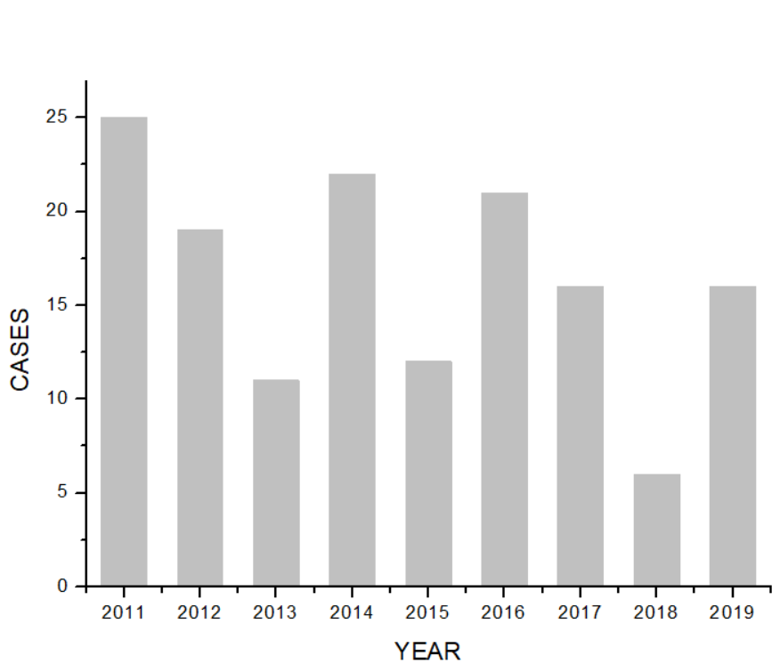
Tab 1a | Tab 1b

Cases divided for year

MONTH CASES %  January 12 8,10  February 11 7,43  March 15 10,13  April 14 9,45  May 10 6,75  June 16 10,81  July 12 8,10  August 13 8,78  September 7 4,72  October 15 10,13  Novembre 9 6,08  December 14 9,54 | 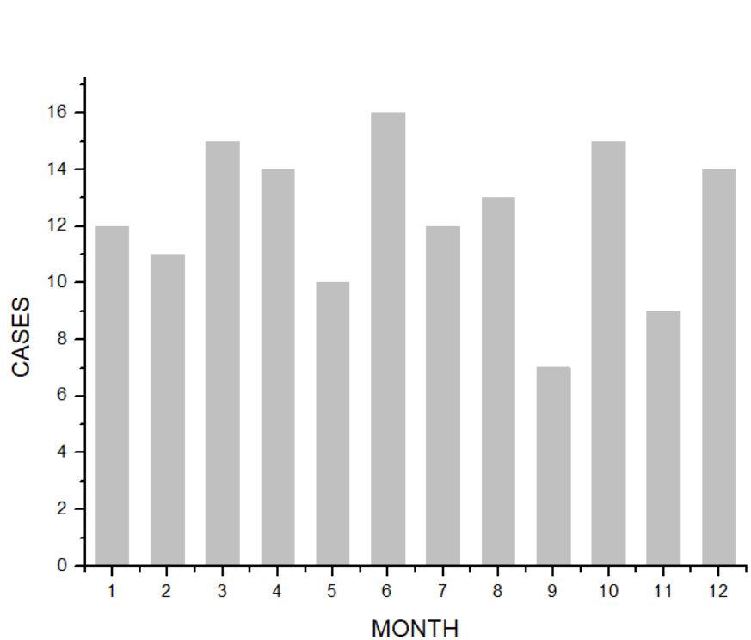
Tab 2a | Tab 2b cases splitted by months of diagnosys

CAUSES | NUMBER OF CASES | %
Cataract surgery | 86 | 58,11
Blebitis | 14 | 9,46
Intravitreal Injection | 11 | 7,43
Perforating trauma | 9 | 6,08
Vitrectomy | 7 | 4,73
Endogenous | 4 | 2,70
Corneal suture removal | 3 | 2,03
Endothelial keratoplasty | 2 | 1,35
Corneal abscess | 2 | 1,35
Corneal ulcer | 2 | 1,35
Iris melanoma surgery | 1 | 0,68
Keratotomy wound leak | 1 | 0,68
Silicone oil removal | 1 | 0,68
corneal wound | 1 | 0,68
IOL reposition | 1 | 0,68
Valve tube extrusion | 1 | 0,68
Yag laser Capsulotomy | 1 | 0,68
Abscess on previous keratoplasty | 1 | 0,68

TAB 3
Causes of endophthalmitis

Tab.4. Cases related to different microrganisms

MICROORGANISM | NUMBER OF CASES | %
Staphylococcus epidermidis | 23 | 15,54
Streptococcus pneumoniae | 10 | 6,76
Staphylococcus hominis | 8 | 5,41
Pseudomonas aeruginosa | 5 | 3,38
Streptococcus sanguinis | 5 | 3,38
Staphylococcus aureus | 4 | 2,70
Staphylococcus haemolyticus | 3 | 2,03
Enterococcus faecalis | 2 | 1,35
Escherichia coli | 2 | 1,35
Granulicatella adiacens | 2 | 1,35
Serratia marcescens | 2 | 1,35
Staphylococcus lugdunensis | 2 | 1,35
Streptococcus gordonii | 2 | 1,35
Aspergillus fumigatus | 1 | 0,68
Bifidobacterium species | 1 | 0,68
Candida parapsilosis | 1 | 0,68
Corynebacterium pseudodiphtheriticum | 1 | 0,68
Haemophilus influenzae | 1 | 0,68
Morganella morganii | 1 | 0,68
Staphylococcus lentus | 1 | 0,68
Streptococco oralis and Streptococco mitis | 1 | 0,68
Streptococcus agalatiae and Enterobacter aerogenes | 1 | 0,68
Streptococcus parasanguinis and Neisseria suppurans | 1 | 0,68
Streptococcus pyogenes | 1 | 0,68
Streptococcus viridans | 1 | 0,68
Abiotrophia defectiva | 1 | 0,68

MICRORGANISM | NUMBER OF CASES | %
Staphylococcus epidermidis | 15 | 28,30
Streptococcus pneumoniae | 6 | 11,32
Staphylococcus hominis | 5 | 9,43
Streptococcus sanguis | 5 | 9,43
Pseudomonas aeruginosa | 3 | 5,66
Enterococcus faecalis | 2 | 3,77
Serratia marcescens | 2 | 3,77
Staphylococcus aureus | 2 | 3,77
Staphylococcus haemolyticus | 2 | 3,77
Staphylococcus lugdunensis | 2 | 3,77
Streptococcus gordonii | 2 | 3,77
Aspergillus fumigatus | 1 | 1,89
Candida parapsilosis | 1 | 1,89
Granulicatella adiacens | 1 | 1,89
Morganella morganii | 1 | 1,89
Staphylococcus lentus | 1 | 1,89
Streptococcus oralis ans Streptococcus mitis | 1 | 1,89
Abiotrophia defectiva | 1 | 1,89

TAB 5 Cases related to different microrganisms after cataract surgery

MICROBES | EVS | UK | NETHERLANDS | INDIA | INDIA | CHINA | OUR STUDY (ALL CASES) | OUR STUDY (POST-CATARACT SURGERY)
GRAM-POSITIVE |  | 93,4 |  |  | 53,1 | 73,9 | 83,5 | 77,8
CNS | 70 | 62,3 | 53,6 | 18,6 | 33,3 | 45,5 | 43,5 | 46,3
S. AUREUS | 10 | 4,9 | 12 | 11,4 |  | 12,4 | 4,7 | 3,7
STREPTOCOCCUS SPP | 9 | 19,6 | 19 | 2,9 | 10,3 | 6,2 | 27,0 | 27,8
ENTEROCOCCUS SPP | 2 | 3,3 | 1,8 | 1,4 |  | 7,2 | 2,3 | 3,7
OTHER GRAM-POSITIVE | 3 | 3,3 | 5,2 | 10 |  | 2,6
GRAM-NEGATIVE | 6 | 6,6 | 6 | 42 | 26,2 | 13,4 | 15,3 | 18,5
FUNGAL |  |  |  | 7,1 | 16,7 | 12,7 | 2,3 | 3,7

Tab. 6 Etiology of our endophthalmitis compared with other studies in different countries

WAITING TIME (hours) | NUMBER OF CASES | %
< 24 | 108 | 79,41
> 24, < 48 | 15 | 11,03
> 48, < 72 | 4 | 2,94
> 72 | 9 | 6,62

Tab 7a patients divided for waiting time from Emergency Department admission and vitrectomy

YEAR | WAITING TIME (hours) | NUMBER OF CASES | %
2011 | < 24 | 12 | 8,82
 | > 24, < 48 | 5 | 3,68
 | > 48, < 72 | 2 | 1,47
 | > 72 | 5 | 3,68
2012 | < 24 | 8 | 5,88
 | > 24, < 48 | 6 | 4,41
 | > 48, < 72 | 2 | 1,47
2013 | < 24 | 10 | 7,35
2014 | < 24 | 21 | 15,44
 | > 24, < 48 | 1 | 0,74
2015 | < 24 | 10 | 7,35
 | > 24, < 48 | 1 | 0,74
2016 | < 24 | 14 | 10,29
 | > 24, < 48 | 2 | 1,47
 | > 72 | 3 | 2,21
2017 | < 24 | 14 | 10,29
 | > 72 | 1 | 0,74
2018 | < 24 | 5 | 3,68
2019 | < 24 | 14 | 10,29

Tab 7b

Patients divided for waiting time from Emergency Department admission and vitrectomy and for years

DAYS | MEAN VA INCREASE
0 | 3,74 ± 3,02
1 | 2,1 ± 2,01
2 | 0,5 ± 0,96
3 | 0,34 ± 0,25
5 | 0,16 ± 0,26
more | 0

TAB. 8 Relationship between waiting time from admission to vitrectomy and visual improvement

FIG. 8

DAYS | MEAN VA INCREASE
0 | 3,97 ± 2,93
1 | 2,42 ± 2,04
2 | 0,67 ± 1,10
3 | 0,27 ± 0,31

TAB. 9 Relationship between waiting time from admission to vitrectomy and visual improvement after cataract surgery

FIG. 9

PATIENTS OPERATED BEFORE 24 HOURS
VA INCREASE ( SNELLEN ) | % OF PATIENTS
9 | 1,03
8 | 8,25
7 | 6,19
6 | 9,28
5 | 10,31
4 | 13,40
3 | 8,25
2 | 8,25
1 | 6,19
<1 | 13,40
0 | 15,46

TAB 10 Percentage of patients underwent vitrectomy before 24 hours with visual improvement.

MEAN VA INCREASE | MEAN DAYS FROM ADMISSION  TO VITRECTOMY
>5 | 0
4 | 0,08 ± 0,08
3 | 0,3 ± 0,3
2 | 0
1 | 0,5 ± 0,83
<1 | 0,65 ± 1,03
0 | 0,14 ± 3,02

TAB. 12 Visual acuity improvement correlation to vitrectomy delay

FIG. 12

MICROORGANISM | VISUAL ACUITY INCREASE | P
Staphylococcus epidermidis | 4,20 ± 2,66 | 0,257
Staphylococcus hominis | 1,90 ± 2,06 | 0,051
Streptococcus pneumoniae | 3,99 ± 3,16 | 0,433
Streptococcus sanguinis | 1,81 ± 2,47 | 0,059

Tab.13
Correlation between visual impairment and type of microorganism

