Research Article
Quality of Life and Sexual Function of Women Adopting a Long-Acting Reversible Contraceptive (LARC) or a Short-Acting Reversible Contraceptive (SARC) after Termination for Unintended Pregnancy

Salvatore Caruso^{1*}, Gabriele Mazza¹, Roberta Brescia¹, Gaia Palermo¹, Giuseppe Caruso² and Stefano Cianci³
¹Department of General Surgery and Medical Surgical Specialties, Gynecological Clinic, Research Group for Sexology, University of Catania, Catania, Italy
²Department of Biometec, University of Catania, Catania, Italy
³Department of Obstetrics and Gynecology, University of Messina, Messina, Italy

*Corresponding author: Salvatore Caruso, MD, Department of General Surgery and Medical Surgical Specialties, University of Catania, Via Santa Sofia 78, 95123 Catania, Italy, Tel: (+39) 0953781101. E-mail: scaruso@unict.it

Citation: Salvatore Caruso (2021) Quality of Life and Sexual Function of Women Adopting a Long-Acting Reversible Contraceptive (LARC) or a Short-Acting Reversible Contraceptive (SARC) after Termination for Unintended Pregnancy. JWHG-Jscholar

Abstract

Introduction: About half of all pregnancies are unintended and half of these result in terminations. Not all women return to their gynecologist for post-abortion check-ups, this could expose them to the risk of further pregnancies. The aim of this prospective cohort study was to investigate the impact of long-acting reversible contraception (LARC) and short-acting reversible contraception (SARC) on sexual function and quality of life (QoL) in women after having undergone termination of pregnancy (TOP) for unintended pregnancy.
Materials and Methods: The Short Form-36 (SF-36) questionnaire and the Female Sexual Function Index (FSFI) were used to investigate, respectively, the QoL and sexual function score of each woman at baseline and at the 6th, 12th, 18th and finally at the 24th month follow-ups. Intention-to-treat analysis was performed. The one-way analysis of variance (ANOVA) and the chi-square test (ꭓ2) were used for between-group analyses of parametric and categorical data, respectively. Within-group analyses were performed using the paired t test for parametric continuous variables, and the Wilcoxon sign rank test for nonparametric variables.
Results: 219 women were enrolled. Of these, 148 (67.6%) adopted a LARC [62 (28.3%) the Levonorgestrel-releasing intrauterine system (LNG-IUS 13.5 mg) and 86 (39.3%) the Etonogestrel 68 mg subdermal implant (ENG-implant)] and 71 (32.4%) chose a SARC (combined oral contraception, progestogen-only contraception, or vaginal ring). The women using a LARC had a better QoL improvement than those women using SARC from the 6th month follow-up until the end on the study (p<0.001). Moreover, the FSFI total score was better in women using a LARC than in those using a SARC throughout the study(p=0.001). None of the women on a LARC had a pregnancy during the study period. On the contrary, 6 (8.5%) women on a SARC had an unintended pregnancy due to discontinuation of the method.
Conclusions: Compared to the SARC options used, those women who choose LARC experienced better QoL and sexual function after TOP and avoided repeat unintended pregnancy.
This trial was approved by the institutional review board of the Ethics Committee of the University Hospital Polyclinic, Catania, Italy, retrospectively registered with n. 109/2020/PO

Keywords: Etonogestrel implant; LARC; LNG IUS; Quality of life; SARC, Sexual function; Termination of Pregnancy; Unintended pregnancy

Introduction

Sexual health is an important aspect that affects the quality of life (QoL) of each individual, in all stages of life [1]. It could be influenced by biological, psychological and social factors [2]. Unwanted pregnancy, as a result of a contraceptive failure, can involve all the above factors, often negatively affecting QoL [3].
In the past 20 years the voluntary abortion rate in southern Europe has declined from 46 to 27 per 1000 women 15–44 years old [4]. However, it is still high. In fact, it is estimated that about half of all pregnancies are unintended and half of these result in voluntary terminations [5]. Not all women return to their gynecologist for post-abortion check-ups, thus possibly exposing them to the risk of further pregnancies [5].
An adequate contraceptive counselling should be offered to all women who wish to terminate a pregnancy, informing them that ovulation can take place as early as 8 days after the abortion [6]. Moreover, more than 50%of women recommencesexual activitywithin 2 weeks, and morethan 85% after 8 days from an abortion [7]. The choice of contraception has to take into account not only what the woman would like to use but also the criteria for its prescription on the basis of medical contraindications [8]. The safety and efficacy differences between Long-Acting Reversible Contraceptives (LARCs) and Short-Acting Reversible Contraceptives (SARCs) could depend on the perfect and typical use of each method. Perfect use, meaning the method is used consistently and correctly every time, while typical use, meaning the method may not always be used consistently and correctly. LARCs are safer and more effective than SARCs. In fact, the typical and perfect use rates of LARCs maycoincide and the percentage is less than 0.7 during the first year of usage. On the other hand, unintended pregnancies per 100 women/year of typical and perfect use of SARCs is 7% and 0.3%, respectively. This could depend on forgetting to take the pill, discontinuation, use of drugs, food poisoning with vomiting and/or diarrhea. Each of these events can be a reason for contraceptive failure [9].
However, among the several reasons why SARCs are the most widely used hormonal methods is the convenience of taking them. Resistance towards LARCs may relate to high upfront costs, the incomplete knowledge of the method, and the limited capacity of health care professionals to give adequate counselling [10].
Theuseof aLARCcould beproposedto awoman with ahistoryof discontinuityin her useof SARCs, such as oral, transdermal or vaginal contraception. On the other hand, to a woman who has used non-hormonal contraception and who has had an unintended pregnancy, either a SARC or a LARC could be suggested [11,12].

The aim of this study was to compare the effects of LARCs, namely Levonorgestrel-releasing intrauterine system (LNG-IUS 13.5 mg) and Etonogestrel 68 mg subdermal implant (ENG-implant), with those of SARCs, namely combined oral contraceptive (COC), progestogen-only pill (POP) and vaginal ring (VR), on QoL and sexual function of women who had had an unintended pregnancy after discontinuing a SARC or who had never used a hormonal contraceptive and underwent surgical termination of pregnancy (TOP).

Materials and Methods

This prospective cohort studywas performed at the FamilyPlanningCentreof the SexologyResearch Group, Department of General Surgery and Medical Surgical Specialties, School of Medicine, University of Catania, Italy. The study protocol conformed to the ethical guidelines of the 2013 Helsinki Declaration, and with the approval of the institutional review board of the Ethics Committee of the University Hospital Polyclinic, Catania, Italy. No study advertising was made and no remuneration was offered. At enrollment, written informed consent was obtained directly from the women who were more than 18 years of age. Parental consent was obtained for teenagers under 18. The time of recruitment was from January 2016 to March 2019. Before enrollment, medical, surgical and medication histories were assessed to ensure study eligibility based on inclusion and exclusion criteria for hormonal contraceptive usage.

Procedures
As an integrated part of our abortion services, women with an unintended pregnancy asking for TOP receive contraceptive counselling. The counseling includes information on how to get an abortion, and on possible contraceptive methods to be adopted and when to start contraception use after termination (LARCs or SARCs) to avoid future unintended pregnancies. Since the service does not offer any LARC, each woman is also informed about the costs of each method. Women are included in an agenda for face-to-face follow-up meetings after abortion. Two weeks before follow-up, each woman receives an appointment confirmation by telephone.
Exclusion criteria for women who chose LNG-IUS included distortion of the uterine cavity due to fibroid(s), cervical dysplasia, or current pelvic inflammatory disease. All women underwent an ultrasonography examination one week after abortion; cervix and vaginal swabs were taken at the second week; finally, at the third week, they received the swab results and any therapy necessary before LNG-IUS placement.

The intrauterine system was placed at the 4th week after TOP, and during the first 7 days of the menstrual cycle. The women were advised to use a barrier method prior to the IUS placement. The ENG implant was inserted through the disposable applicator into the innermost part of the arm, the day of TOP, during the surgical abortion. The women who chose to adopt a SARC received the prescription for the contraceptive when they were discharged from hospital. They were advised to start the COC, POP or VR the evening after the TOP.

Instruments

The QoL and sexuality of the women were assessed with standardized, validated questionnaires. The Short Form-36 (SF-36) questionnaire validated in the Italian population was used to assess QoL [13]. The questionnaire contains 36 questions in four categories of somatic aspects [physical activity (10 items), physical role (4 items), bodily pain (2 items), and general health (6 items)], and four mental aspects [vitality(4 items), social activity (2 items), emotional role (3 items) and mental health (5 items)]. Women were instructed to place a mark on a 0–100 scale for each item that best corresponded to their feelings, from the lowest to the highest score of a given category of the QoL questionnaire. Thereafter, the sum of all items of each category was made. Mean values were calculated based on individual items within a given category. Consequently, somatic and mental scale scores were obtained, with higher scores indicating better functioning.
To measure the level of sexual behavior the self-administered Female Sexual Function Index (FSFI) validated in the Italian gynecological population was used [14]. The FSFI consists of six domains, which include desire (two items), arousal (four items), lubrication (four items), orgasm (three items), satisfaction (three items), and pain (three items), answered on a five point Likert scale, ranging from 0 (no sexual activity) or 1 (never/very low) to 5 (always/very high). A score is calculated for each of the six domains and the total score is obtained summing all the items. The total score range is 2–36. A cutoff of ≤26.55 is usually accepted for diagnosis of sexual dysfunction [15].
Furthermore, each woman received a diary to record daily sexual activity during the contraceptive usage covering behaviors from self-stimulation to arousal with their partner and actual intercourse. Moreover, the incidence of adverse events and the characteristics of bleeding were also recorded. Each woman of both the LARC and SARC groups completed all the questionnaires at the baseline evaluation and at each follow-up.

At the end of the study, the women were asked to rate their satisfaction with their contraceptive method as very satisfied, somewhat satisfied, neither satisfied nor dissatisfied, dissatisfied, or very dissatisfied. In addition to the basal evaluation, the study had four follow-ups: at the 6th, 12th, 18th and finally at the 24th month.

Statistical Analysis

Assuming a standard deviation of 15 and a mean difference of 10 with a p ≤0.05, the sample size calculation indicated that 46 subjects would be the minimum number for each study arm required to have 90% statistically significant power. Considering a dropout rate of 25-30% [16], 145 women were considered the number of subjects to be invited to participate in the study.
Intention-to-treat analyses were performed for all efficacyvariables and included all patients who had undergone the baseline evaluation and had at least one efficacy assessment after the baseline visit. Subjects that had missing information on one or more questionnaire items were included in the analysis. Of them, 4, 8 and 8 participants were using IUS-LNG, ENG implant and SARCs, respectively. They dropped out of the study or stopped treatment for adverse events (see results). The last observation carriedforward was used to select data such that missing datawerereplaced byvalues from the last available assessment.

Theone-wayanalysis of variance(ANOVA) and the chi-squaretest (ꭓ2) wereused for between-group analyses of parametric and categorical data, respectively.

Within-group analyses were performed using the paired t test for parametric continuous variables, and the Wilcoxon sign rank test for nonparametric variables.

Scores are presented as means ± SD. The result was statistically significant when p<0.05. Statistical analysis was carried out using a software package for ™ Windows 95 (Grantz SA, Primer of Biostatistics, McGraw-Hill Inc., New York, USA, 1997).
Results

Two hundred sixty-eight eligible women were recommended by health care professionals to use a hormonal contraceptive after TOP. After receiving contraceptive counselling on each method, 49 (18.3%) women chose not to use any hormonal contraceptive. Consequently, 219 (81.7%) women were enrolled. Of them 62 (28.3%) women chose the IUS-LNG, 86 (39.3%) the ENG implant, and 71 (32.4%) adopted a SARC, nominally COC, POP or VR. The choice of women to use a SARC mainly depended on their inability to pay for a LARC. Moreover, a limited number of women stated they would not accept something foreign inside their body. This was declared by the women during contraceptive counseling. The demographic characteristics and the contraceptive history of each group are reported in Table 1.

At enrollment, 216 (98.6%) women reported that they had undergone one [115 (53.3%)], two [50] (23.1%)] or three [51] (23.6%)] surgical TOP for unintended pregnancies; the termination was performed between the seventh and twelfth week of gestational age, without adverse effects. Women who were using a LARC had had more previous TOPs and fewer children than women who were usingaSARC(p=0.001). Furthermore, duringcontraceptivecounselling, 71 (32.4%) women reported to have used a SARC, namely oral pill (22.8%) or VR (9.6%), however, they reported to have had no adverse events to induce discontinuation. No women had previously used a LARC. Finally, 102 (46.6%) women had not used any contraceptive and 46 (21%) had used non-hormonal contraception, although they showed no contraindications to hormonal contraception usage.

IUS-LNG

The IUS-LNG was placed at the 3rd [13 (20.9%)], 4th [17 (27.5%)], 5th [19 (30.7%)] or 6th [13] (20.9%)] day of the cycle, on the basis of quantity and length of the menses, and at the first insertion attempt. Within the first 6 months, 5 (8.1%) women requested the removal of the system due to bleeding that was unresponsive to medical therapy. Furthermore, 4 (6.4%) women were planning a pregnancy, thereforetheyaskedforthe removal of thesystem betweenthe 12th and 24th month follow-ups. They became pregnant 3-6 months after removing the device. Consequently, 53 (85.5%) women completed the study. No pregnancy occurred during the study and no pelvic infection was diagnosed. There was no expulsion or partial expulsion of the IUS into the cervical canal.

ENG implant

The ENG implant was placed after TOP. Within the first 6 months, 8 (9.3%) women requested the removal of the implant because of bleeding that was unresponsive to medical therapy. Finally, 7 (8.1%) women discontinued the implant after 12 months of usage to plan a pregnancy. They became pregnant 2-5 months after implant removal. Therefore, 71 (82.6%) women completed the study. None of them had a pregnancy during implant usage.

SARCs
All the women who chose the SARC started taking the oral contraceptive the evening after TOP. Instead, the women who adopted the VR started the method on average 4-6 days after TOP, when bleeding decreased. During the first 6 months, 8 (11.3%) women discontinued the hormonal
contraceptive because of bleeding that was unresponsive to medical treatment. Moreover, 6 (8.5%)women dropped-out because of unintended pregnancy after discontinuation of the method between the 6th month and 12th month follow-ups. All these women asked for a further TOP. Finally, 5 (7%) women dropped-out of the study between 12 and 18 months. Consequently, 52 (73.2%) women completed the study. Figure 1 shows the flowchart of the study.

Figure 2 shows the intragroup QoL analysis. The women who had chosen the IUS-LNG or the ENG-implant reported a gradual and steady improvement in both somatic and mental health total scores from the 6th month to 24th month, compared to the baseline values (p≤0.001). On the contrary, the women on a SARC had an improvement of both scores from the 12th month to 24th month, compared to the baseline values (p≤0.001).Women on LARCs mainly reported QoL improvements from the 6th month follow-up as regards body pain (p<0.001); and gradually in subsequent follow-ups, until the end of the study, as regards physical activity, physical role, body pain and general health (somatic aspects) (p≤0.001), and vitality, social activity, vitality, emotional roles, mental health and social function (mental aspects) (p≤0.001). Women on SARCs showed similar improvements as regards each item of the somatic and mental aspects from the 12th month follow-up until the end of the study (p≤0.001).

Figure 3 shows the intergroup analysis. At baseline, no statistical differences were observed between 8 the groups for both the somatic (p<0.2) and the mental (p<0.1) health scores. However, the women 9 using IUS-LNG or the ENG-implant had a better improvement of both the scores than those of the women using a SARC, from the 6th month until the end on the study (p<0.001).

Finally, Table 2 shows the intergroup statistical comparison analysis of the SF-36 somatic and mental health total scores between women using the LARC IUS-LNG or ENG-implant. No statistically significant difference was observed between the two groups at each follow-up (p≥0.08), except for a better somatic score of the women using IUS-LNG than those adopting the ENG implant at the 12th month follow-up (p=0.01).

Table 3 shows the intragroup and intergroup changes of the FSFI total score recorded during the study. Women on both the LARCs had a gradual improvement of the score from the 6th month to the 24th month follow-ups compared to the baseline values (p<0.001). Even if a gradual improvement of the total score was also observed in the SARC group throughout the study (p≤0.001), at the 6th month follow-up the FSFI score was 22.3±1.5, thus under the cut-off value (<26.55) compared to the baseline value. Moreover, at baseline the intergroup analysis was not statistically significant (p=1).

The FSFI total score was better in women using a LARC than in those using a SARC from the 6th to the 18th month of the study (p=0.001). At the 24th month of the study, the difference was more modestly significant (p=0.03).

Discussion

Findings and interpretation

This prospectivecohort studyinvestigated the QoLand the sexual function ofwomen who had chosen to use a LARC, namely LNG-IUS 13.5 mg or ENG-implant, or adopted a SARC method, namely COC, POP or VR after having undergone TOP for unintended pregnancy.

Firstly, the QoL of the women on a LARC improved gradually from 6 months after the placement of

the IUS-LNG or the ENG-implant up to the end of the study. The women on a SARC had a slower improvement of their QoL, having benefits from the 12th month. Moreover, the women using IUS-LNG or the ENG-implant had a better QoL improvement than those women using a SARC, from the 6th month until the end on the study. Furthermore, both the LARCs promoted a similar QoL improvement.

Secondly, all the women had a gradual improvement of sexual function from the 6th month, even if it was moresignificant in thosewho wereusingthe LARCs compared to the SARCs. Moreover, women on IUS-LNG or the ENG-implant had a similar improvement of their sexual function. No woman on a LARC had a pregnancy during its usage.

It was previously reported that during contraceptive counseling some women declared that their choice to use a SARC mainly depended on their inability to pay for a LARC. On the other hand, a limited number of women stated they would not accept something foreign inside their body, nominally a LARC. Both choices may have affected the QoL and FSFI total scores. However, in this current study it was not possible to analyze these variables.

Not all women who take a hormonal contraceptive experience unintended pregnancy. The women who were enrolled in this study constituted a subgroup at risk of unintended pregnancy. In fact, most women in this study had had elective abortions due to failure of their contraceptive methods. No women had previously used a LARC; most of them had used a SARC or condom, or no method. Therefore, appropriate counselling had been given concerning the usefulness of LARCs for a sexuality without the risk of unintended pregnancy. However, a large number of the women chose to adopt a SARC, mainly because of their inability to pay for the LARC. Of these, 6 (8.5%) women dropped-out because of unintended pregnancy due to discontinuation of the SARC between the 6th month and 12th month follow-ups. This percentage was lower than that reported by women at enrollment; in fact, 98.6% of them have had at least one unintended pregnancy with TOP. However, this is an aspect to be considered when women on typical rather than perfect usage of SARCs [17] or, even more so, on non-hormonal contraceptives with previous unwanted pregnancies, which was highlighted in previousstudies [18].Consequently,adherenceto hormonal contraception dosagemust be explained and appropriate advice given regarding discontinuation: the reasons why an effective method of contraception was previously abandoned must be the focus of current counseling [19,20]. At enrolment all women had sexual dysfunction, but it was not an inclusion criterion in the study. This could have depended on their experience having a strong negative influence on their sexuality when they asked for a TOP.

Another important aspect is that the women in our study started using ENG implant, COC, POP or VRearlyafter TOP.If wehad adopted theroutineinsertion at 2-4 weeks after the abortion, the women could have had sexual intercourse prior to receiving contraception, risking an unintended pregnancy [16,21,22].The IUS-LNG placement was an exception to this procedure. In fact, even if its placement is recommended at the time of abortion [23], the choice to do this a month after abortion depended on the partial expulsion of the device [24], which in our experience was 15% when inserted immediately after surgical abortion (personal unpublished data). Women were advised to use a condom at each intercourse before IUS-LNG placement.

Strengths and weaknesses of the study

The strength of this study was the contraceptive counseling adopted as an integral part of abortion services to help women avoid future unwanted pregnancies and impaired QoL and sexuality. The timeliness with which contraception was started avoided long periods for women to reflect on the method to be adopted, with the risk of not using any: ENG-implant immediately after the TOP, and the SARC the evening after the TOP; the IUS-LNG replacement a month after the TOP was an exception dueto the partial expulsion of the device when inserted immediatelyafter surgical abortion. Consequently, ahigh percentageof women (67.6%) adopteda LARCand no woman hadanunwanted pregnancy, excluding those who asked for the removal of the system to plan a pregnancy.

Theeducational and social status of the participants wereboth factors that did not influencethe choice of contraceptive method. The main weakness of our study was the impossibility to perform a randomized study, mainly depending on the cost of the LARCs, which had to be paid for in one instalment. In fact, 32.4% of the women chose a SARC, although only a limited percentage of them (8.5%) discontinued and had an unwanted pregnancy.

Finally, other variables that could negatively affect a woman's choice of contraceptive and their QoL, in its mental aspects, such as mood and anxiety, have not been adequately investigated with validated tools. These areas could be a reason for future investigation.
Differences in results and conclusion in relation to other studies

Other authors reported similar data to ours [25-28]. This could mean that the effects on QoL and sexuality, and effectiveness of a contraceptive method may depend on the reasons why a woman chooses to use it [16]. It could be the case of women on an ENG-implant for the treatment of female chronic pelvic pain [29]. Other authors observed no change [30], or a negative interference of LNG-IUS on sexuality [31,32]. These discrepancies in the results of the aforementioned studies could depend on the characteristics of the enrolled participants and on the aim of the studies; moreover, regarding the IUS, all the above studies used a LNG-IUS (Mirena) that was different from the one we adopted (Jaydess) in terms of pharmacological properties (total LNG 52mg/20μg daily release rate Vs total LNG 13.5 mg/14μg daily release rate, ours), and physical dimensions (height/breadth, 32/32mm Vs 30/28mm ours). Finally, a recent study with healthy women who were using Jaydess reported no change of QoL and sexual function at the 12th month follow-up [33].
Furthermore, the differences in results among studies on the effects of LARCs on QoL could depend on the adverse events that provoke discontinuation, mainly bleeding. In our study, 8.8%% of the women asked for LARC removal because of bleeding that was unresponsive to medical therapy. This percentage was similar [34] or less [35] than that reported by other authors.
Finally, in line with the rarity of events reported by other studies, no complications associated with the insertion and removal of the implant occurred [36].

Relevance of the findings: implications for clinicians and policymakers

Hormonal contraception is part of gender medicine aimed at improving a woman's health [37]. Nonetheless, the efficacy and safety of current hormonal contraceptives are aimed at reducing unintended pregnancy rates [38]. Today we have a wide range of hormonal contraceptives. This allows us to choose the most appropriate method to prescribe to a particular woman, based on her preferences of the route of contraceptive administration and regimen [39].

At enrolment, several women (32.4%) were not able to adopt a LARC, even if they had wanted to, because of economic reasons. Some authors argue that LARCs are very effective methods of contraception to prevent further unintended pregnancy after TOP [40]. Furthermore, the effectiveness of LARCs is better than SARCs, even more so when the LARC is placed immediately after TOP [41]. Usually, women who use SARCs in a typical manner have more failure rates than those who use a LARC. In fact, women who use pills, patches or vaginal rings have a pregnancy rate of 7 pregnancies per 100 woman/years. In women using LARC, the rate is reduced to 0.3 pregnancies per 100 woman/years [42].

Unanswered questions and future research

Easy access to LARCs could be the correct strategy to further decrease the rate of unintended pregnancies [43]. However, there are still many barriers to the adoption of this method, such as incorrect counselling, lack of information and immediate access to the method in the place where the termination of pregnancy takes place [44], or the high cost in one payment and the low amount of reimbursements [45,46]. Indeed, the cost of the LARC is similar or lower than the cost of the SARC over 3 years of usage. However, purchasing the contraceptive monthly, nominally COC, POP or VR, is easier and cheaper for women than buying the LARC in one amount.

The use of LARCs decreases the rate of unintended pregnancies especially in countries where public health suffers from their high number [44]. On the other hand, not all countries allow women access to hormonal contraception for free, although they guarantee access to abortion services. For the above reasons, the aim of a future study could be to investigate specifically the socio-economic status of users, differentiating them according to the contraceptive adopted. Moreover, it will be necessary to design a funded project that offers LARCs at no cost to women.

Conclusions

The women who underwent TOP for an unintended pregnancy experienced better positive changes in their QoL and sexual function during LARC use than women who adopted a SARC. On the other hand, women on typical but not perfect usage of a SARC may risk unintended pregnancy. However, these women usually choose a SARC because of their lower cost compared to LARCs [46].

Declarations
Ethics approval and consent to participate

Ethics Committee Catania 1, University Hospital Polyclinic, Catania, Italy, approved the study protocol. It conformed to the ethical guidelines of the 2013 Helsinki Declaration. Informed consent was obtained directly from all women who were over 18 years of age. Parental consent was obtained for teenagers under 18.

Availability of data and materials
The data are stored in the database of the study. The datasets generated and analyzed during the current study are not publicly available due to the individual consent signed by each participant, but are available from the corresponding author on reasonable request and on a new consent obtained from each subject.
Competing interests
The authors declare that they have no competing interests.
Authors' contributions
Conception and Design: SC; GM; StC
Acquisition of Data: SC; GC; RB
Analysis and Interpretation of Data: SC; GP; Drafting the Article: GM; GC;
Revising It for Intellectual Content: SC; GM; RB; GP; GC; StC Final Approval of the Completed Article: SC; GM; RB; GP; GC; StC
Acknowledgment
The authors wish to thank The Scientific Bureau of the University of Catania for language support.

References

1. Gabalci E, Terzioglu F (2010) The effect of family planning methods used by women of reproductive age on their sexual life. Sexuality and Disability28: 275-85.
2. Williams SL, Parisi SM, Hess R, Schwarz EB (2012) Associations between recent contraceptive use and quality of life among women. Contraception 85: 282-7.
3. Sarı O, Dağcıoğlu BF, Akpak YK, Yerebatmaz N, İleri A (2021) Planned and unplanned pregnancy and its association with coping styles and life quality. Health Care Women Int 20: 1-11
4. Sedgh G, Bearak J, Singh S, Bankole A, Popinchalk A, et al. (2016) Abortion incidence between 1990 and 2014: global, regional, and subregional levels and trends. Lancet 388: 258-67.
5. Sedgh G, Singh S, Hussain R (2014) Intended and unintended pregnancies worldwide in 2012 and recent trends. Stud Fam Plann 45: 301-14
6. Schreiber CA, Sober S, Ratcliffe S, Creinin (2011) Ovulation resumption after medical abortion with mifepristone and misoprostol. Contraception 84: 230-3.
7. Boesen HC, Rørbye C, Nørgaard M, Nilas L (2004) Sexual behavior during the first eight weeks after legal termination of pregnancy. Acta Obstet Gynecol Scand 83: 1189-92.
8. Curtis KM, Tepper NK, Jatlaoui TC, Berry-Bibee E, Horton LG, et al. (2016) U.S. Medical Eligibility Criteria for Contraceptive Use, 2016. MMWR Recomm Rep 65: 1-103.
9. Festin MPR (2009) Overview of modern contraception. Best Pract Res Clin Obstet Gynaecol 66: 4-14.
10. ACOG Committee Opinion no 450: Increasing use of contraceptive implants and intrauterine devices to reduce unintended pregnancy. Obstet Gynecol 114: 1434-8.
11. Rose SB, Lawton BA (2012) Impact of long-acting reversible contraception on return for repeat abortion. Am J Obstet Gynecol 206: 37.e1–e6
12. Winner B, Peipert JF, Zhao Q, Buckel C, Madden T, et al. (2012) Effectiveness of long-acting reversible contraception. N Engl J Med 366: 1998-2007.
13. Apolone G, Mosconi P (1998) The Italian SF-36 Health Survey: translation, validation and norming. J Clin Epidemiol 51: 1025-36.
14. Nappi RE, Albani F, Vaccaro P, Gardella B, Salonia A, et al. (2008) Use of the Italian translation of the Female Sexual Function Index (FSFI) in routine gynecological practice. Gynecol Endocrinol 24: 209–14.
15. Wiegel M, Meston C, RosenR (2005) Thefemalesexual functionindex (FSFI): cross-validation and development of clinical cutoff scores. J Sex Marital Ther 31: 1-20.
16. Caruso S, Cianci S, Vitale SG, Fava V, Cutello S, et al. (2018) Sexual function and quality of life of women adopting the levonorgestrel-releasing intrauterine system (LNG-IUS 13.5 mg) after abortion for unintended pregnancy. Eur J Contracept Reprod Health Care 23: 24-32.
17. Trussell J (2011) Contraceptive failure in the United States. Contraception 83: 397-404.
18. Caruso S, Vitale SG, Fava V, Pasqua SD, Rapisarda AMC, et al. (2020) Quality of life of women using the etonogestrel long-acting reversible contraceptive implant after abortion for unplanned pregnancy. Eur J Contracept Reprod Health Care. 25: 251-58
19. Bitzer J, Abalos V, Apter D, Martin R, Black A (2016) Targeting factors for change: contraceptive counselling and care of female adolescents. Eur J Contracept Reprod Health Care. 21: 417-30.
20. Hubacher D, Spector H, Monteith C, Chen PL (2018) Not seeking yet trying long-acting reversible contraception: a 24-month randomized trial on continuation, unintended pregnancy and satisfaction. Contraception 97: 524-32.
21. Hognert H, Kopp Kallner H, Cameron S, Nyrelli C, Jawad I, et al. (2016) Immediate versus delayed insertion of an etonogestrel releasing implant at medical abortion-a randomized controlled equivalence trial. Hum Reprod 31: 2484-90.
22. Sothornwit J, Werawatakul Y, Kaewrudee S, Lumbiganon P, Laopaiboon M (2017) Immediate versus delayed postpartum insertion of contraceptive implant for contraception. Cochrane Database Syst Rev 4: CD011913.
23. Rowlands S, Gemzell-Danielsson K (2017) for and on behalf of the European Society of Contraception Expert Group on Abortion. Postabortion contraception. Eur J Contracept Reprod Health Care 22: 162-3.
24. Okusanya BO, Oduwole O, Effa EE (2014) Immediate postabortal insertion of intrauterine devices. Cochrane Database of Systematic Reviews 2014: 7.
25. Gorgen H, Api M, Akça A, Cetin A (2009) Use of the levonorgestrel-IUS in the treatment of menorrhagia: assessment of quality of life in Turkish users. Arch Gynecol Obstet 279: 835-40.
26. Bastianelli C, Farris M, Benagiano G (2011) Use of the levonorgestrel-releasingintrauterine system, quality of life and sexuality. Experience in an Italian family planning center. Contraception 84: 402-8.
27. Di Carlo C, Sansone A, De Rosa N, Gargano V, Tommaselli GA, et al. (2014) Impact of an implantable steroid contraceptive (etonogestrel-releasing implant) on quality of life and sexual function: a preliminary study. Gynecol Endocrinol 30: 53-6.
28. Guida M, Farris M, Aquino CI, Rosato E, Cipullo LMA, et al. (2019) Nexplanon Subdermal Implant: Assessment of Sexual Profile, Metabolism, and Bleeding in a Cohort of Italian Women. Biomed Res Int 2019: 3726957
29. Sansone A, De Rosa N, Giampaolino P, Guida M, Laganà AS, et al. (2018) Effects of etonogestrel implant on quality of life, sexual function, and pelvic pain in women suffering from endometriosis: results from a multicenter, prospective, observational study. Arch Gynecol Obstet 298: 731-6.
30. Baldaszti E, Wimmer-Puchinger B, Löschke K (2003) Acceptability of the long-term contraceptive levonorgestrel-releasing intrauterine system (Mirena): a 3-year follow-up study. Contraception 67: 87-91.
31. Enzlin P, Weyers S, Janssens D, Poppe W, Eelen C, Pazmany E, et al. (2012) Sexual functioning in women using levonorgestrel -releasing intrauterine systems as compared to copper intrauterine devices. J Sex Med 9: 1065-73.
32. Chapa HO, Ramirez A, Dawson D (2017) Etonogestrel contraceptive implant-associated secondary anorgasmia. Contraception 96: 254-6.
33. Neri M, Piras B, Paoletti AM, Vallerino V, Corda V, et al. (2018) Long-actingreversible contraception (LARC) with the intrauterine system with levonorgestrel (6 mcg/d): observational study on the acceptability, quality of life, and sexuality in Italian women. Gynecol Endocrinol 34: 532-5.
34. Barros Pereira I, Carvalho RM, Graça LM (2015) Intra-abortion contraception with etonogestrel subdermal implant. Eur J Obstet Gynecol Reprod Biol 185: 33-5.
35. Peterson AM, Brown A, Savage A, Dempsey A (2019) Prevalence of early discontinuation and associated factors among a retrospective cohort of etonogestrel contraceptive implant users. Eur J Contracept Reprod Health Care 24: 475-9.
36. Reed S, Do Minh T, Lange JA, Koro C, Fox M, et al. (2019) Real world data on Nexplanon® procedure-related events: final results from the Nexplanon Observational Risk Assessment study (NORA). Contraception 100: 31-6.
37. Caruso S, Cianci S, Cariola M, Fava V, Di Pasqua S, et al. (2017) Improvement of low sexual desire due to antiandrogenic combined oral contraceptives after switching to an oral contraceptive containing 17β-Estradiol. J Womens Health (Larchmt) 26: 728-34.
38. Wellings K, Brima N, Sadler K, Copas AJ, McDaid L, et al. (2015) Stopping and switching contraceptive methods: findings from Contessa, a prospective longitudinal study of women of reproductive age in England. Contraception 91: 57-66.
39. Caruso S, Agnello C, Romano M, Cianci S, Lo Presti L, et al. (2011) Preliminary study on the effect of four-phasic estradiol valerate and dienogest (E2V/DNG) oral contraceptive on the quality of sexual life. J Sex Med 8: 2841-50.
40. Gemzell-Danielsson K, Kopp HK (2015) Post abortion contraception. Womens Health (Lond) 11: 779-84.
41. Committee on Gynecologic Practice Long-Acting Reversible Contraception Working Group. Committee opinion no. 642: increasing access to contraceptive implants and intrauterine devices to reduce unintended pregnancy. Obstet Gynecol 126: e44-e48.
42. Winner B, Peipert JF, Zhao Q, Buckel C, Madden T, et al. (2012) Effectiveness of long-acting reversible contraception. N. Engl J Med 366: 1998–2007.
43. Curtis KM, Peipert JF (2017) Long-Acting Reversible Contraception. N Engl J Med 376: 461-68.
44. Mack N, Crawford TJ, Guise JM, Chen M, GreyTW, et al. (2019) Strategies to improve adherence and continuation of shorter-term hormonal methods of contraception. Cochrane Database Syst Rev 4: CD004317.
45. Birgisson NE, Zhao Q, Secura GM, Madden T, Peipert JF (2015) Preventing unintended pregnancy: the Contraceptive CHOICE Project in review. J Womens Health (Larchmt) 24: 349-53.
46. Secura GM, Madden T, McNicholas C, Mullersman J, Buckel CM, et al. (2014) Provision of no-cost, long-acting contraception andteenage pregnancy. N Engl J Med 371: 1316-23.

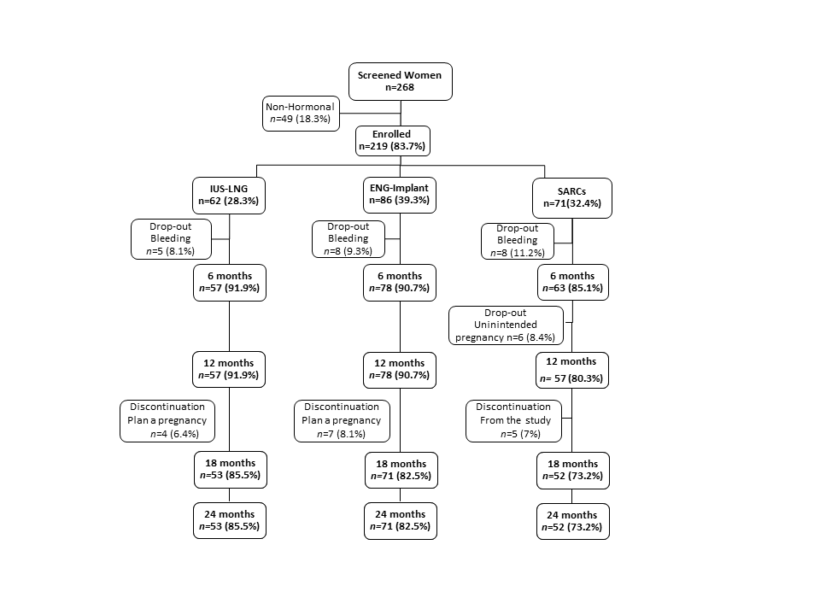
Figures

Figure 1. Flowchart of the study
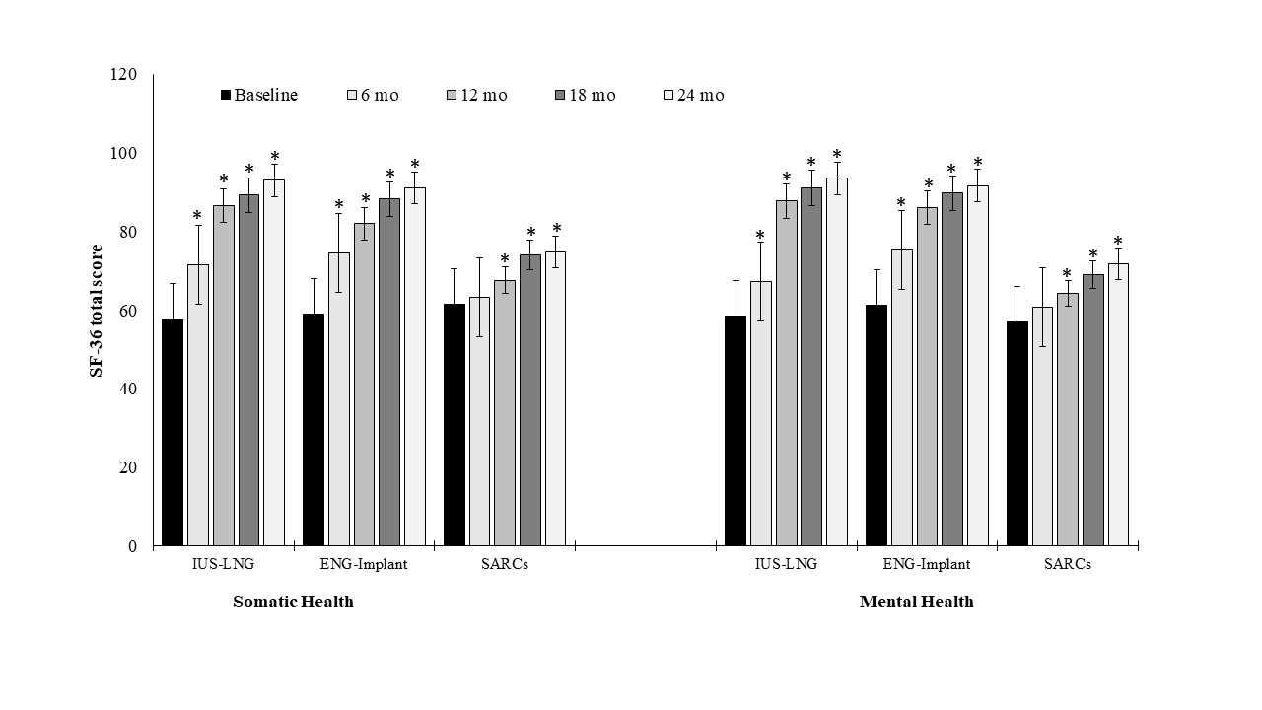

Figure 2: Intragroup statistical comparison analysis of the Quality of Life (SF-36 somatic and mental health scores) of women on LARC (A) and on SARC methods (B) over the 24-month study with baseline values, after termination for unintended pregnancy. *Vs Baseline, p<0.001

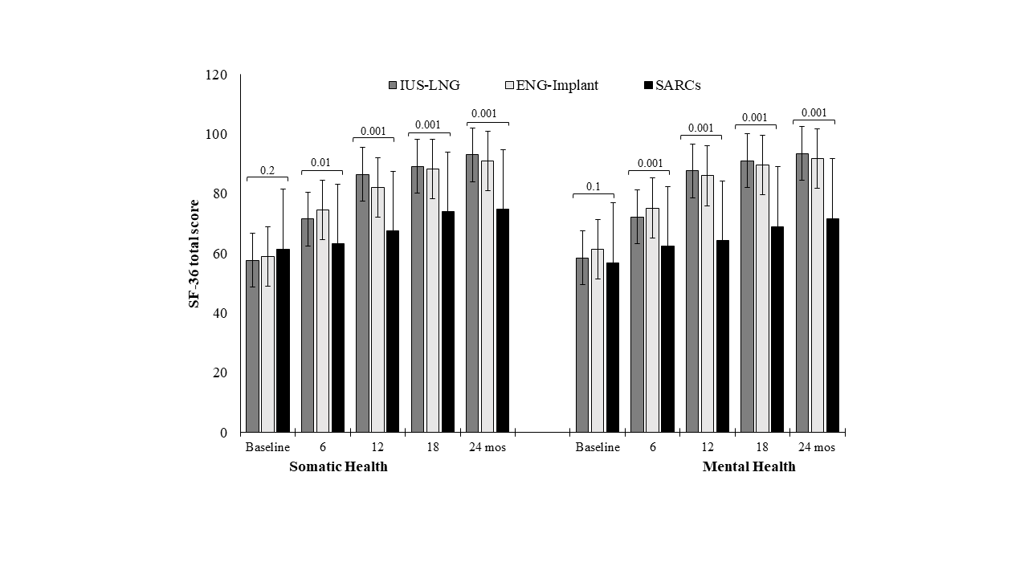

Figure 3: Intergroup statistical comparison analysis of the Quality of Life (SF-36 somatic and mental health scores) of women on LARC (A) and on SARC methods (B) over the 24-month study, after termination for unintended pregnancy

