 |  | dr. Mojtaba miladinia  Academic Researcher
Nurse Scientist  Ahvaz Jundishapur University of Medical Sciences; School of Nursing and Midwifery  Contact  PHONE:  +98 61 3311 0000  EMAIL:  Miladinia.m@ajums.ac.ir  Miladimojtaba@gmail.com  WEBSITE:  SCOPUS: 57142421300  ORCID: 0000-0002-6352-7008  researchgate.net/profile/Mojtaba-Miladinia  LinkedIn: mojtaba-miladinia-816207121  scholar.google.com/citations?user=HL107HYAAAAJ&hl=en |  | PhD in Nursing  Department of Nursing, Nursing Care Research Center in Chronic Diseases, School of Nursing, Ahvaz Jundishapur University of Medical Sciences (AJUMS), Ahvaz, Iran  Nursing faculty member with extensive experience in clinical research with a focus on clinical trial design, symptom management, complementary medicine and care. Also a referee for several international journals.  I am a member of Nursing Care Research Center in Chronic Diseases in affiliation with AJUMS. Also, I am a member of editorial board of CEOS Clinical Nephrology and Research journal.  SKILLS  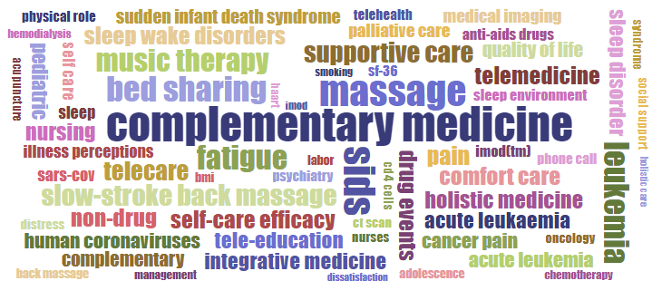

NO. | TITLE | JOURNAL | IF | SJR | SCOPUS CITESCORE | YEAR
1 | Role of self-management program based on 5A nursing model in quality of life among patients undergoing hemodialysis: a Randomized Clinical Trial  Original Article | BMC Nephrology  24(1):- | 2.3  Q3 | 0.746  Q2 | 4.3  Q2 | 2023
2 | Perception of coronavirus disease (COVID-19) and its relationship with coping strategies and perceived social support in iranian people: a descriptive correlational study  Original Article | BMC Nursing  22(1):- | 3.2  Q1 | 0.769  Q1 | 3.3  Q2 | 2023
3 | Determining massage dose-response to improve cancer-related symptom cluster of pain, fatigue, and sleep disturbance: A 7-arm randomized trial in palliative cancer care  Original Article | Palliative Medicine  37(1), pp. 108-119 | 4.4  Q1 | 1.425  Q1 | 7.5  Q1 | 2023
4 | A randomized trial of comparing video telecare education vs. in-person education on dietary regimen compliance in patients with type 2 diabetes mellitus: a support for clinical telehealth Providers  Original Article | BMC Endocrine Disorders  22(1):- | 2.7  Q4 | 0.733  Q2 | 4  Q3 | 2022
5 | Final triage methods to decide on home-isolation versus hospitalization in COVID-19 pandemic: a challenge for clinicians  Original Article | Journal of Emergency Practice and Trauma  8(2):90-94 |  | 0.136  Q4 | 0.4  Q4 | 2022
6 | The challenge of medication errors in the emergency department setting  Research Letter | Journal of Emergency Practice and Trauma  8(1):1-2 |  | 0.136  Q4 | 0.4  Q4 | 2022
7 | Slow-Stroke Back Massage Compared with Music Therapy for Leukemia-Related Pain and Fatigue: A Randomized Controlled Trial  Original Article | JCO Oncology Practice  17(11):E1614-E1621 | 4  Q2 | 1.349  Q1 | 4.9  Q1 | 2021
8 | Prevalence of substance use among psychotic patients and determining its strongest predictor  Original Article | Iranian Journal of Psychiatry  16(2):124-130 |  | 0.584  Q3 | 3.5  Q2 | 2021
9 | The challenge of deciding between home-discharge versus hospitalization in COVID-19 patients: The role of initial imaging and clinicolaboratory data  Original Article | Clinical Epidemiology and Global Health  10:- | 2.6 | 0.615  Q2 | 4.3  Q2 | 2021
10 | The relationship between pain, fatigue, sleep disorders and quality of life in adult patients with acute leukaemia: During the first year after diagnosis  Original Article | European Journal of Cancer Care  27(1):- | 2.1  Q2 | 0.694  Q3 | 4  Q3 | 2018
11 | The comparison of the effect of two complementary medicine methods (Music therapy and massage therapy) on postoperative acute pain after abdominal surgery: A randomized clinical trial study  Original Article | Iranian Red Crescent Medical Journal  19(6):- | 0.4  Q4 |  |  | 2017
12 | Effects of slow-stroke back massage on symptom cluster in adult patients with acute leukemia: Supportive care in cancer nursing  Original Article | Cancer Nursing  40(1):31-38 | 2.6  Q1 | 0.632  Q2 | 4  Q2 | 2017
13 | Complementary and alternative medicine in the pediatrics with leukemia: A narrative review study  Review | International Journal of Pediatrics  5(1):4175-4183 |  |  |  | 2017
14 | A comparison of quality of life between adolescences with beta thalassemia major and their healthy peers  Original Article | International Journal of Pediatrics  4(1):1195-1204 |  |  |  | 2016
15 | Pediatric nurses' medication error: The self-reporting of frequency, types and causes  Original Article | International Journal of Pediatrics  4(3):1439-1444 |  |  |  | 2016
16 | Controlling acute post-operative pain in Iranian children with using of music therapy  Original Article | International Journal of Pediatrics  4(5):1725-1730 |  |  |  | 2016
17 | Anxiety control in the Iranian children with chronic leukemia: Use of a non-drug method  Original Article | International Journal of Pediatrics  4(1):1225-1231 |  |  |  | 2016
18 | Effects of slow-stroke back massage on chemotherapy-induced nausea and vomiting in the pediatrics with acute leukemia: A challenge of controlling symptoms  Original Article | International Journal of Pediatrics  3(6):1145-1152 |  |  |  | 2015
19 | Sudden infant death syndrome: Risk factors and the relationship between them  Original Article | International Journal of Pediatrics  3(6):1103-1110 |  |  |  | 2015
20 | Prevalence and the relationship between characteristics and parental conditions with risk factors for Sudden Infant Death Syndrome (SIDS)  Original Article | International Journal of Pediatrics  3(6):1135-1143 |  |  |  | 2015

